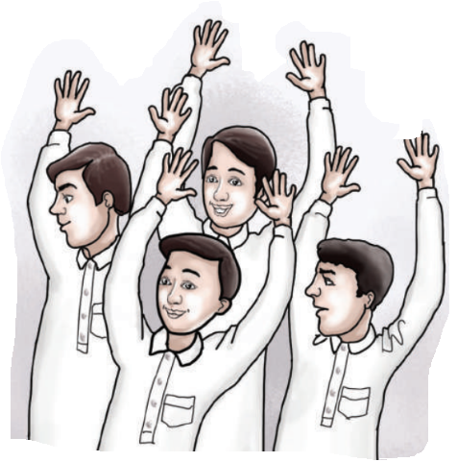
Unit: 2 Lesson: 1 Page: 12

Objective: I can match instructions correctly with pictures.

Match:


⃝ ⃝ ⃝ ⃝

⃝ ⃝ ⃝ ⃝
