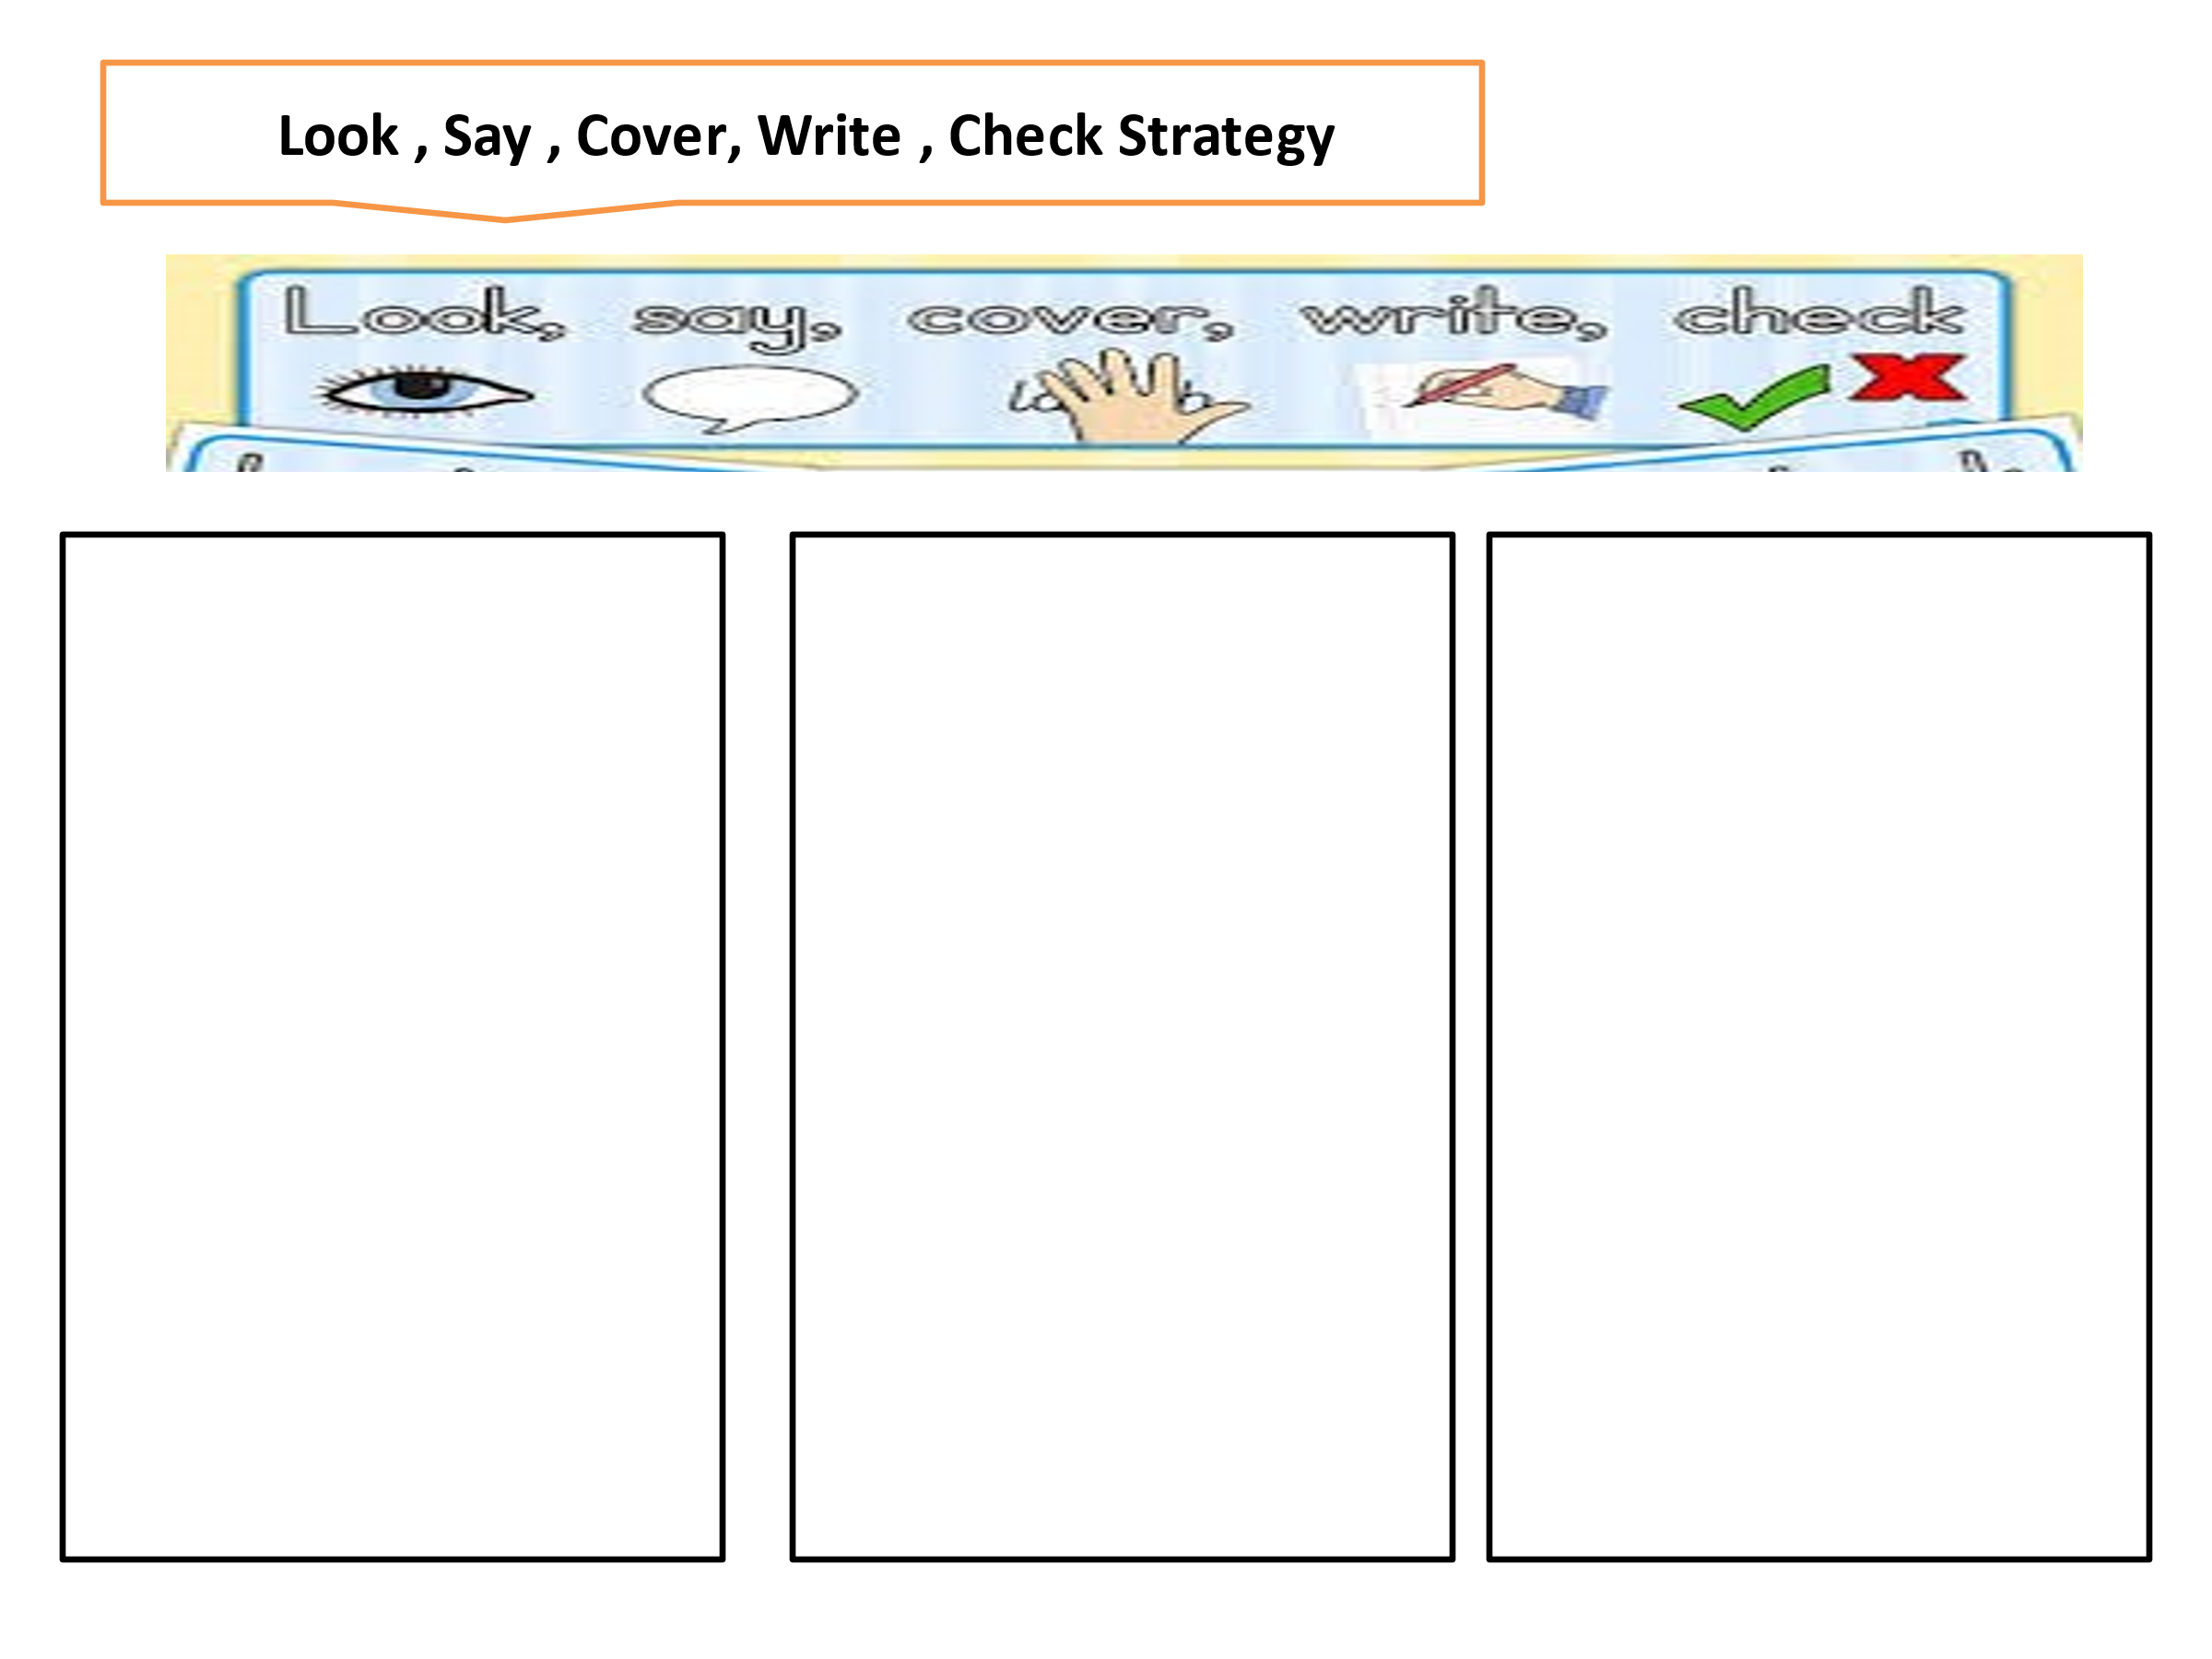
Sheep
Pie
Rain
Day

Sheep
Pie
Rain
Day

Meat
Sheep
Rice
Tie
Train
play
Meat
Sheep
Rice
Tie
Train
play

