
Super Goal 2 - English Language
Second Intermediate Grade
Third Term Final Exam 1444-2023
First Round | Time: 1.5 hour

Kingdom of Saudi Arabia
Ministry of Education
………. Education Directorate
……………Intermediate School

المراجع
checker

أ /..........
الدرجة كتابه
Written
المجموع
Total / 30
المصحح
corrector

Q16
Q26
Q37
Q4
4
Q57

اسم الطالب
رقم الجلوس
Composition

اللهّم لا سَهلَ إلا ما جعلتُه سَهلاً فإنكَ تَجعَلُ الحزنَ إذا شِئتَ سَهلاَ " "
Write about things you have to do at home ?
- What chores do you do?
- When do you do them?
- What do you like to do?
- What don’t you like to do?
..................................................................................................................................................................................................................
..................................................................................................................................................................................................................
..................................................................................................................................................................................................................
..................................................................................................................................................................................................................
..................................................................................................................................................................................................................
..................................................................................................................................................................................................................
..................................................................................................................................................................................................................
..................................................................................................................................................................................................................
..................................................................................................................................................................................................................
..................................................................................................................................................................................................................

6

اقلب الصفحة
Comprehension

6

- Read the following passage and answer the questions below:

What’s the strangest food you have ever eaten? People in the U.S. and Europe think that bugs are a strange thing to eat. But many people around the world eat bugs every day.
Bugs are eaten in 36 African countries, 29 Asian countries, and 23 Central and South American countries.

Bugs that live on land are not very different from bugs that live in the sea. Many people think that shrimp, crab, and lobster are really just "sea bugs." And like sea bugs, land bugs are good for you. Many contain protein, iron, and calcium- nutrients your body needs to stay healthy.

Dave Gordon is a famous chef in the United States. He is called "The Bug Chef." He has written many books about why everyone should eat bugs. He says that grasshoppers, for example, have a lot more protein than chicken or beef. Also, bugs are an inexpensive food. They are everywhere! He wants Americans to eat more bugs. He travels to different places and shows people how to cook with them. Many people are surprised to find out that they can be delicious!

A. Choose the correct answer:
- A nutrient your body needs to stay healthy is ____.
a. grasshopper b. calcium c. chicken d. beef
- Many people call shrimp, crab, and lobster ____.
a. sea bugs b land bugs c fish d. vegetables
- Bugs are eaten in _____ Asian countries.
a. 36 b. 23 c. 12 d. 29

B. Write (T) for True or (F) for False:

4. Bugs are a healthy food to eat.
5. Many people around the world eat bugs every day.
6. Dave Gordon is a famous doctor.
اقلب الصفحة

7
Grammar

- Choose the correct answer

- Karl: What are you going to do tomorrow? Larry: _____
a. I go to study. b. I going to study. c. I’m going to study. d. I’m going studying
- Riyadh is _______.
a. a beautiful city b. a city beautiful c. a beautiful d. beautiful a city
- They _________ going to go by plane.
a. isn’t b. are c. is d. am
- Jane: Will it be sunny tomorrow? Amira: No, ______.
a. it won’t b. it will c. won’t it d. will it
- Jim: _____ on vacation? Gordon: We’ll probably go in the spring.
a. Where will you go b. Where you will go c. When you will go d. When will you go
- If the lake ___, the children will probably go ice-skating.
a. frozen b. freezes c. freeze d. will freeze
- _____ he understand what you were talking about?.
a. Could b. cans c. will can d. can not
- My brother _____ play tennis now. He is in the field.
a. will not can b. can not c. will can d. can
- _________ carry that for you thank you.
a. can b. let me c. could d. will
- He was so surprised that he _____ speak.
a. was almost able to b. couldn’t hardly c. was able just to d. could hardly
- There was so much traffic that I was _____ for work.
a. almost late b. just late c. absolutely late d. hardly late
- The injured runner didn’t win, but he_____ the race..
a. wasn’t able to finish b. could finish c. was able to finish d. couldn’t finish
- I _____ Italy last year.
a. has visited b. have visited c. visited d. visit
- Max: Have you ever seen snake? Tom: Yes, ____.
a. I has b. I have c. I have seen d. I has seen

Orthography

4
- Choose the correct letters :
- Are you going on va…..ation ? ( c – o – r )
- Scuba di…ing in The Red Sea ( q – o – v )
- Spring is usually c….ol ( v – o – r )
- It gets very cold in win…er ( q – t – x )
- Children Please put away your to….s ( v – o – y )
- Can I borrow your cell p….one? ( q – h – x )
- The ele….ator wasn’t working. ( v – o – y )
- Have You Had an Exciting Li…e? ( x – o – f )

اقلب الصفحة

Vocabulary

- Choose the correct answer:

7

- This quiet beach is ____.
a. noisy b. relaxing c. adventurous d. expensive
- This hiking vacation in the mountains is ____.
a. adventurous b. luxurious c. expensive d. relaxing
- It’s _______________ today. Hold on to your hat!
a. windy b. sunny c. cloudy d. snows
- Don’t forget your sunglasses. It’s very _____________.
a. cloudy b. rainy c. sunny d. windy
- I have no idea mean ____________ .
a. I don't know b. I have no problem c. He knows d. I have to say
- I will bring some snacks from the_________.
a. bathroom b. the roof c. Kitchen d. garage
- I _____ when I saw the snake. I was so surprised!
a. fired b. shrieked c. lightning d. wounds
- Did you see the storm last night? The _____ was amazing!
a. lightning b. wounds c. fired d. risk
- A zorse is half zebra, half _________.
a. horse b. fish c. Elephant d. Tiger
- Which of the following sports are unusual:
a. Dennis b. Football c. Basketball d. Hang gliding
- Definitely means: _____________.
a. not sure b. certainty c. very frightened d. You’re crazy!

- Write the correct word under the picture.
Hospital – Desert – Scuba diving
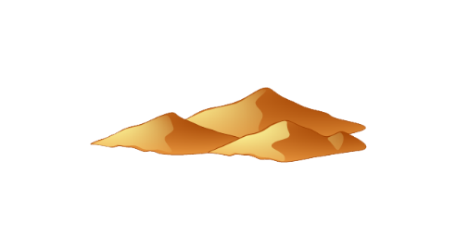
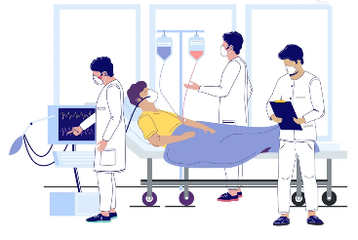
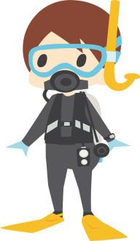
14.
13.
12.

………………………………….
………………………………….

………………………………….

انتهت الأسئلة .. ..
وبالله التوفيق والنجاح ..
ا

