
المملكة العربية السعودية
Kingdom of Saudi Arabia
Ministry of Education
------- Educational Directorate
------- Future Educational Schools
1st grade intermediate 2022
3rd Term – Final Exam
وزارة التعليم
الإدارة العامة للتعليم بن
مدارس م ن التعليمية
الصف الاول المتوسط
الاختبار النهائي للفصل الدراسي الثالث1443
Total  written | 5 spelling | 4 Vocabulary | 3 Grammar | 2 Comprehension |  | 1 Composition | Q. NO.
 |  |  |  |  |  |  | Mark Given
30 | 4 | 7 | 7 | 6 |  | 6 | Mark
 |  |  | Reviser |  |  |  | Corrector
زمن الاختبار: ساعتان
اسم الطالب: ------------------------------------ رقم الجلوس: ------------- الصف الأول المتوسط

6

1) Composition
1- Write a paragraph about “Your Favorite Place"
You may use 50 words:
…………………………………………
………………………………………………………………………………………………………………………………………………………………………………………………………………………………………………………………………………………………………………………………………………………………………………………………………………………………………………………………………………………………………………………………………………………………………………………………………………………………….

2) Comprehension

6
2- Read the following passage then answer the questions:

The Sports Center
I like to go to the sports center. I go there every weekend. At the sports center, you can do many things. For example, you can play golf or tennis. There is a pool, so you can also swim or relax by the pool. There is a beach next to the sports center. You can swim, water-ski, or windsurf in the ocean. You can also sail on windy days. There aren’t any fish near the beach, so you can’t snorkel. When I go to the sports center, I like to play volleyball on the beach. I also like to jog on the beach. I can’t swim well, so I don’t like to water-ski or windsurf.
A- Put ( ) or ( x ):
1. The writer likes the sports center. ( )
2. You can swim in the pool or in the ocean. ( )
3. People can windsurf in the pool. ( )
4. You can’t use a boat in the ocean. ( )
5. In the sports center, there aren't many things. ( )
B- Choose the correct answer:
1. There is a (peach – beach – fetch) next to the sports center.
2. There aren’t any (fish – meat – fruit) near the beach
3. He doesn’t like to water-ski or (windows – doors – windsurf).
4. You can also sail on (rainy – snowy – windy) days.
C- Answer the following questions:
1. Where does the writer like to go?.............................
2. When does he go?...........................
3. What does he play on the beach? ..............................
3) Grammar

A: Choose the correct answer:

7
1. She (can – can't – does) cook well. She is bad at cooking.
2. We (don't like – doesn't like – isn't like) to stay up for late hours.
3. She (am – is – are) going to visit her friends.
4. Ali is a nice guy. I want you to meet (them – him – her)
5. He wants (to reads – to read – to read) some books.
6. We (was – were – are) at home, waiting for you.
7. They (eat – eating – ate) a delicious meal last weekend.
8. Did you do your homework? No, I (is – did – didn't).
B: Chang into Negative:
1. They can play football.
…………………………………………………………………………………………………………………………………………………………………………………………………………………
2. He is going to dust his room.
……………………………………………………………………………………………………………………………………
3. We stopped at the supermarket to buy ice cream.
……………………………………………………………………………………………………………………………………
C: Make Yes/No question:
1. He can read English well.
……………………………………………………………………..……………………………………………………………
2. She is going to call her friend.
……………………………………………………………………………………………………………………………………

3. We visited our friends in Najran.
……………………………………………………………………………………………………………………………………
4) vocabulary:

7
A- Match the words with the pictures:
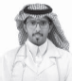
doctor - meal – shirt – bus stop – fireworks – beach
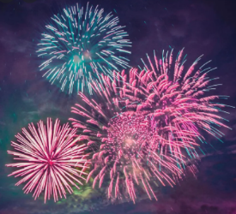
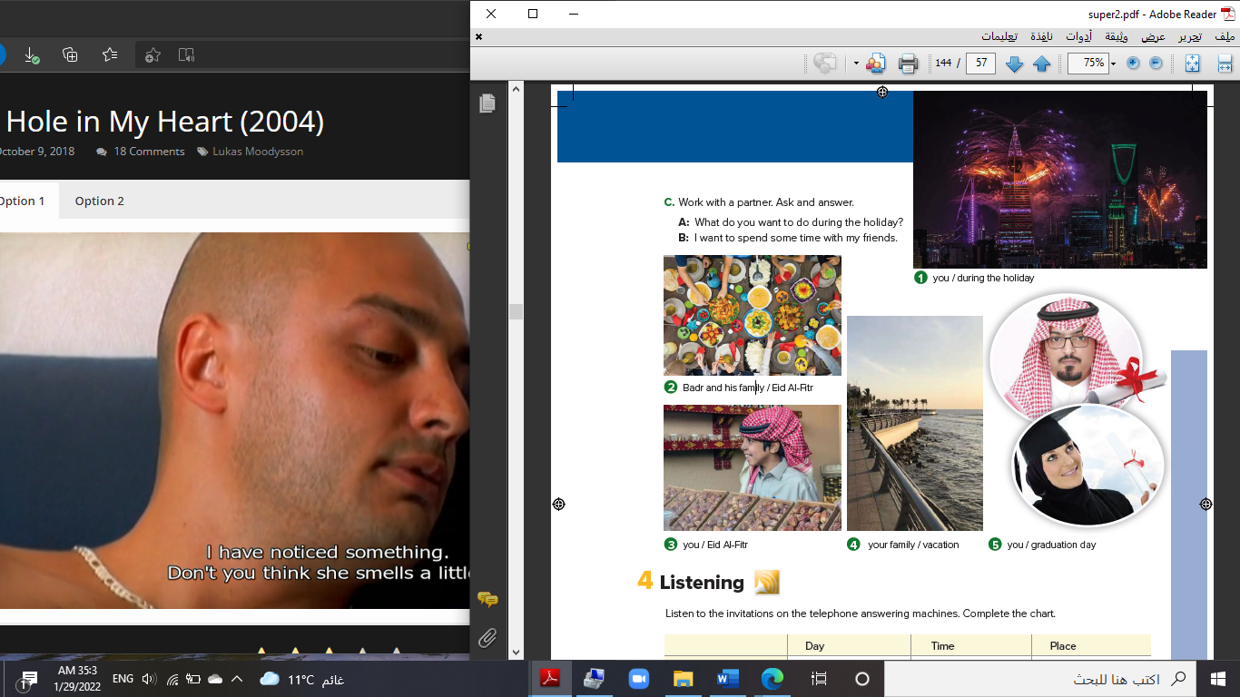

……………... ……………. ……..………. ……..…… ………… …………..
B- Match the answers:

a. green color | 1. You can open an account. ------
b. Riyadh | 2. Men wear it for work. ------
c. bank | 3. In Saudi Arabia, people decorate houses in ------
d. thobe | 4. The King of Saudi Arabia is ------
e. King Salman | 5. It was a traditional place then it became the capital ------

C- Circle the correct spelling:

1. natonial - nashional – national
2. house – huoes - hosue
3. yesteday – yesterday – yetserday

5) Orthography:

4

A- Fill in the missing letters:

1- buil__ing
p – u – r – o – s
2- cons__le
3- celeb__ation
4- air__ort
B- Choose the odd one out:
1. suit jeans tie abaya
2. watch school help eat
3. Emirates Kuwait under Oman
4. teacher morning afternoon evening

End of Questions
Best of Luck

