المملكة العربية السعودية |  |  |  |  |  |  |  | المادة: | اللغة الانجليزية
وزارة التعليم |  |  |  |  |  |  |  | الصف | السادس الابتدائي
الادارة العامة للتعليم ب_______ |  |  |  |  |  |  |  | التاريخ: | 30/11/1443 هـــ
مدرسة ابي _____ الابتدائية |  |  |  |  |  |  |  | الزمن: | ساعة ونصف
اختبار نهاية الفصل الدراسي الثالث – الدور الأول للعام الدراسي 1442/1443 هـ
أسم المصحح |  | التوقيع |  |  | أسم المراجع |  |  |  |  | التوقيع
الدرجة رقما 30 |  | مجموع الدرجة كتابة
أسم الطالب: |  |  |  | الفصل |  | 6 / |  | رقم الجلوس

- Choose: General Questions

4
- Does your school have a school bus ?
a. About 300. b. It has a big yellow bus.
- What should you do to live a healthy life?
a. I have a headache. b. I should do some exercise.
- Where’s the post office?
a. It’s near here. b. Do not litter.
- Where are you going?
a. I’m going to Dubai. b. Apple juice,please.

- Write or :

- You can buy cakes from the bakery . ( )

- My school starts at 11:00 pm . ( )
2

Controlled Writing
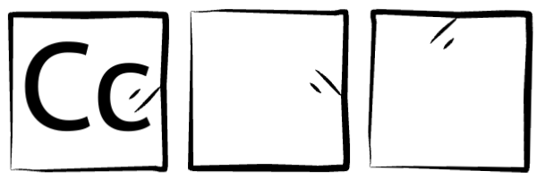
- Complete:
April | bookstore | Dammam | math | shirt

- Subjects: history , science , ______________________ .

5
- Clothes: jacket, scarf, __________________________ .

- Places: DVD store, flower shop, ___________________ .

- Cities: Riyadh, Jeddah, __________________________.

- Months : February , December , ____________________.

اقلب الصفحة - 1 -
4
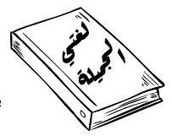
- Number: Reading Short Sentences

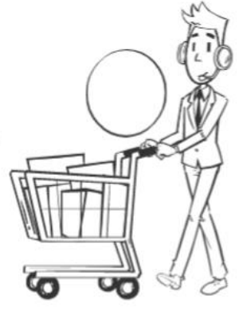
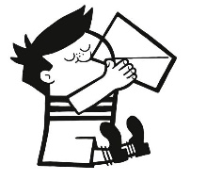
1. The subject I like the most is Arabic .
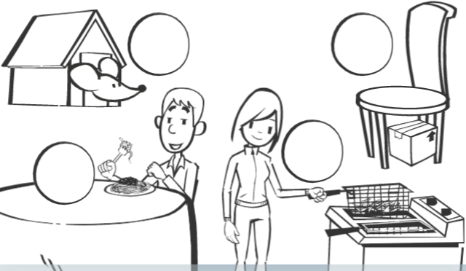
2. I ate pasta this evening.

3. He goes to the supermarket.

4. He drank the milk because he was thirsty .
6
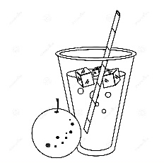
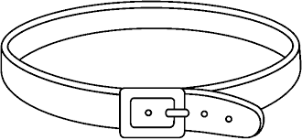
- Match: Vocabulary

belt

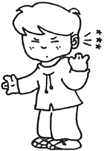
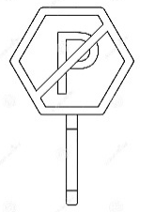
earache

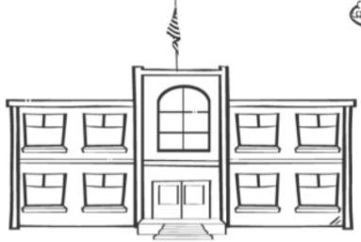
juice

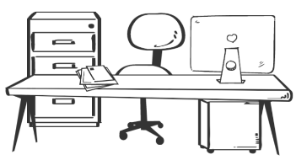
No parking

office

school

5
- Choose: Grammar

- Last year I am - was in the 5th grade.

- I should - shouldn’t watch too much TV.

- We are go – going to the library.

- The past of do is did - does .

- I didn’t brush - brushed my teeth this morning.

4

- Complete: Spelling

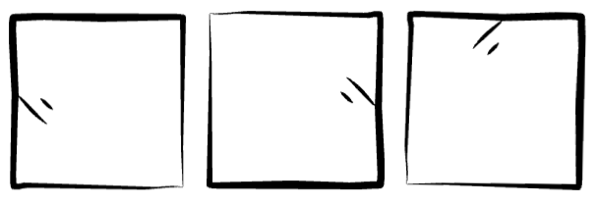
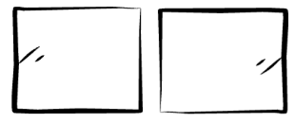

ur gl sk sq
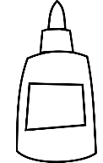
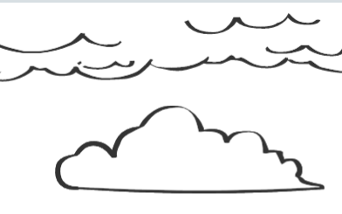
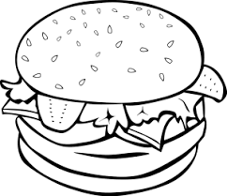

__ __ y __ __ ue b__ __ ger __ __uare
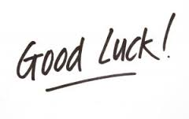
انتهت الأسئلة - 2 -

