Revision
I. General Questions
A. Match "A" with "B":
IV. Controlled writing
"A" |  | "B"
1. What's the name of your school? |  |  | This year I like English.
2. Do you have school uniform? |  |  | Yes, we do.
3. Which subject do you like this year? |  |  | 9th Elementary School.
4. What would you like to drink? |  |  | I'm going to Dubai.
5. where is the post office? |  |  | Go straight and you'll find it.
6. Where are you going? |  |  | I'd like some juice.
- Choose:

- How many students are there in your school?
a. About 500. b. Yes, we do
- What should you do to live a healthy life?
a. I have a headache. b. I should do some exercise.
- Where’s the post office?
a. It’s near here. b. Do not litter.

________________________________________________________________________
A. Unscramble and write:
1.u– b – e – l
……………………………………………………………………………………….
2. u- t- e c
……………………………………………………………………………………….
B. Complete: [ Paris – candy store –snow - book store - laugh - math - orange ]
1. ……………………………….sells candy.
2. The Eiffle Tower is in ……………………….
3. I'd like some………………………juice, please.
4. When I feel happy, I ………………
5. My favourite subject is …………
6……………….sells books.
7. it's white. You ski on it………………
III. Reading short sentences
A. Number.


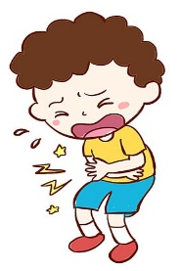
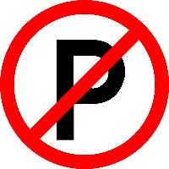
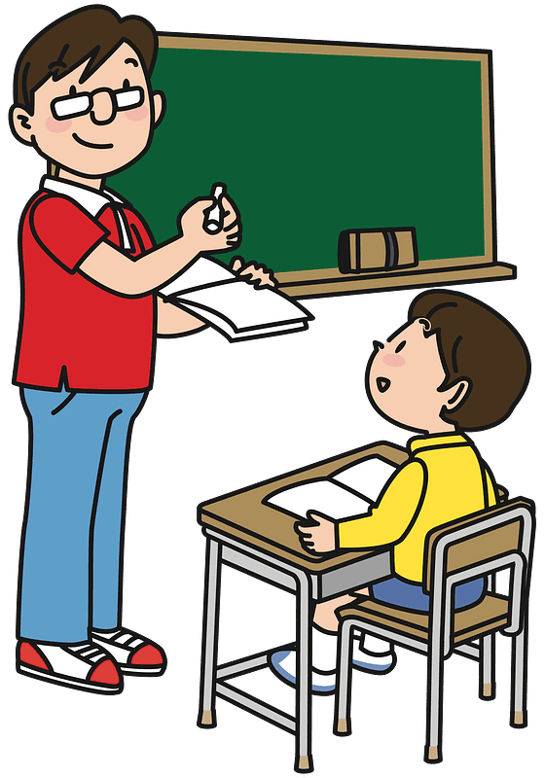
1. No parking.
2. Listen to the teacher.
3. He's scuba diving.
4. I have a stomachache.

II. Grammar
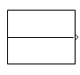
A. Choose the correct answer:
5
1. Did you ( drink – drank - drunk ) milk in the morning.
2. We ( is – are – am ) going to the bookstore.
3. There ( was – were - are ) a little green house.
4. I'm going to [ visit – visiting – visits ] my grandma.
5. Last year I [ went – go – going ] to Riyadh.
B. Do as shown between brackets.
1. Last year I ( am ) in the 5th grade. ( Correct )
………………………………………………………………………
2. The past tense of get up is…………….. ( Complete )
__________________________________________________________________________
V. Vocabulary
…
A.Write the correct number under the correct picture:
1. toothache 2. science 3. School bus 4. bakery 5. stapler 6. skirt gliding crocodile

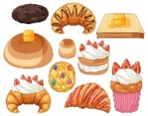
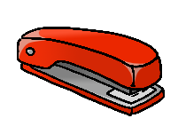

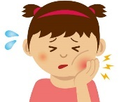

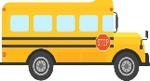

( ) ( ) ( ) ( ) ( ) ( )

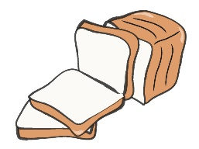 | 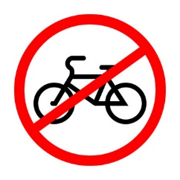 | 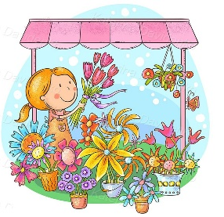 | 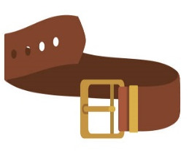 | 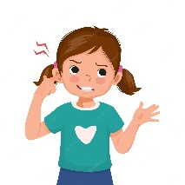
juice | No bicycle | Candy store | shirt | earache
bread | library | Flower store | belt | backache

VI. Orthography(spelling)

A. Circle the correct missing litters:

  4. b __ __ d | 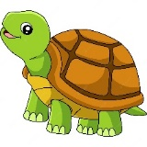  3. t __ __ tle |   2. __ __ uare |   1.__ __arf
ir / ur | ir / ur | sc / sq | sc / sk
  8. __ __ y | 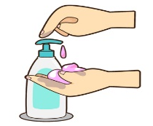  7. lo _ _ _ _ |   6. tiss __ __ | 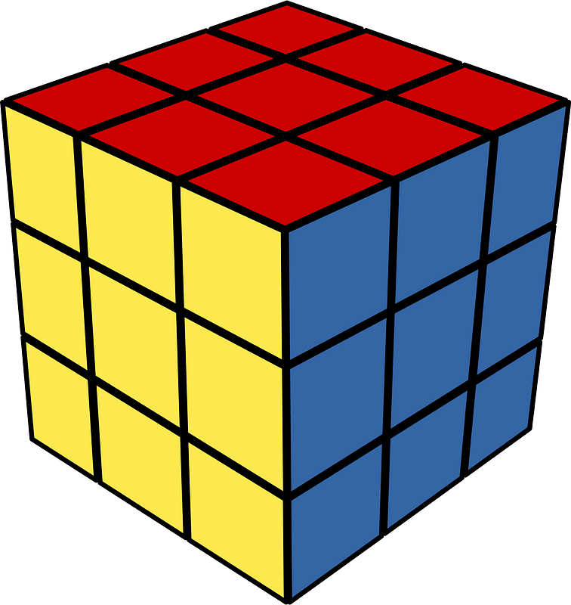  5. c __ b e
sc / sk | sh / tion | qe / ue | w /u
B. Complete: [ ur – sc - ue – ir ]
 | 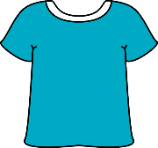 | 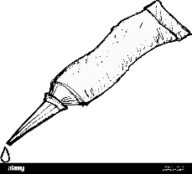 | 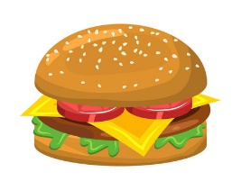
_ _ ary | sh_ _ t | gl_ _ | b_ _ ger

T. Dalal Al-Otaibi

