Kingdom of Saudi Arabia  Ministry of Education  Tabuk) )  Al Abnna 2 Secondary School |    | Corrected by:  ………………….. |  | Mid term Exam  Third term  1444  Second grade  Time:45 min  Mega Goal 2.3

Reviewed by:

…………………..

اختبار منتصف الفصل الدراسي الثالث

…………………..

10
 | اختبار منتصف الفصل الدراسي الثالث  …………………..  10 | Checked by:  …………………..
Name | ……………………………………………….... |  | Class |  | ……………

عزيزي الطالب: كل فقرة ستكون بـ (0.5) درجة، والتعبير سيكون بـ( ٤ درجات)، ومجموع ما تحصل عليه من هذا الاختبار من درجات سيقسم على ( 2 ) ليكون مجموع درجات اختبار منتصف الفصل ( 10) درجات ، مع تمنياتي لك بالتوفيق.

1.Reading

Read the following paragraph then chose the correct answer:
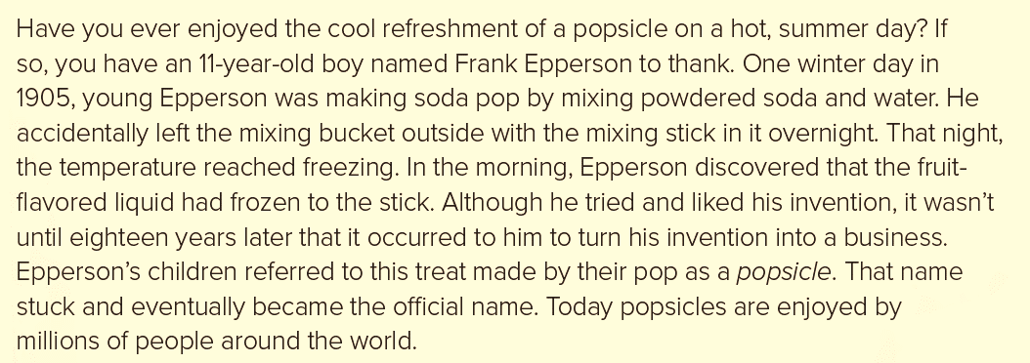
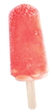
2

- Who discovered the food?
- 11-years-old boy
- Frank Epperson
- One winter
- When was is discovered?
- in 2030
- in 1905
- in 776 b.c.e
- How did he happen to discover it?
- He put it in his refrigerator.
- Frank mixed it with ice.
- Frank left a bucket of soda out one cold night with a mixing stick in it, and it froze.
- What happened after he discovered it?
- Turning into a business
- He gave it to his friend as a gift.
- Just ate it.
1

2. Grammar

- This movie is so ………… .
- bore | - too bored | - boredom | - boring
- The older we grow, ………………. we become.
- wise | - wiser | - the wiser | - wisest
- She is ………………… a beautiful girl that everyone stares at her.
- so | - such | - too | - very
- I failed my exam. I wish I had ……………. harder.
- study | - studies | - studying | - studied
- Most of the news on TV is …………..
- depressed | - depress | - depressing | - bored
- He is …………… dressed.
- get | - got | - gets | - getting
- I wish I had …………….. early.
- wake up | - waken up | - woke up | - wake
- Ali decided to ………………. smoking.
- pick up | - wake up | - give up | - cut up
- I wake …………………. at 7:30 every day.
- up | - off | - on | - over
- Please , turn ……………. the TV I want to watch the new program.
- off | - on | - down | - into
- There aren't …………….. students in the class.
- some | - no | - much | - any
- How …………….. milk does she drink?
- many | - much | - old | - long
- How ………….. burgers does he eat?
- many | - much | - old | - long
- He has ………………… friends that will help.
- a few | - a little | - much | - any

2

3.Vocabulary
- Choose the correct answer:

- The odd word is:
- sugar | - spoon | - vanilla | - cocoa
- The odd word is:
- half | - a quarter | - taste | - one
- I love the ……………. of coffee.
- bitter | - licensed | - aroma | - distinguish
- The medicine tastes too ……………….
- bitter | - licensed | - aroma | - distinguish
- The odd word is:
- worried | - longer | - bigger | - funnier
- Khaled is ……… . He can speak Arabic and English perfectly.
- Pediatric | - puzzled | - bilingual | - irritated
- Nora decided to be become a ………. because she really loves children.
- Pediatric | - puzzled | - bilingual | - irritated
- 3- I'm really getting …………. where the insect spray.
- Pediatric | - puzzled | - bilingual | - irritated

- Choose the correct word for each picture:
 | a. a parrot b. mynah | 
 | a. prompt b. cardiovascular | 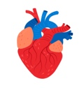
 | a. laugher b. talker | 
 | a. popsicle b. cocoa | 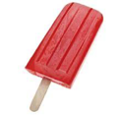
 | a. wafer b. cookies | 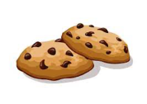
 | a. potato chips b. popcorn | 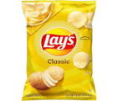

3

4. Writing
Write an essay about “laughter “explaining the beneficial effect
on mood and sense. These guide words may help you:

increases your heart rate, oxygen levels in your body, lose weight, burn up to 50 calories, physical advantages, make people alert, sleep more soundly, laughter club,

.....................................................................................................................................................
.....................................................................................................................................................
.....................................................................................................................................................
.....................................................................................................................................................
.....................................................................................................................................................
.....................................................................................................................................................
.....................................................................................................................................................
.....................................................................................................................................................
.....................................................................................................................................................
.....................................................................................................................................................
.....................................................................................................................................................
.....................................................................................................................................................
4
Best wishes ..
My Regards - Tr. Abdullah AL Zahrani
2023

