ا
Kingdom of Saudi Arabia
The Ministry Of Education
General Directorate of Education
Secondary School
English Language Final Exam
English : Mega Goal 4
Time: 3 Hours
Final Exam – 1st term -1443.H

اختبار مقرر ( اللغة الانجليزية ) الفصل الدراسي الثاني ( الدور الأول)- - للعام الدراسي 1443هـ - نظام المقررات

اسـم الطالبة: ................................................................. رقم الجلوس: .......................... الصف: ........................

" اللَهُم لاَ سَهْلَ إلاَ مَا جَعًلَتُهُ سَهْلاً ,وَ أنْتَ تَجْعَل الحَزَنَ إذا شِئتً سَهْلاً"
Guided comps | Free Comps. | Reading Comprehension | Grammar | Vocabulary | Total | Corrected by | Revised by | Checked by
_____  6 | _____  6 | ______  6 | ______  6 | _____  6 | ______  30

Ⅰ- Guided Composition

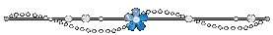

A) Write an assay about ( Laughter is the Best Medicine) using the notes below :

Guided words: positive - benefits – get rid – depression - anxiety – relationship - faster –
mood - normal - amazing – mental - medicine -fun – tough - situation - easy- cute
…………………………………………………………………………………………………………………………………………..………………………………………………………………………………………………………………………………………..………………………………………………………………………………………………………………………………………………….…

ـــــــــــــــ
6
…………………………………………………………………………………………………………………………………………………………………………………………………………………………………………………………………………………………………………………………………………………………………………………………………………………………………………………………………………………………………………………………………………………………………………………………………………………………………………………………………………………………………………………………………………………………………………………………………………………………………………………………………………………………………………………………………………………………………………………………………………………………………………………………………………………………………………………………………………………………………………………………………………………………………………………………………………………………………………………………………………………………………………………………………………………………………………………………………..………………………………………………………………………………………………………………………………………..……………………………………………………………………………………………………………………………………………………………..………….…
…………………………………………………………………………………………………………………………………………..………………………………………………………………………………………………………………………………………..………………………………………………………………………………………………………………………………………………….…………………………………………………………………………………………………………………………………………………………………………………………………………………………………………………………………………………………………..
mark | item
2 | organization of ideas  ( main idea , supporting details)
2 | accuracy and range of vocabulary and grammar
1 | mechanism  ( punctuation , capitalization , spacing )
2 | spelling

mark | item
2 | organization of ideas  ( main idea , supporting details)
2 | accuracy and range of vocabulary and grammar
1 | mechanism  ( punctuation , capitalization , spacing )
2 | spelling

………………………………………………………………………………………………………………………………………………………………………………………………………………………………………………………………………………………………………………………………………………………………………………………………………………………………………………………………………………………………………………………………………………………………………………………………
……………………………………………………………..………………………………………………………………………………
……………………………………………………………………………………………………………………………………………………………………………………………………………………………………………………………………………………………………………………………………………………………………………………………………………………………………………………………………………………………………………………………………………………………………………………………………………………………………………………………………………………………………………………………………………..………………………………………………………………………………………………………………………………………..………………………………………………………………………………………………………………………………………………………………………………………………………………………….……………………………………………………………………….

Page: 1 out of 4
P. T. O

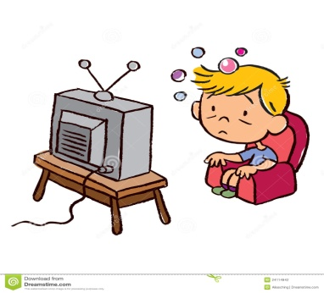

Page: 1 out of 4
P. T. O

Page: 1 out of 4
P. T. O

II - Free Composition

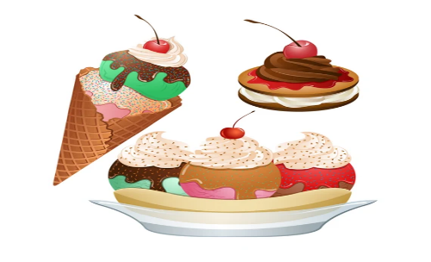 Choose ONE of the following topics, and then write a composition about it:


1-Write a list of the most popular " Desserts and Snacks" in the world .
…………………………………………………………………………………………………………………………….………………………………………………………

…………………………………………………………………………………………………………………………………………..………………………………………

………………………………………………………………………………………………………………………………………………………………………………….

…………………………………………………………………………………………………………………………………………………………………………………

…………………………………………………………………………………………………………………………………………………………………………………

……………………………………………………………………………………………………………………………………………….……………………………….

…………………………………………………………………………………………………………………………………………………………………………………

…………………………………………………………………………………………………………………………………………………………………………………

……………………………………………………………………………………………………………………………………………….……………………………….
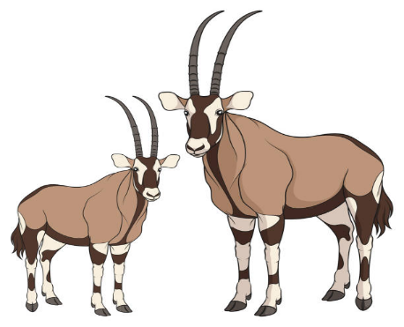

ـــــــــــــــ
6
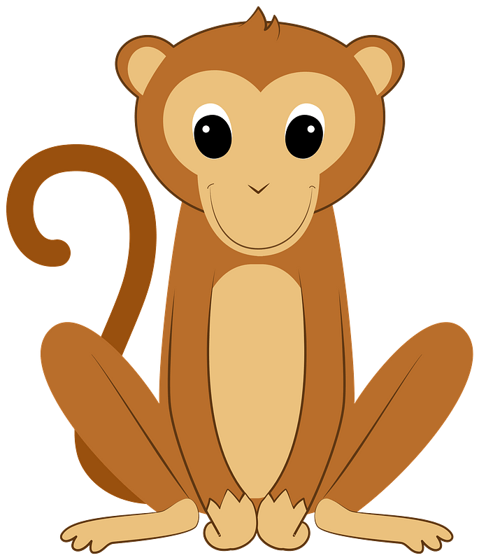

2-Write a list of ( Animals ) that live in Saudi Arabia ::

…………………………………………………………………………………………………………………………….………………………………………………………

…………………………………………………………………………………………………………………………………………..………………………………………

………………………………………………………………………………………………………………………………………………………………………………….

…………………………………………………………………………………………………………………………………………………………………………………

…………………………………………………………………………………………………………………………………………………………………………………

……………………………………………………………………………………………………………………………………………….……………………………….

……………………………………………………………………………………………………………………………………………..………………………………
…………………………………………………………………………………………………………………………………………………………………………………

…………………………………………………………………………………………………………………………………………………………………………………

……………………………………………………………………………………………………………………………………………….……………………………….

Page: 2 out of 4
P. T. O

Ⅲ Comprehension

ـــــــــــــــ
6

Read the following passage then answer the questions below :

French Fries
French fries are one of the most common food around the world . French fries are long, thin pieces of potato fried in oil or fat . Vegetables oil is the best fat to make amazing fries . French fries are served hot, either soft or crispy, and are generally eaten as part of lunch or dinner or by themselves as a snack, and they commonly appear on the menus of diners and fast food restaurants. French Fries are usually salted and, depending on the country, may be served with ketchup, mayonnaise or tomato sauce.

To achieve golden-brown perfection, you have to fry them twice: first at a low temperature, to poach them; then at a high heat, to crisp them up. Actually , French fries are better when cooked at restaurants .Some people got addicted to French Fries because they don't need a fork or spoon to eat them . They can eat French fries with their fingers .

Many restaurants selling French fires frequently combine servings of fries with another food, for example, fried fish or beef burgers. In fact , French fries go with hot dogs, hamburgers, fish and all sorts of sandwiches. Many countries in every corner of the globe have their own way of eating this beloved dish.

A-Answer the following questions :

1- What are French fries ?
………………………………………………………………………………………………………………………………………………………

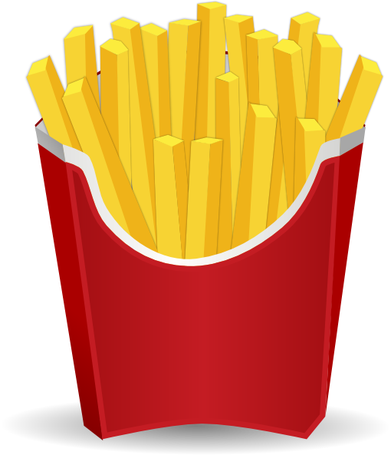2- Why did some people get addicted to French Fries ?
……………………………………………………………………………………………………………………………………………………………………

3- Do French fries go with all sorts of sandwiches ?
………………………………………………………………………………………………………………………………………………………………….

B-Choose the correct answer:

- The best fat to make amazing French fries is ( vegetables – corn – olive - palm ) oil.
- To achieve golden-brown perfection, you have to (grill - roast – boil - fry) them twice
- crispy in line (3) means (crunchy – flexible – organic - neutral)
- The opposite of beloved is (admired – popular – favorite - unloved )

C- Write ( True ) or ( False ) :

1- French Fries are usually salted. ( )

2-French fries may be served without ketchup, mayonnaise or tomato sauce.( )

Page: 3 out of 4
P. T. O
P. T. OP. T. OP. T. O
Page:3 out of 4Page: 2 out of 4Page: 2 out of 4

V-- Grammar

ـــــــــــــــ
6

A-Choose the correct answer from those given between brackets:
1- I can't drink the coffee. It's (not – too - more – enough) hot.
2 – He has been (teach – teaches – taught – teaching) since 2002.
3-My mom is very (tired – tiring - tiredness – tiresome). She worked very hard today.
4-She is (so – such – too – very) a beautiful girl that everyone stares at her .
5- There aren't (some – no - much – any ) students in the class .
6- Neither students ( nor – or – but- and) teacher was at class..

B-Do as shown between brackets

1- He is a hard worker…………………………………………………………………………….. (Rewrite using adverb of manner)

2-I’m not very tall. I ……………………………………………………………(be) taller. (Complete using wish)
3-He was not ill. Still, he walked very slowly. (Combine using as if)
…………………………………………………………………………………………………………………………………………………………………………………………………….……………

4- I put my shoes on. ………………………………………………………………………. (Replace the noun object with a pronoun)

C-Correct the verb between brackets
1- He should ( take) …………………………………… to hospital .
2- He used to (loves) …………………………chocolate as child.

Ⅳ-Vocabulary

ـــــــــــــــ
6

A-Fill in the spaces with suitable word :
aroma - furnish - marathon

- Thousands of runners participate in the ………………………………………… every year.
- I love the ………………………………………… of coffee .

B -Fill in the spaces with suitable word :

- 1- Large – red – small – medium 2- Cancer – Alzheimer – Rheumatism – test

C-Match the words with their meanings: D-Match the words with their opposites:
1 | cool | ( ) | bad
2 | rotten | ( ) | great
 |  | ( ) | poisons

1 | exterior | ( ) | immoral
2 | moral | ( ) | monolingual
 |  | ( ) | interior

F- Write the correct word for each pictures :
(whisk – adobe house – measure - medal – DNA)
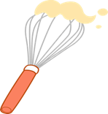
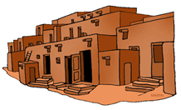

…………………………………….. …………………………………………………. ……………………………………… ……………………………………..

…………

♥The End ♥
☺Good Luck ☺

Page:4 out of 4

English Teacher : Entisar Al-Obaidallah
Page:4 out of 4

ا
Kingdom of Saudi Arabia
The Ministry Of Education
General Directorate of Education
Secondary School
English Language Final Exam
English : Mega Goal 4
Time: 3 Hours
Final Exam – 1st term -1443.H

اختبار مقرر ( اللغة الانجليزية ) الفصل الدراسي الثاني ( الدور الأول)- - للعام الدراسي 1443هـ - نظام المقررات

اسـم الطالبة: ................................................................. رقم الجلوس: .......................... الصف: ........................

" اللَهُم لاَ سَهْلَ إلاَ مَا جَعًلَتُهُ سَهْلاً ,وَ أنْتَ تَجْعَل الحَزَنَ إذا شِئتً سَهْلاً"
Guided comps | Free Comps. | Reading Comprehension | Grammar | Vocabulary | Total | Corrected by | Revised by | Checked by
_____  6 | _____  6 | ______  6 | ______  6 | _____  6 | ______  30

Ⅰ- Guided Composition

A) Write an assay about ( Laughter is the Best Medicine) using the notes below :

Guided words: positive - benefits – get rid – depression - anxiety – relationship - faster –
mood - normal - amazing – mental - medicine -fun – tough - situation - easy- cute
…………………………………………………………………………………………………………………………………………..………………………………………………………………………………………………………………………………………..………………………………………………………………………………………………………………………………………………….…

ـــــــــــــــ
6
…………………………………………………………………………………………………………………………………………………………………………………………………………………………………………………………………………………………………………………………………………………………………………………………………………………………………………………………………………………………………………………………………………………………………………………………………………………………………………………………………………………………………………………………………………………………………………………………………………………………………………………………………………………………………………………………………………………………………………………………………………………………………………………………………………………………………………………………………………………………………………………………………………………………………………………………………………………………………………………………………………………………………………………………………………………………………………………………………..………………………………………………………………………………………………………………………………………..……………………………………………………………………………………………………………………………………………………………..………….…
mark | item
2 | organization of ideas  (main idea , supporting details)
2 | accuracy and range of vocabulary and grammar
2 | mechanism  (punctuation, capitalization , spacing )

………………………………………………………………………………………………………………………………………………
………………………………………………………………………………………………………………………………………………………………………………………………………………………………………………………………………………………………………………………………………………………………………………………………………………………………………………
……………………………………………………………..………………………………………………………………………………
……………………………………………………………………………………………………………………………………………………………………………………………………………………………………………………………………………………………………………………………………………………………………………………………………………………………………………………………………………………………………………………………………………………………………………………………………………………………………………………………………………………………………………………………………………..………………………………………………………………………………………………………………………………………..………………………………………………………………………………………………………………………………………………………………………………………………………………………….……………………………………………………………………….

Page: 1 out of 4
P. T. O

Page: 1 out of 4
P. T. O

Page: 1 out of 4
P. T. O

II - Free Composition

Choose ONE of the following topics, and then write a composition about it:

1-Write a list of the most popular " Desserts and Snacks" in the world .
…………………………………………………………………………………………………………………………….………………………………………………………

…………………………………………………………………………………………………………………………………………..………………………………………

………………………………………………………………………………………………………………………………………………………………………………….

…………………………………………………………………………………………………………………………………………………………………………………

…………………………………………………………………………………………………………………………………………………………………………………

……………………………………………………………………………………………………………………………………………….……………………………….

…………………………………………………………………………………………………………………………………………………………………………………

…………………………………………………………………………………………………………………………………………………………………………………

……………………………………………………………………………………………………………………………………………….……………………………….

ـــــــــــــــ
6

2-Write a list of ( Animals ) that live in Saudi Arabia ::

…………………………………………………………………………………………………………………………….………………………………………………………
mark | item
2 | organization of ideas  ( main idea , supporting details)
2 | accuracy and range of vocabulary and grammar
2 | mechanism  (punctuation , capitalization , spacing )

…………………………………………………………………………………………………………………………………………..………………………………………

………………………………………………………………………………………………………………………………………………………………………………….

…………………………………………………………………………………………………………………………………………………………………………………

…………………………………………………………………………………………………………………………………………………………………………………

……………………………………………………………………………………………………………………………………………….……………………………….

……………………………………………………………………………………………………………………………………………..………………………………
…………………………………………………………………………………………………………………………………………………………………………………

…………………………………………………………………………………………………………………………………………………………………………………

……………………………………………………………………………………………………………………………………………….……………………………….

Page: 2 out of 4
P. T. O

Ⅲ Comprehension

ـــــــــــــــ
6

Read the following passage then answer the questions below :

French Fries
French fries are one of the most common food around the world . French fries are long, thin pieces of potato fried in oil or fat . Vegetables oil is the best fat to make amazing fries . French fries are served hot, either soft or crispy, and are generally eaten as part of lunch or dinner or by themselves as a snack, and they commonly appear on the menus of diners and fast food restaurants. French Fries are usually salted and, depending on the country, may be served with ketchup, mayonnaise or tomato sauce.

To achieve golden-brown perfection, you have to fry them twice: first at a low temperature, to poach them; then at a high heat, to crisp them up. Actually , French fries are better when cooked at restaurants .Some people got addicted to French Fries because they don't need a fork or spoon to eat them . They can eat French fries with their fingers .

Many restaurants selling French fires frequently combine servings of fries with another food, for example, fried fish or beef burgers. In fact , French fries go with hot dogs, hamburgers, fish and all sorts of sandwiches. Many countries in every corner of the globe have their own way of eating this beloved dish.

3
A-Answer the following questions : (1 mark each)

1- What are French fries ?
French fries are long, thin pieces of potato fried in oil or fat .

2- Why did some people get addicted to French Fries ?
because they don't need a fork or spoon to eat them .
OR They can eat French fries with their fingers .

3- Do French fries go with all sorts of sandwiches ?
Yes , they do

B-Choose the correct answer: (½ mark each)

- The best fat to make amazing French fries is ( vegetables – corn – olive - palm ) oil.
- To achieve golden-brown perfection, you have to (grill - roast – boil - fry) them twice
- crispy in line (3) means (crunchy – flexible – organic - neutral)
2
- The opposite of beloved is (admired – popular – favorite - unloved )

C- Write ( True ) or ( False ) : (½ mark each)
1

1- French Fries are usually salted. ( T )

2-French fries may be served without ketchup, mayonnaise or tomato sauce.( F )

Page: 3 out of 4
P. T. O
P. T. OP. T. OP. T. O
Page:3 out of 4Page: 2 out of 4Page: 2 out of 4

V-- Grammar

ـــــــــــــــ
6

A-Choose the correct answer from those given between brackets: (½ mark each)
1- I can't drink the coffee. It's (not – too - more – enough) hot.
2 – He has been (teach – teaches – taught – teaching) since 2002.
3
3-My mom is very (tired – tiring - tiredness – tiresome). She worked very hard today.
4-She is (so – such – too – very) a beautiful girl that everyone stares at her .
5- There aren't (some – no - much – any ) students in the class .
6- Neither students ( nor – or – but- and) teacher was at class..
2

B-Do as shown between brackets(½ mark each)

1- He is a hard worker . He works hard . (Rewrite using adverb of manner)

2-I’m not very tall. I wish I were (be) taller. (Complete using wish)
3-He was not ill. Still, he walked very slowly. (Combine using as if)
He walked very slowly as if he was ill .

4- I put my shoes on. (Replace the noun object with a pronoun)
I put them on ..

C-Correct the verb between brackets(½ mark each)
1
1- He should ( take) be taken to hospital .
2- He used to (loves) love chocolate as child.

Ⅳ-Vocabulary
2

ـــــــــــــــ
6

A-Fill in the spaces with suitable word : (½ mark each)
aroma - furnish - marathon
2

- Thousands of runners participate in the marathon every year.
- I love the aroma of coffee .
1
B -Circle the odd word : (½ mark each)

- 1- Large – red – small – medium 2- Cancer – Alzheimer – Rheumatism – test

C-Match the words with their meanings: (½ mark each) D-Match the words with their opposites:
1 | cool | ( 2 ) | bad
2 | rotten | ( 1 ) | great
 |  | ( - ) | poisons
2
1 | exterior | ( 2 ) | immoral
2 | moral | ( - ) | monolingual
 |  | ( 1 ) | interior

2

F- Write the correct word for each pictures : (½ mark each)
(whisk – adobe house – measure - medal – DNA)

DNA adobe house medal whisk

…………

♥The End ♥
☺Good Luck ☺

Page:4 out of 4

English Teacher : Entisar Al-Obaidallah
Page:4 out of 4

