المملكة العربية السعودية  وزارة التعليم  الإدارة العامة للتعليم بـن  مدرسة مستقبل ن الابتدائية | بسم الله الرحمن الرحيم  اختبار الفصل الدراسي الثالث  للعام الدراسي 1443 هـ | المادة | لغة انجليزية
 |  | الصف | الرابع
 |  | الزمن | ساعة ونصف
 |  | الفصل | ----- /4
اسم الطالب رباعيا: .............................................................................................................
السؤال | 1 | 2 | 3 | 4 | 5 | 6 | المجموع
الدرجة
الدرجة | 6 | 6 | 4 | 5 | 4 | 5 | 30
المصحح


I- General Questions:

6
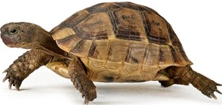
Q1: A- Choose the correct answer:
1. Do you have a pet?
( Yes, I am 9 years old – Yes, I have a turtle - Yes, I am fine )

2. What day do you like?
I like ( Ali – windy - Friday ).
3. What's the weather like today?
It's ( sunny - Monday - cow ).

B- Match the questions in column (A) with the correct answers in column (B):

6

6
B | A
( ) I'm thirsty.  ( ) Yes, I am.  ( ) These are shirts. | 1. Are you happy? 2. What's the matter? 3. What are these?

Q2: A Write the correct number under each picture:
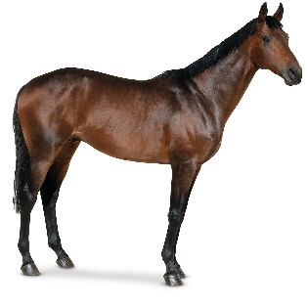
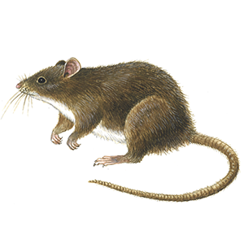
1.zebra 2.mouse 3.umbrella 4.horse 5.rainy 6.hungry


( ) ( ) ( ) ( ) ( ) ( )

Q3: Put ( ) or ( X ):

4
1. I have a fish. ( )
2. It is a tiger. ( )

3.There was a farmer who had a horse. ( )
4. It is windy today. ( )

Q4: A. Choose the correct answer:

5
- ( Do – Is – Are ) you have a pet?
- I ( likes – like - liking ) Sunday.
- ( He – She - We ) is scared.
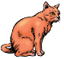
- B – Change into plural
One duck | twelve ----------
One cat | ten ----------

4
Q5: Choose the missing letter:
__ase | __olf | __loudy | __aptop
F – V | W - F | C - K | L - C

Q6: Copy:

5
I have a new cap.

End of Questions

