
بسم الله الرحمن الرحيم
English Language
Intermediate Grade 3rd
2nd period Exam
Kingdom of Saudi Arabia
Ministry of Education

Student's Name : class:

Grammar
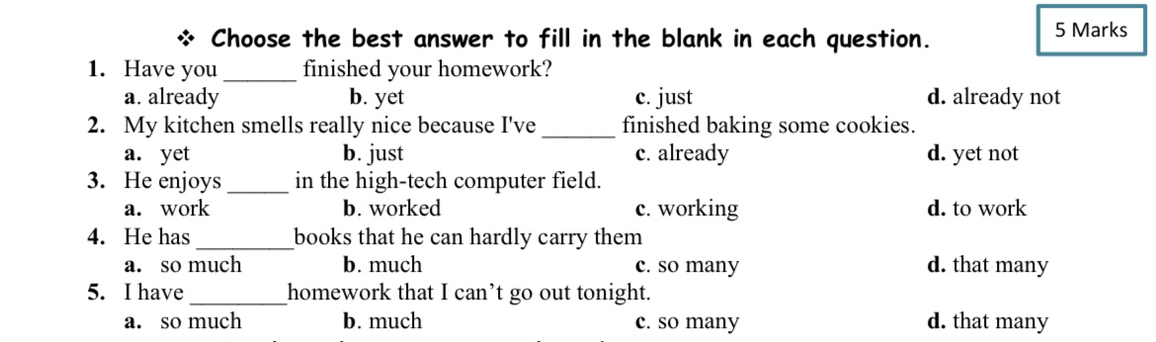

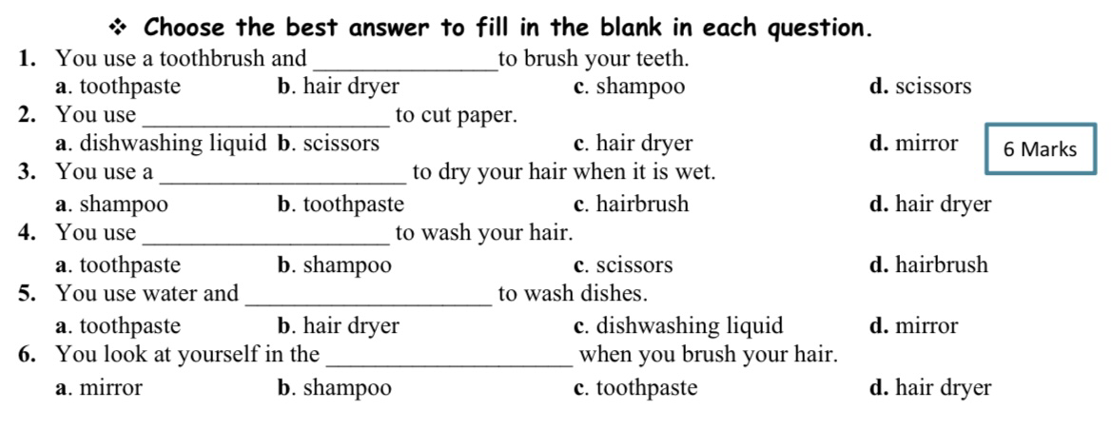
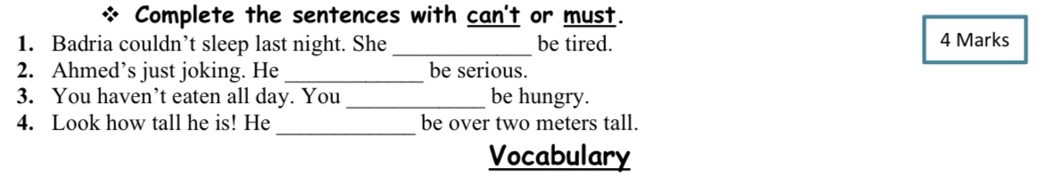

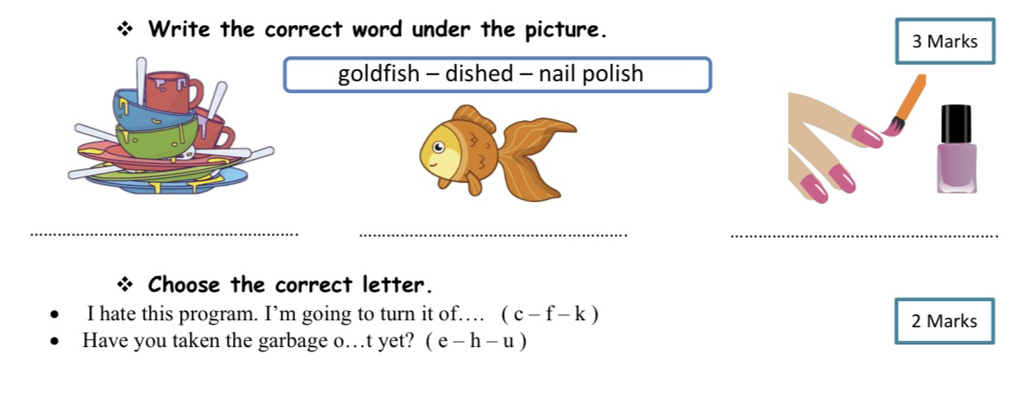

I wish you all the best!
Ms. Rawan Alhajri

