English Language Final Exam |  | Kingdom of Saudi Arabia
The third Trimester, 1st Session, 1443 |  | Ministry of Education
The first Intermediate Grade |  | General Directorate of Education in Bisha
Time: 2 hours |  | East Education Office
No. of pages: 3 |  | Rabbah Intermediate School
مستعينة بالله أجيبي عن الأسئلة التالية:

I- Guided Composition:
6
Write a paragraph about yourself:

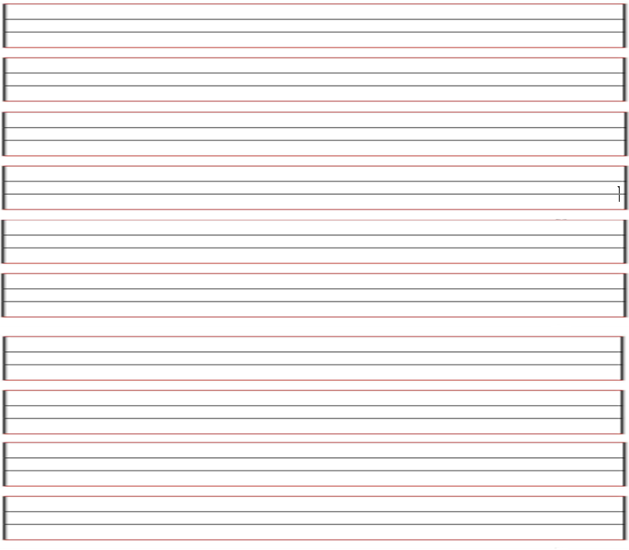

II- Reading Comprehension
6
Read the passage carefully and answer the questions below:

Maha is 37 years old . She is an engineer . She lives in Riyadh with her father . Her father is a doctor . She goes to work by car. She likes sports especially tennis and football.
A/Questions :1- Where does she live ? …………………………..…...................................................
B/ Choose the right answer:
1-Her father is a ( engineer – doctor – teacher ).
2- She is an ( engineer _ police – law).
C/ Put ( ) or ( ) :

1- She goes to work by bus . ( ) 2- Maha is 37 years old . ( )

3- Maha likes sports. ( )
-------------------------------------------------------------

III- Grammar:
A- Choose the correct answer:1
7
- Renad ( like – likes – liked ) to read.
- Masha’el ( are – is - was ) going to study for the exam.
- Please listen! I’m talking to ( them – him – you ).
4. There ( was – were – is ) an old castle in the city.
5. Nja’ah ( work – worked – working ) yesterday.
B- correct the mistake: 1
- Bana\ going \a new dress \ is \to buy ( reorder).
…………………………………………………………………………………………………………..…………………………..
- Dhabyah must followed the rules. (correct the mistake)
…………………………………………………………………………………………………….………………………………
-------------------------------------------------------------

IV- Vocabulary:
7
A) Write the correct number under each picture:1
1- balcony 2- oaisis 3- restaurant 4-race

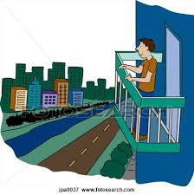 |  |  | 
هذه الصورة بواسطة كاتب غير معروف مرخصة بالاسم CC BY-NC-ND
B) Find the odd words. 1

- bank hotel park apple
- shorts jeans shirt pants
- flags cat parade fireworks
-------------------------------------------------------------

V- Orthography:
4

Choose the correct letter:1

- hospi__al 3- holi__ay
- b_ouse 4- celeb__ity
------------------------------------------------------------

The End of the Questions

Good Luck😊 Latifa Alyousef ♥

