English Language Final Exam |  | Kingdom of Saudi Arabia
The third Trimester, 1st Session, 1443 |  | Ministry of Education
The second Intermediate Grade |  | General Directorate of Education in Bisha
Time: 2 hours |  | East Education Office
No. of pages: 3 |  | Rabbah Intermediate School
مستعينة بالله أجيبي عن الأسئلة التالية:

I- Guided Composition:
6
Write a paragraph about yourself:

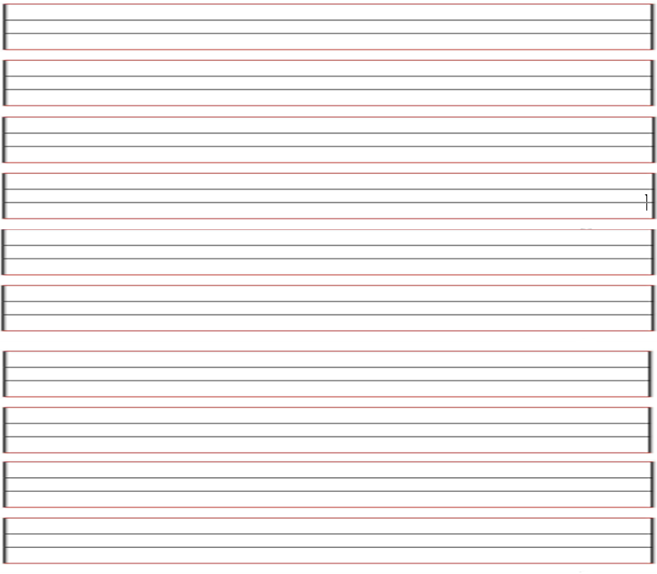

II- Reading Comprehension
6
Read the passage carefully and answer the questions below:

Noura and her family were in London last week. It was very expensive. They stayed in a hotel for three days. Then they took an apartment. Noura stayed there until Friday. She flew home last night. Her father is still there. Her mother is with her father. Next week Noura is going somewhere else.
Choose the correct word:-1
- Mohammad and his family were in London last ( day - week – month)
2. They took an ( apartment – hotel – taxi ) .
3. He stayed there ( after – before - until ) Friday.
4. Next ( week – month - holiday ) Mohammad is going somewhere else .
B)Put ( ) or ( ):-1
1- Mohammad and his family went to Paris. ( )
2-lt was very expensive in London. ( )
-------------------------------------------------------------

III- Grammar:
A- Choose the correct answer:1
7
- Omar drives ( slow – slows – slowly )
- I will ( travel – traveling _ travels ) to Jeddah
- Could you ( give – gives – giving ) me a pen?
4. I ( was – were – is ) sleeping
5. Omar ( read – reads – reading ) the book.
B- correct the mistake: 1
- Sara was able to finishing all housework yesterday ( reorder).
…………………………………………………………………………………………………………..…………………………..
- Omar has eat chocolate. (correct the mistake)
…………………………………………………………………………………………………….………………………………
-------------------------------------------------------------

IV- Vocabulary:
7
A) Write the correct number under each picture:1
1- relaxing 2- rainy 3- graduation 4-carseat phone

 | 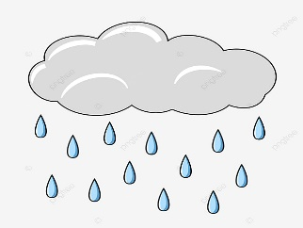 |  | 
هذه الصورة بواسطة كاتب غير معروف مرخصة بالاسم CC BY-NC-ND
B) Find the odd words. 1

- winter August summer
- thanks sorry not now
- football hang gliding basketball
-------------------------------------------------------------

V- Orthography:
4

Choose the correct letter:1

- o__erpower 3- __umidity
- mo__quito 4- desert sa__ari
------------------------------------------------------------

The End of the Questions

Good Luck😊 Latifa Alyousef ♥

