English Language Final Exam |  | Kingdom of Saudi Arabia
The third Trimester, 1st Session, 1443 |  | Ministry of Education
The third Intermediate Grade |  | General Directorate of Education in Bisha
Time: 2 hours |  | East Education Office
No. of pages: 3 |  | Rabbah Intermediate School
مستعينة بالله أجيبي عن الأسئلة التالية:

I- Guided Composition:
6
Write a paragraph about yourself:
نموذج اجابة

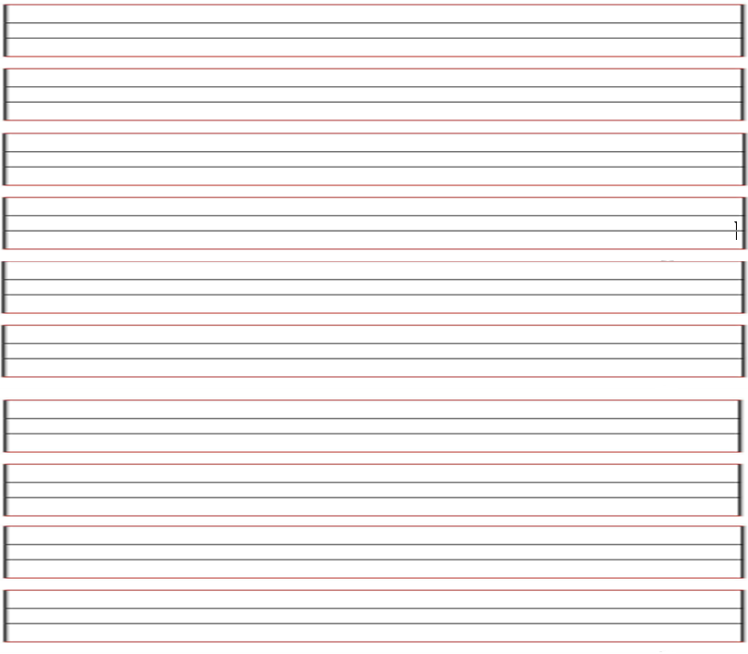

II- Reading Comprehension
6
Read the passage carefully and answer the questions below:
Mohrah is a student .She is 15 years old . She likes shopping . Her favorite mall is Al Obaikan shopping Centre. It is in Taif. It is very big and there is a large parking. There are many dress , flower , toy shops. She goes to the Alobaikan mall every Thursday. Her father buys food from the supermarket there. In the coffee shop Mohrah and her family drink cappuccino and have their lunch in the restaurant. She likes to eat beef burger. Shopping in Al Obaikan Mall is easy and interesting. Mohrah q’s mother always tells her to buy what she needs not what she wants.
A) Choose the correct word:-1
1-She goes to the Al Obaikan Mall every (Saturday -Thursday - Monday ).
2-In the coffee shop Mohrah and her family drink ( tea - milk – cappuccino ).
B)Put ( ) or ( ):-1
1- Mohrah is 15 years old. ( √ ) 2-Al Obaikan Mall is in Jeddah. ( ꭓ )
C)Answer the fowling questions:-1
1- Is Mohrah a student ? Yes, she is……………………………....
2- What does her father buy ? Her father buys food from the supermarket there.……………….

III- Grammar:
7
A- Choose the correct answer:1
- Saydah was watching TV ( when – while – that ) she was eating dinner
- Have you done your H.W ( yet – already – just ) ?
- Sara would rather ( drinking – drank – drink ) coffee than tea
4. It’s polite to (said – says – say )please
5- English was( so – such – more ) easy exam that they could pass it
B- Do as shown between brackets: 1
- we\ May\ have \ cookies \ some \? ( reorder).
…May I have some cookie please…………………..…………………………..
- Tip is not common in Saudi Arabia (correct the mistake)
… Tipping is not common in Saudi Arabia

IV- Vocabulary:
7
A) Write the correct number under each picture:1
1- airshow 2- mud 3- toothpaste 4-cell phone

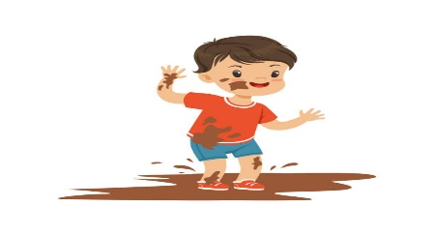 |  | 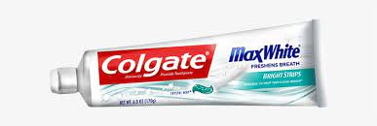
Cell phone | airshow | toothpaste
هذه الصورة بواسطة كاتب غير معروف مرخصة بالاسم CC BY-NC-ND
B) Match words in column (A) with the opposites in column (B)1
B | A
( 4 ) Able to change in different situation.  ( 3 ) To be similar to.  ( 2 ) phone.  ( 1 ) Money you borrow.  ( ) act as a guide. | 1- loan  2- Call up  3- To fit in  4- flexible

V- Orthography:
4

Choose the correct letter:1

- absen_t_minded 3- dish_w_ashing
- en_v_ironment 4- globali_z_ed

The End of the Questions

Good Luck😊
Latifa Alyousef ♥

