
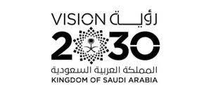
Kingdom of Saudi Arabia 1443. H
Ministry of Education
The First session- The third Term
…………………. Intermediate School
Time : 2 hours
Final Exam of English for third Grade Intermediate
أسم الطالبة /.................................................................... الصف/............................... رقم الجلوس /............................
انتظام ( ) انتساب ( ) التاريخ / / 1443 هـ

ختم المدرسة
عزيزتي الطالبة؛
تأكدي أن عدد الأوراق ( 3 )
بدون الغلاف

Items | Marks in numbers | The deserved  mark | Teacher's Sign | Reviser's Sign
Guided Composition | 6
Reading Comprehension | 6
Grammar | 7
Vocabulary | 7
Orthography | 4 |  |  | Auditor’s sign
Total | 30
Listening | 5
Speaking | 5
Final mark | 40
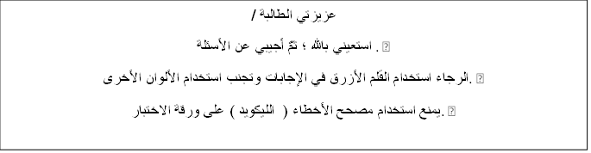
عزيزتي الطالبة /
استعيني بالله ؛ ثمَّ أجيبي عن الأسئلة . •
الرجاء استخدام القلم الأزرق في الإجابات وتجنب استخدام الألوان الأخرى. •
يمنع استخدام مصحح الأخطاء ( الليكويد ) على ورقة الاختبار. •

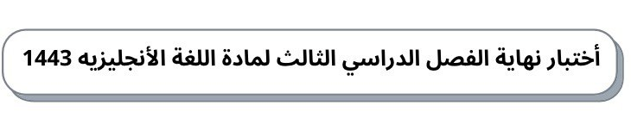

30
ثانوية ومتوسطة ............... الصف/ ثالث متوسط الدور الأول الزمن/ساعتان

A -Writing 6 /
1.write about culture customs at your country ,
Use helping word (culture -famous -generosity -present – together-forehead )
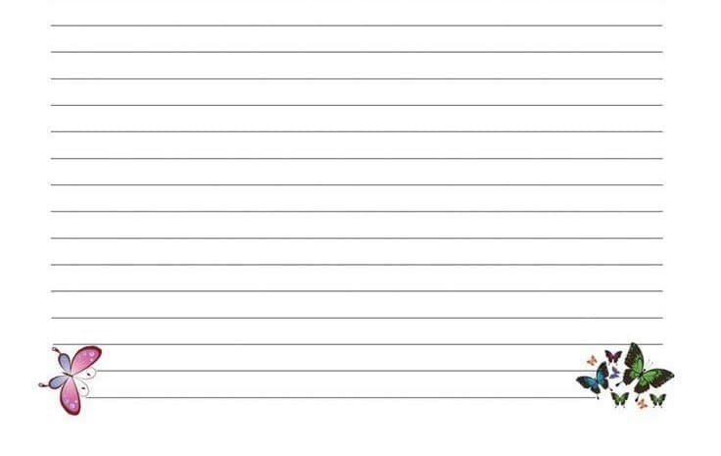

B -Reading Comprehension 6 /
.Read the following passage and answer the questions:
Sara is interested in Geography books. She has already read many books about India
Indonesia, Bangladesh and Japan. She learned a lot about these countries. Sara visits the school library almost every day where she can read a lot of Geography books. The librarian is always ready to help her choose any book which she likes to read about it. Last week, Sara wrote a very good note in the school Magazine and the headmaster was happy to read that note. She gave her some books as a gift..

1- What does Sara visit ?

2. What did Sara write ?

3. Sara is interested in English books..

True
False

4- The headmaster was .....................to read Sara's note.
happy
sad
5-The headmaster gave Sara some books as a gift
True
False
6- The librarian isn’t always ready to help her choose any book.
True
False

C-Grammar 7/

- You have done the dishes yet. ( Make it negative )

2. Turn the TV down . ( Replace the object noun by pronoun)

3- If you cook an egg in the microwave , it .
explode
explodes
4- He is………. Fast that he won the race.
so
such
5 – They stop ……………………….. tennis in the winter.
play
playing
6- It has ………………….. a beautiful view of the harbor.
such
so

7- the airline refusing to …………… for our hotel
pay
paying

D- Vocabulary 7 /
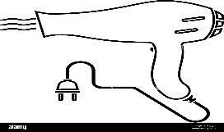
1 -.This is
hair dryer
Mall
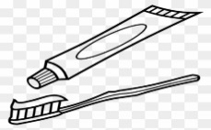
2.This is
tooth past
airport

3-.the odd word is
hair brush
hair dryer
door

4.This is
nail polish
scissors

5- At long last . Means:
Finally.
this has gone too far.

6- write the name under each picture

- ……………………….. 2 ………………………………..

E- Orthography Write the missing letter 4/

1- Sــــــــــــــampo 2- boـــــــــــk 3-scisـــــــــــors 4- dishwasـــــــــing

End of questions
T.Nora ALenzy

