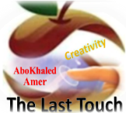

المملكة العربية السعودية
Kingdom of Saudi Arabia
Ministry of Education
------- Educational Directorate
------- Future Educational Schools
1st grade intermediate 2022
3rd Term – Final Exam
وزارة التعليم
الإدارة العامة للتعليم بن
مدارس م ن التعليمية
الصف الاول المتوسط
الاختبار النهائي للفصل الدراسي الثالث1443
Total  written | 5 spelling | 4 Vocabulary | 3 Grammar | 2 Comprehension |  | 1 Composition | Q. NO.
 |  |  |  |  |  |  | Mark Given
30 | 4 | 7 | 7 | 6 |  | 6 | Mark
 |  |  | Reviser |  |  |  | Corrector
زمن الاختبار: ساعتان
اسم الطالب: ------------------------------------ رقم الجلوس: ------------- الصف الأول المتوسط

6

1) Composition
1- Write a paragraph about “Your Favorite Place"
You may use 50 words:
…………………………………………
………………………………………………………………………………………………………………………………………………………………………………………………………………………………………………………………………………………………………………………………………………………………………………………………………………………………………………………………………………………………………………………………………………………………………………………………………………………………….

2) Comprehension

6
2- Read the following passage then answer the questions:

The Sports Center
I like to go to the sports center. I go there every weekend. At the sports center, you can do many things. For example, you can play golf or tennis. There is a pool, so you can also swim or relax by the pool. There is a beach next to the sports center. You can swim, water-ski, or windsurf in the ocean. You can also sail on windy days. There aren’t any fish near the beach, so you can’t snorkel. When I go to the sports center, I like to play volleyball on the beach. I also like to jog on the beach. I can’t swim well, so I don’t like to water-ski or windsurf.
A- Put ( ) or ( x ):
1. The writer likes the sports center. ( )
2. You can swim in the pool or in the ocean. ( )
3. People can windsurf in the pool. ( )
4. You can’t use a boat in the ocean. ( )
5. In the sports center, there aren't many things. ( )
B- Choose the correct answer:
1. There is a (peach – beach – fetch) next to the sports center.
2. There aren’t any (fish – meat – fruit) near the beach
3. He doesn’t like to water-ski or (windows – doors – windsurf).
4. You can also sail on (rainy – snowy – windy) days.
C- Answer the following questions:
1. Where does the writer like to go?.............................
2. When does he go?...........................
3. What does he play on the beach? ..............................
3) Grammar

A: Choose the correct answer:

7
1. She (can – can't – does) cook well. She is bad at cooking.
2. We (don't like – doesn't like – isn't like) to stay up for late hours.
3. She (am – is – are) going to visit her friends.
4. Ali is a nice guy. I want you to meet (them – him – her)
5. He wants (to reads – to read – to read) some books.
6. We (was – were – are) at home, waiting for you.
7. They (eat – eating – ate) a delicious meal last weekend.
8. Did you do your homework? No, I (is – did – didn't).
B: Chang into Negative:
1. They can play football.
…………………………………………………………………………………………………………………………………………………………………………………………………………………
2. He is going to dust his room.
……………………………………………………………………………………………………………………………………
3. We stopped at the supermarket to buy ice cream.
……………………………………………………………………………………………………………………………………
C: Make Yes/No question:
1. He can read English well.
……………………………………………………………………..……………………………………………………………
2. She is going to call her friend.
……………………………………………………………………………………………………………………………………

3. We visited our friends in Najran.
……………………………………………………………………………………………………………………………………
4) vocabulary:

7
A- Match the words with the pictures:
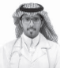
doctor - meal – shirt – bus stop – fireworks – beach
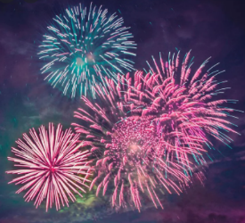
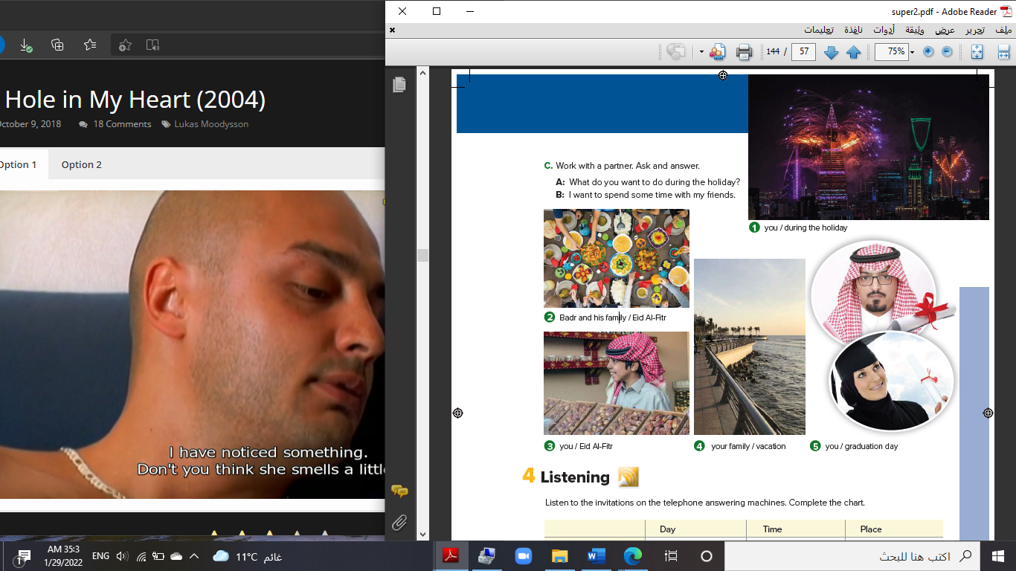

……………... ……………. ……..………. ……..…… ………… …………..
B- Match the answers:

a. green color | 1. You can open an account. ------
b. Riyadh | 2. Men wear it for work. ------
c. bank | 3. In Saudi Arabia, people decorate houses in ------
d. thobe | 4. The King of Saudi Arabia is ------
e. King Salman | 5. It was a traditional place then it became the capital ------

C- Circle the correct spelling:

1. natonial - nashional – national
2. house – huoes - hosue
3. yesteday – yesterday – yetserday

5) Orthography:

4

A- Fill in the missing letters:

1- buil__ing
p – u – r – o – s
2- cons__le
3- celeb__ation
4- air__ort
B- Choose the odd one out:
1. suit jeans tie abaya
2. watch school help eat
3. Emirates Kuwait under Oman
4. teacher morning afternoon evening

End of Questions
Best of Luck https://t.me/abokhaledamer
المملكة العربية السعودية
Kingdom of Saudi Arabia
Ministry of Education
------- Educational Directorate
------- Future Educational Schools
1st grade intermediate 2022
3rd Term – Final Exam
وزارة التعليم
الإدارة العامة للتعليم بن
مدارس م ن التعليمية
الصف الاول المتوسط
الاختبار النهائي للفصل الدراسي الثالث1443
Total  written | 5 spelling | 4 Vocabulary | 3 Grammar | 2 Comprehension |  | 1 Composition | Q. NO.
 |  |  |  |  |  |  | Mark Given
30 | 4 | 7 | 7 | 6 |  | 6 | Mark
 |  |  | Reviser |  |  |  | Corrector
زمن الاختبار: ساعتان
اسم الطالب: ------------------------------------ رقم الجلوس: ------------- الصف الأول المتوسط

6

1) Composition
1- Write a paragraph about “Your Favorite Clothes"
You may use the following words: favorite – cool – wear – home - weather- school-…
…………………………………………
………………………………………………………………………………………………………………………………………………………………………………………………………………………………………………………………………………………………………………………………………………………………………………………………………………………………………………………………………………………………………………………………………………………………………………………………………………………………….

2) Comprehension

6
2- Read the following passage then answer the questions:

Janadriyah Festival
Every year in Saudi Arabia, many people from all over the country and from abroad attend the Janadriyah national heritage and culture festival. The festival takes place in a village near Riyadh, and it is normally held between November and March when the heat is less extreme. The festival celebrates symbols of Saudi identity. There are camel races and horse races, displays of regional costumes, cuisines, and crafts such a carpet-weaving, and pottery. There are donkey rides, which are very popular with children. The festival lasts for two weeks.

A- Put ( ) or ( x ):
1.The text is about camel racing in Saudi Arabia. ( )
2.Only people who live in Saudi Arabia can attend the festival. ( )
3.The festival is usually held when the temperatures are cooler. ( )
4.Children like the donkey rides. ( )
5. The festival lasts for two weeks. ( )
B- Choose the correct answer:
1. Janadriyah is Every (month – season – year) in Saudi Arabia.
2. There are camel races and horse (eating – races – graces).
3. The festival celebrates symbols of Saudi (flag – people – identity)
4. The festival is between November and (April – March – May).
C- Answer the following questions:
1. What is the name of the festival?.............................
2. Where does Janadriyah take place?...........................
3. How long does the festival last? ..............................
3) Grammar

A: Choose the correct answer:

7
1. She is good at English. She (can – can't – is) speak it well
2. He (don't like – doesn't like – isn't like) to cook food.
3. They (am – is – are) going to sleep early.
4. I want to meet my neighbors. I don’t know (them – him – her)
5. We need (to buy – buy – buying) some snacks.
6. He (was – were – are) at home.
7. They (went – goes – going) to the beach last summer.
8. Did he play football? Yes, he (is – did – didn't).
B: Chang into Negative:
1. I can clean my room.
…………………………………………………………………………………………………………………………………………………………………………………………………………………
2. She is going to help her mom.
……………………………………………………………………………………………………………………………………
3. They watched TV at home.
……………………………………………………………………………………………………………………………………
C: Make Yes/No question:
1. She can cook lunch.
……………………………………………………………………..……………………………………………………………
2. They are going to study English.
……………………………………………………………………………………………………………………………………

3. He worked hard.
……………………………………………………………………………………………………………………………………
4) vocabulary:

7
A- Match the words with the pictures :
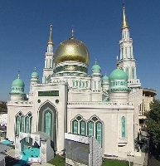
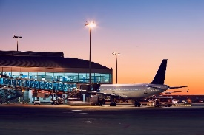
pizza – shoes – graduation – mosque – airport – exercise
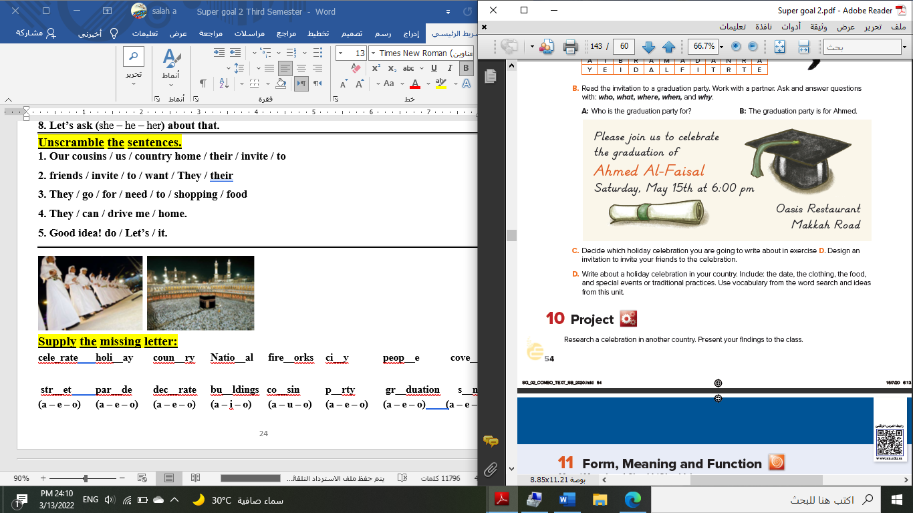

……………... ……………. ……..………. ………… …………… …………..
B- Match the answers:

a. National Day | 1. Visitors can sleep there. --------
b. Vacation | 2. Women wear these formal clothes. --------
c. hotel | 3. In Saudi Arabia, people celebrate the -------
d. abayas | 4. Majed Ahmed Abdullah was a famous -------
e. footballer | 5. We traveled to Egypt during the summer ---------

C- Circle the correct spelling:

1. moring - morning – marning
2. skyscraper – skyskraper - ckyscraper
3. celebote – celeprate – celebrate

5) Orthography:

4

A- Fill in the missing letters:

1- cl__thes
a – o – u – s – c
2- book__tore
3- par__de
4- pop__lation
B- Choose the odd one out:
1. shorts jeans pants TV
2. school restaurant gym eat
3. watched TV Played tennis helped Ali eat fish
4. footballer doctor scientist car

End of Questions
Best of Luck https://t.me/abokhaledamer

المملكة العربية السعودية
Kingdom of Saudi Arabia
Ministry of Education
------- Educational Directorate
------- Future Educational Schools
2nd grade intermediate 2022
3rd Term – Final Exam
وزارة التعليم
الإدارة العامة للتعليم بن
مدارس م ن التعليمية
الصف الثاني المتوسط
الاختبار النهائي للفصل الدراسي الثالث1443
Total  written | 5 spelling | 4 Vocabulary | 3 Grammar | 2 Comprehension |  | 1 Composition | Q. NO.
 |  |  |  |  |  |  | Mark Given
30 | 4 | 7 | 7 | 6 |  | 6 | Mark
 |  |  | Reviser |  |  |  | Corrector
زمن الاختبار: ساعتان
اسم الطالب: ------------------------------------ رقم الجلوس: ------------- الصف الثاني المتوسط

6

1) Composition
1- Write a paragraph about “How the Weather Affects you "
You may talk about the following words: Feel – rainy – window – spend – trouble
…………………………………………
………………………………………………………………………………………………………………………………………………………………………………………………………………………………………………………………………………………………………………………………………………………………………………………………………………………………………………………………………………………………………………………………………………………………………………………………………………………………….

2) Comprehension

6
2- Read the following passage then answer the questions:

Wonderful Vacation
Last vacation I went with my family to Egypt. At the beginning, we went on a cruise on the River Nile. We left Cairo on Friday morning and got back on Monday evening. It was a wonderful experience. Then we stayed in Cairo for five days. We went sightseeing and we visited the Egyptian Museum, too. There were so many interesting things to see there. We also visited the Pyramids in Giza and took lots of pictures. They were amazing! My parents and I also tried camel riding. It was lots of fun. I really want to visit Egypt again. It’s beautiful and there are many things to see and do there!
A- Put ( ) or ( x ):
1.Last vacation, they went on vacation to Egypt. ( )
2.They stayed in Cairo for seven days. ( )
3.They visited the pyramids and the museum. ( )
4.They all tried horse riding in the pyramids. ( )
5. They really want visit Egypt again. ( )
B- Choose the correct answer:
1. The family left Cairo on (Monday – Sunday – Friday) morning.
2. They went (sightseeing – hang gliding – scuba diving) in Egypt.
3. The vacation to Egypt was lots of (fan – fat – fun).
4. There were (few – many – lot) things to see and do in Egypt.
C- Answer the following questions:
1. Where did the family go last summer?.........................
2. Did they enjoy their stay there?...........................
3. What is the river they went on a cruise on? ..................
3) Grammar

A: Choose the correct answer:

7
1. He is (go to – goes to – going to) spend happy time.
2. (What – Where – When) are they going to leave for London?
3. Maybe, she (will – am going to – have) visit us next holiday.
4. What is the weather like today? (He is – She is – It is) sunny.
5. Can you (clear – clears – clearing) my way, please?
6. (Let – Tell – Lets) me help you with this box.
7. They (waiting – were waiting – wait) for the bus when it started raining.
8. We have (used – use – uses) all the toothpaste.
B: Chang into Negative:
1. We are going to brush our teeth.
…………………………………………………………………………………………………………………………………………………………………………………………………………………
2. He was feeding the fish.
……………………………………………………………………………………………………………………………………
3. She has spoiled all the nail polish.
……………………………………………………………………………………………………………………………………
C: Make Yes/No question:
1. They will set the table.
……………………………………………………………………..……………………………………………………………
2. They were washing the dishes.
……………………………………………………………………………………………………………………………………

3. I have finished all the cooking.
……………………………………………………………………………………………………………………………………
4) vocabulary:

7
A- Match the words with the pictures:
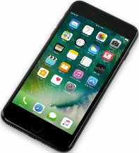
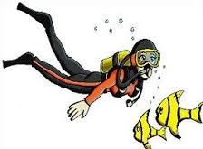
anaconda – cellphone – relaxing – snowy – scuba diving – safari
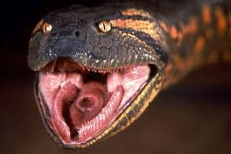
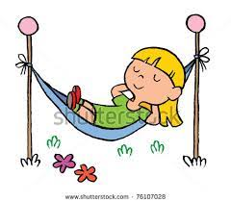
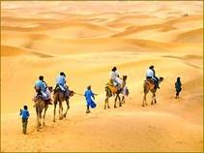

……………. ……………. ……..……. ………..…… …………… …………..
B- Match the answers:
a. introduce news | 1. We went to the mountains for -------
b. very cold | 2. Wild animals usually live in the --------
c. cliff hanging | 3. How many months are there in a year? ---------
d. jungle | 4. We say, " I hear " when we ---------
e. twelve months | 5. The temperature is "below zero" means it is ---------

C- Circle the correct spelling:

1. windy - widny – winyd
2. parot – parrat - parrot
3. wierd – weird – weired

5) Orthography:

4

A- Fill in the missing letters:

1- des__rt
p – s – u – e – t
2- zookee__er
3- ho__pital
4- pop__lar
B- Choose the odd one out:
1. can could will Ali
2. helped cleaned worked sleep
3. stormy parrot foggy snowy
4. scuba diving hang gliding cliff hanging doctor

End of Questions
Best of Luck https://t.me/abokhaledamer


المملكة العربية السعودية
Kingdom of Saudi Arabia
Ministry of Education
Educational Directorate
Future Educational Schools
2nd grade intermediate 2022
3rd Term – Final Exam
وزارة التعليم
الإدارة العامة للتعليم بن
مدارس مستقبل ن التعليمية
الصف الثاني المتوسط
الاختبار النهائي للفصل الدراسي الثالث1443
Total  written | 5 spelling | 4 Vocabulary | 3 Grammar | 2 Comprehension |  | 1 Composition | Q. NO.
 |  |  |  |  |  |  | Mark Given
30 | 4 | 7 | 7 | 6 |  | 6 | Mark
 |  |  | Reviser |  |  |  | Corrector
زمن الاختبار: ساعتان
اسم الطالب: ------------------------------------ رقم الجلوس: ------------- الصف الثاني المتوسط

6

1) Composition
1- Write a paragraph about “Yourself "
You may use the following words:
name – years old – student – live – have – English – want to be
…………………………………………
……………………………………………………………………………………………………………………………………………………………………………………………………………………………………………………………………………………………………………………………………………………………………………………………………………………………………………………………………………………………………………………………………………………………………………………………………………………………………………………………….

2) Comprehension

6
2- Read the following passage then answer the questions:

My best friend is Ali. He is 15 years old. He is from Abha, but he lives in Najran with his family. His father is a policeman, and his mother is a teacher. He has two brothers and three sisters. Ali is a good tennis player, and he plays it on Friday with his friends. At school, Ali is good at English and math. He studies hard to be a doctor when he grows up.
A- Answer the following questions:
1) How old is Ali? --------------------------------------------------------------------.
2) Where does he live? --------------------------------------------------------------------.
3) How many brothers does he have? --------------------------------------------------.
4) What is his father's job? --------------------------------------------------------------------.
5) Where does his mother work? ----------------------------------------------------------------.
6) What sport is Ali good at? -------------------------------------------------------------------.
B- Put (T) for true sentences and (F) for false ones:
1) Ali is my brother. ( )
2) He has five sisters. ( )
3) He wants to be a policeman. ( )
4) He lives in Abha. ( )
5) He plays football on Friday.
6) He likes English and math. ( )
3) Grammar

A: Choose the correct answer:

7
1. He will (travels – travel – traveling) to Abha tomorrow.
2. (Are – Can – Is) you take a photo of me?
3. My father let me (playing – play – plays) football on Friday.
4. What is the weather like today? (He – She – It) is sunny.
5. We have (uses – used – using) all the toothpaste.
6. We (will – are going – going to) to visit him next week.
7. (Was – Were – Are) you sleeping at 5 o'clock yesterday?
8. He (is – has – have) eaten his lunch.
B: Do as shown:
1. He will come on time. (Negative)

…………………………………………………………………………………………………………………………………………………………………………………………………………………
2. He will sleeps early. (Correct)

…………………………………………………………………………………………………………………………………………………………………………………………………………………
3. She has cooked lunch at home. (Make Yes/No Question)

…………………………………………………………………………………………………………………………………………………………………………………………………………………
4. Can you give me a pen? (Agree)

…………………………………………………………………………………………………………………………………………………………………………………………………………………
5. He was (read) when I called him. (Correct)

…………………………………………………………………………………………………………………………………………………………………………………………………………………
6. They (is) going to come home early. (Correct)
…………………………………………………………………………………………………………………………………………………………………………………………………………………
4) vocabulary:

7
A- Match the questions with answers:
a. It is hot. | ( ) Where will you go tomorrow?
b. It is cold. | ( ) How will you go?
c. No problem. | ( ) What is the weather like in summer?
d. My favorite sport is tennis. | ( ) What is the weather like in winter?
e. I will stay for a week. | ( ) Could you do me a favor?
f. Lose one's job. | ( ) What's your favorite sport?
g. I will go to Abha. | ( ) How long will you stay in Riyadh?
h. I will go by car. | ( ) Be fired means:

B- Write the words under the pictures:
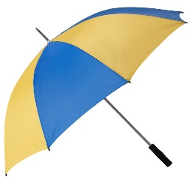
rain – sunny – cloudy – snow – windy – umbrella
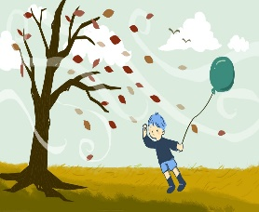
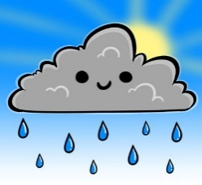
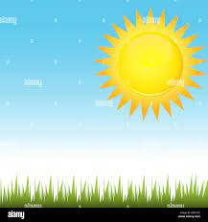


……………. ……………. ……..……. ………..…… …………… …………..

5) Orthography:

4

A- Fill in the missing letters:
a – e – i – o – u

1. sm__rt 2. exc__ting 3. __asy
4. danger__us 5. d__fficult 6. P__pular

B- Choose the correct word:
1. sfae safe seaf
2. poplaro larpopu popular

End of Questions
Best of Luck

المملكة العربية السعودية
Kingdom of Saudi Arabia
Ministry of Education
------- Educational Directorate
------- Future Educational Schools
2nd grade intermediate 2022
3rd Term – Final Exam
وزارة التعليم
الإدارة العامة للتعليم بن
مدارس م ن التعليمية
الصف الثاني المتوسط
الاختبار النهائي للفصل الدراسي الثالث1443
Total  written | 5 spelling | 4 Vocabulary | 3 Grammar | 2 Comprehension |  | 1 Composition | Q. NO.
 |  |  |  |  |  |  | Mark Given
30 | 4 | 7 | 7 | 6 |  | 6 | Mark
 |  |  | Reviser |  |  |  | Corrector
زمن الاختبار: ساعتان
اسم الطالب: ------------------------------------ رقم الجلوس: ------------- الصف الثاني المتوسط

6

1) Composition
1- Write a paragraph about “Your Best Friend "
You may talk about the following words: His name – His age – His favorite color – His father job – His favorite subject – His favorite sport – His future job
…………………………………………
………………………………………………………………………………………………………………………………………………………………………………………………………………………………………………………………………………………………………………………………………………………………………………………………………………………………………………………………………………………………………………………………………………………………………………………………………………………………….

2) Comprehension

6
2- Read the following passage then answer the questions:

Bill's Family
My name’s Bill. I’m 12 years old. I have two brothers and one sister. My father is a doctor, and my mother is an English teacher. I live in a flat with my family. Our flat is on the second floor and there are three bedrooms and one kitchen. We also have a beautiful balcony. Our favorite day of the week is Saturday. We all get up at about 10 o’clock and have breakfast. Then I play computer games with my sister. After lunch, I go to the park to play football with my brothers. In the evening, I often play basketball with my friends. I like it but my brothers love football.
A- Put ( ) or ( x ):
1.In this passage, the boy's name is Billa. ( )
2.His father is a doctor. ( )
3.His flat is on the fourth floor. ( )
4.On Sunday, they have breakfast at 10 o'clock. ( )
5. He plays computer games with his brothers. ( )
B- Choose the correct answer:
1. Bill's mother is an (science – math - English) teacher.
2. In his flat, they have a beautiful (horse – yard – balcony).
3. He plays (tennis – football – computer games) with his brothers.
4. Bill's family are (six – seven – eight) members.
C- Answer the following questions:
1. How old is Bill?.............................
2. How many brothers does Bill have?...........................
3. Where does he go after lunch? ..............................
3) Grammar

A: Choose the correct answer:

7
1. They (am – is – are) going to visit their uncle.
2. (What – Where – Who) is he going to spend the weekend?
3. I (will – am going to – have) probably travel to Abha next summer.
4. (Why – When – What) is the weather like today?
5. (Could – Have – Are) you help me with this bag?
6. Let me (carry – carrying – carries) this box for you.
7. Hans (walk – was walking – walking) to college when he saw Samir.
8. She has (cleans – cleaning – cleaned) her own room.
B: Chang into Negative:
1. He is going to wash the car.
…………………………………………………………………………………………………………………………………………………………………………………………………………………
2. They were cooking lunch at home.
……………………………………………………………………………………………………………………………………
3. They have watched TV with their kids.
……………………………………………………………………………………………………………………………………
C: Make Yes/No question:
1. He will do his homework.
……………………………………………………………………..……………………………………………………………
2. Ali was helping his mom in the kitchen.
……………………………………………………………………………………………………………………………………

3. We have brushed our teeth.
……………………………………………………………………………………………………………………………………
4) vocabulary:

7
A- Match the words with the pictures:
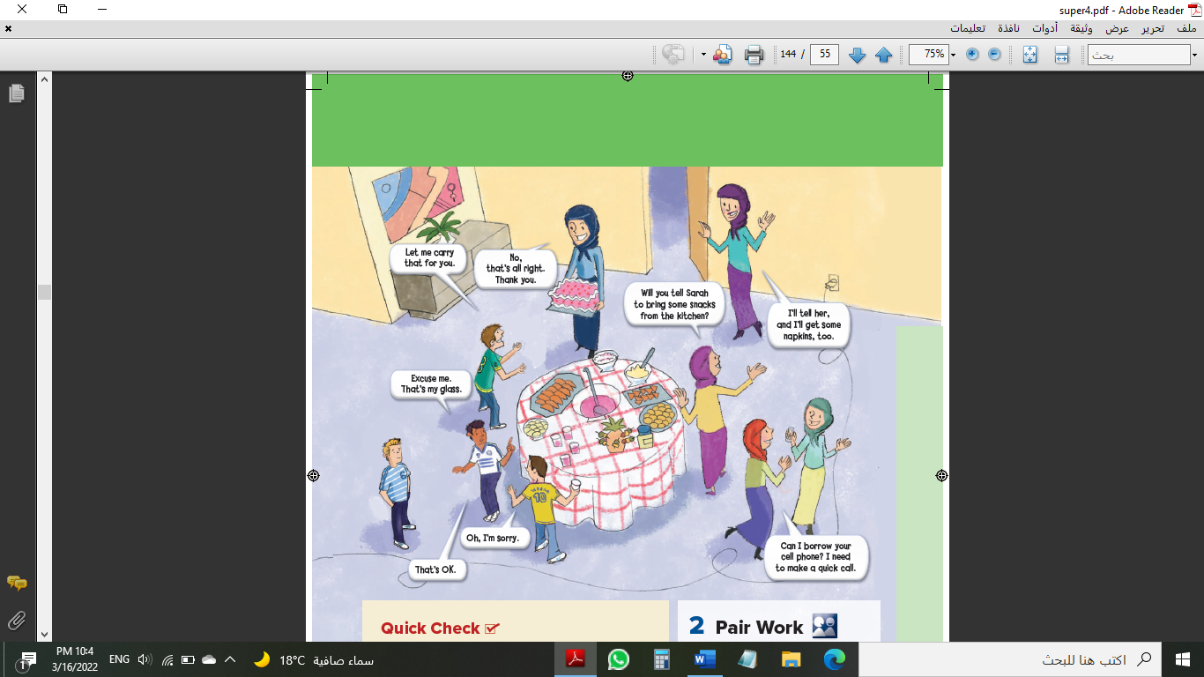
cake – parrot – pyramids – cliff hanging – graduation – rainy


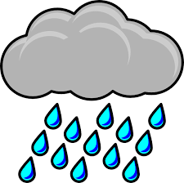

……………. ……………. ……..……. ………..…… …………… …………..
B- Match the answers:
a. not certain | 1. We go the sea for ------
b. No problem | 2. We say: "It depends" when we are ------
c. scuba diving | 3. How many seasons are there in a year? ------
d. Lost his job | 4. Can you open the door for me, Please? ------
e. Four seasons | 5. He was "fired" means that he -------

C- Circle the correct spelling:

1. awesome - awosome – owesome
2. snaek – snake - sanke
3. emergancy – emargency – emergency

5) Orthography:

4

A- Fill in the missing letters:

1- saf__ri
l – a – c – o – n
2- wor__d
3- fav__r
4- atta__k
B- Choose the odd one out:
1. written taken seen eat
2. going reading sing working
3. sunny cloudy year snowy
4. zebra doctor turtle zorse

End of Questions
Best of Luck https://t.me/abokhaledamer

المملكة العربية السعودية
Kingdom of Saudi Arabia
Ministry of Education
------- Educational Directorate
------- Future Educational Schools
3rd grade intermediate 2022
3rd Term – Final Exam
وزارة التعليم
الإدارة العامة للتعليم بن
مدارس م ن التعليمية
الصف الثالث المتوسط
الاختبار النهائي للفصل الدراسي الثالث1443
Total  written | 5 spelling | 4 Vocabulary | 3 Grammar | 2 Comprehension |  | 1 Composition | Q. NO.
 |  |  |  |  |  |  | Mark Given
30 | 4 | 7 | 7 | 6 |  | 6 | Mark
 |  |  | Reviser |  |  |  | Corrector
زمن الاختبار: ساعتان
اسم الطالب: ------------------------------------ رقم الجلوس: ------------- الصف الثالث المتوسط

6

1) Composition
1- Write a paragraph about “Customs and Culture Shock "

You may use these words: in Mediterranean Countries - in England – in Japan - in Asian Country – in Mexico – in India – in United States and China – in Germany

…………………………………………
………………………………………………………………………………………………………………………………………………………………………………………………………………………………………………………………………………………………………………………………………………………………………………………………………………………………………………………………………………………………………………………………………………………………………………………………………………………………….

2) Comprehension

6
2- Read the following passage then answer the questions:

Omar Ibn Alkattab
Amir EL-Momeneen Omar Ibn Alkattab, may Allah bless him, was the second Caliph. He was a kind man and a good Muslim. He often gave food to the poor. Omar sometimes walks through the streets at night he walked alone, he had no soldiers with him. He had ordinary clothes on, and nobody knew that he was the Caliph. He listened to people to know their problems. One night, Omar was having a walk in a poor part of the city. He could smell food cooking. Many people were having dinner.
A- Put ( ) or ( x ):
1. Omar Ibn Alkattab was the third caliph. ( )
2. Omar Ibn Alkattab was a good Muslim. ( )
3. Omar Ibn Alkattab never walked through the streets at night. ( )
4. Omar Ibn Alkattab had very high and expensive clothes. ( )
5. Omar Ibn Alkattab made sure that many people were having dinner. ( )
B- Choose the correct answer:
1.Omar Ibn Alkattab gave food to the (rich – wealthy – poor) people.
2. At night, he had no (visitors – soldiers – guides) with him.
3. He could smell (food – books – cars) cooking.
4. At night, nobody knew that he was the (caliph – captain – poor)
C- Answer the following questions:
1. Who was the second caliph?........................
2. Was Omar Ibn Alkattab a kind man?.........................
3. Why did he listen to the people? .................

7
3) Grammar

A: Choose the correct answer:
1. People (who – which – when) live in glass houses shouldn't throw stones.
2. They stop (playing – play – to play) tennis in winter. They no longer play.
3. If you (sleep – sleeping – sleeps) in the class, the teacher won’t be happy.
4. He has (yet – already – no) come home.
5. I expect him (arrive – arriving – to arrive) home early.
6. He was cancelling his flight (when – while – what) we were calling him.
7. The floor is very messy. Can you clean (it – them – him) up.
8. (Helping – helped – Helps) my friends is a great fun.
B: Do as shown between brackets:
1. I can’t stand watch scary films. (Correct)
------------------------------------------------------------------------------------------
2. I have done my homework. (Change into Negative)
------------------------------------------------------------------------------------------
3. used – football – He – to – play (Rearrange)
------------------------------------------------------------------------------------------
4. She was (clean) the room when her brother entered the room. (Correct)
------------------------------------------------------------------------------------------
5. Turn the TV down. (Change into two-word verb)
------------------------------------------------------------------------------------------
6. Have they gone to school yet? (Answer)
------------------------------------------------------------------------------------------
4) vocabulary:

7
A- Match the words with the pictures:
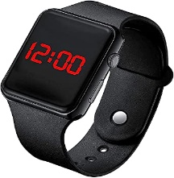
toothpaste – shopping – watch – pedal cab – iron – remove shoes

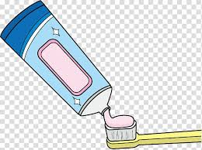
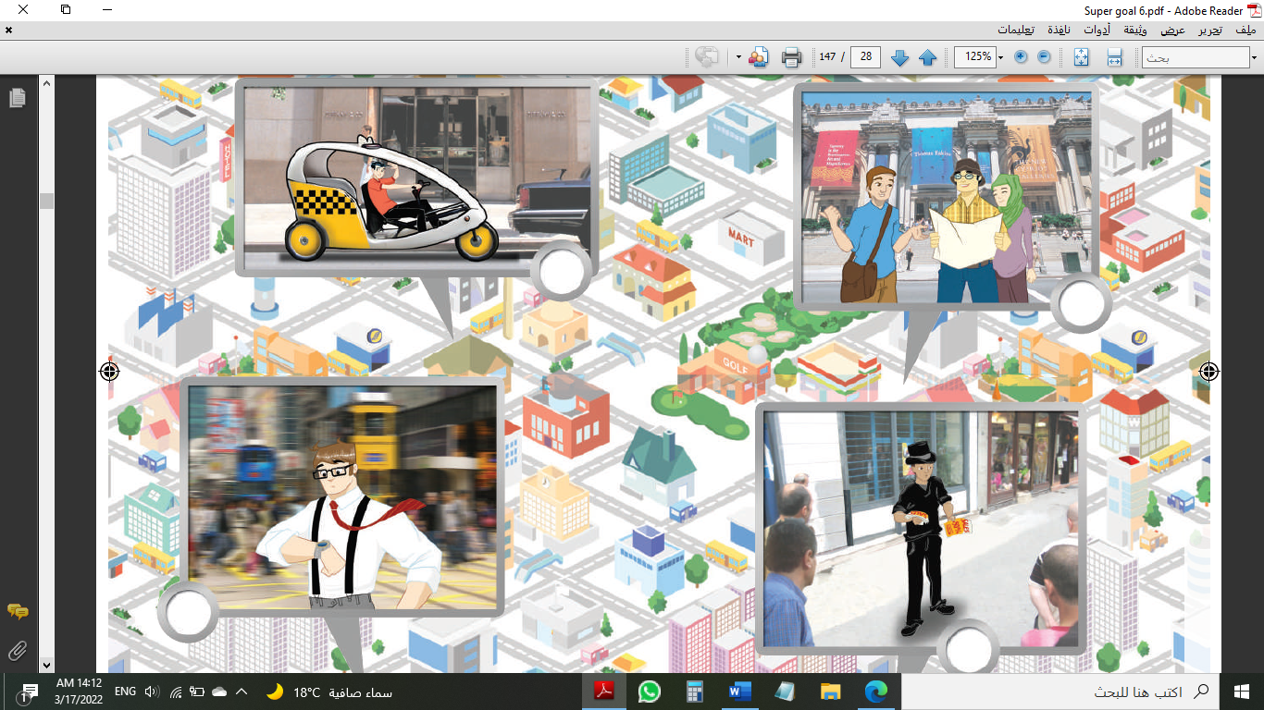

……………. ……………. ……..……. ………..…… …………… …………..
B- Match the answers:
a. guide | 1. A fashionable person is someone who -------
b. phoned me | 2. He shows the tourists the important places, he is a ------
c. dresses well | 3. He "called me up", means he -------
d. Of course, | 4. When you say, " At long lat." You mean --------
e. Finally | 5. If you want to say, "Yes" in a strong way, you say -------

C- Circle the correct spelling:

1. shampo - shampoo – shompoo
2. people – poeple - peopel
3. tickit – tickete – ticket

5) Orthography:

4

A- Fill in the missing letters:

1- cult__re
o – a – u – v - f
2- polluti__n
3- compl__in
4- talkati__e
B- Choose the odd one out:
1. eating reading working sing
2. Germany India China Hassan
3. done sleep eaten gotten
4. funny clever bus athletic

End of Questions
Best of Luck https://t.me/abokhaledamer

المملكة العربية السعودية
Kingdom of Saudi Arabia
Ministry of Education
------- Educational Directorate
------- Future Educational Schools
3rd grade intermediate 2022
3rd Term – Final Exam
وزارة التعليم
الإدارة العامة للتعليم بن
مدارس م ن التعليمية
الصف الثالث المتوسط
الاختبار النهائي للفصل الدراسي الثالث1443
Total  written | 5 spelling | 4 Vocabulary | 3 Grammar | 2 Comprehension |  | 1 Composition | Q. NO.
 |  |  |  |  |  |  | Mark Given
30 | 4 | 7 | 7 | 6 |  | 6 | Mark
 |  |  | Reviser |  |  |  | Corrector
زمن الاختبار: ساعتان
اسم الطالب: ------------------------------------ رقم الجلوس: ------------- الصف الثالث المتوسط

6

1) Composition
1- Write a paragraph about “Your Favorite Place "
You may use these words: Abha – last summer – family – shopping – friends - …
…………………………………………
………………………………………………………………………………………………………………………………………………………………………………………………………………………………………………………………………………………………………………………………………………………………………………………………………………………………………………………………………………………………………………………………………………………………………………………………………………………………….

2) Comprehension

6
2- Read the following passage then answer the questions:

Culture Shock
Standing in a line at checkout counters at the supermarket. Listening to people talking on phones in restaurants. It's annoying. When people talk on their cell phones and drive. Rushing to phone and out it's a telemarketer who's calling. People who lost weight now and try to control what others eat. People who are always late, and don't apologize. When salespeople try talk you into buying something you don't want or need. People who don't say "Please" or "Thank you". When people enter a door or an elevator and don't hold it open for the others who are right behind them. I can't stand people who chew with their mouths. People who borrow stuff without give it back. People who don’t give up their subway or bus to seats seniors or to those with disabilities.
A- Put ( ) or ( x ):
1.Listening to people talking on cellphones in restaurants is annoying. ( )
2. People who are always late, and don't apologize is good. ( )
3. People who don't say "Please" or "Thank you" is good. ( )
4.It's bad when people talk on their phone while driving. ( )
5. We should give up our seats to people with disabilities. ( )
B- Choose the correct answer:
1. Standing in a (lion – line – lone) at the supermarket is good.
2. People who don't hold the (elevator – escalator – book) door.
3. "Call up" means (phone – learn – let someone have).
4. "Give back" means (phone – learn - return).
C- Answer the following questions:
1. What we should do at the supermarket?........................
2. Is it OK you chew with your mouth open?.........................
3. What should you do when you borrow a stuff? .................
3) Grammar

A: Choose the correct answer:

7
1. A rude person is someone (who – which - where) isn't polite.
2. While I (watched – watching – was watching) TV, my mom was cooking lunch.
3. She hasn't cleaned her room (just – already – yet).
4. We enjoy (watched – watching – watches) movies with our friends.
5. Your shoes are dirty. Please, take (it – us – them) off.
6. If you help me, I (thanked – thanks – will thank) you.
7. I choose to (eats – eating – eat) burger for lunch.
8. (Swim – Swims – Swimming) is my favorite sport.
B: Chang into Negative:
1. It is a good idea to work at night.
…………………………………………………………………………………………………………………………………………………………………………………………………………………
2. He was making the bed.
……………………………………………………………………………………………………………………………………
3. I have helped my little brother.
……………………………………………………………………………………………………………………………………
C: Make Yes/No question:
1. They will set the table.
……………………………………………………………………..……………………………………………………………
2. He was helping the lady.
……………………………………………………………………………………………………………………………………

3. She has studied English.
……………………………………………………………………………………………………………………………………
4) vocabulary:

7
A- Match the words with the pictures:
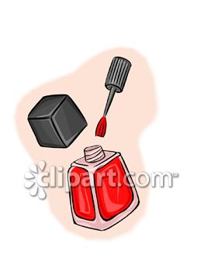
chopsticks – airshow – nail polish – garbage – police officer – gold fish
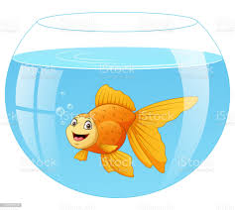


……………. ……………. ……..……. ………..…… …………… …………..
B- Match the answers:
a. thief | 1. A talkative person is someone who -------
b. ticket | 2. He tried to steal the boy's backpack; he is a ---------
c. speaks a lot | 3. He was driving so fast, so he took a ----------
d. No kidding | 4. When you are undecided, you are ----------
e. up in the air | 5. When you are surprised and can't believe, you say ------

C- Circle the correct spelling:

1. scissors - sicossrs – sicorsses
2. chioces – choices - shoices
3. geust – guset – guest

5) Orthography:

4

A- Fill in the missing letters:

1- wat__h
o – m – t – c – f
2- mirr__r
3- environ__ent
4- cus__oms
B- Choose the odd one out:
1. athletic clever friendly book
2. thief police officer work guide
3. done go eaten gotten
4. pedal cab taxi bus doctor

End of Questions
Best of Luck https://t.me/abokhaledamer

