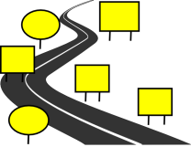
Two-word verb
- Choose the suitable words:
clean up – turn on – put away – take out – throw away – turn off

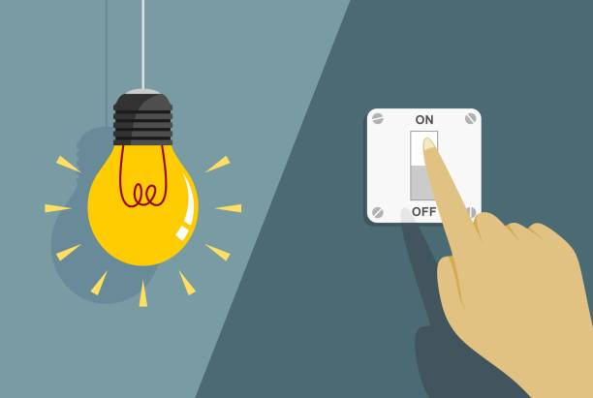
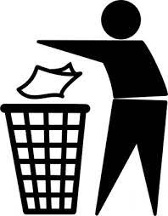
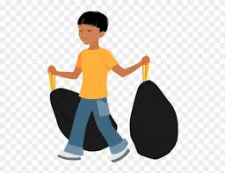
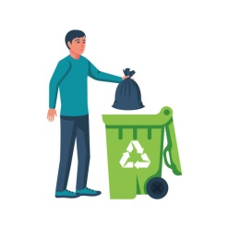

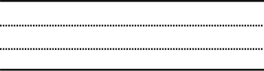
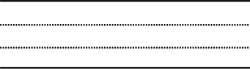
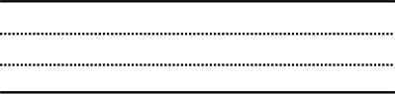
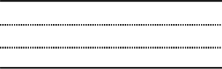

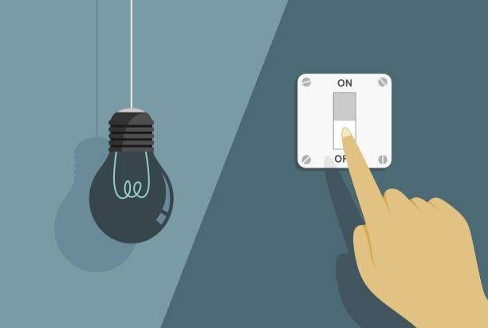
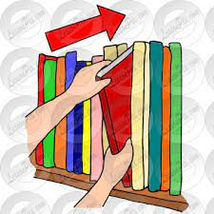

I can't stand …

1- Using someone else's mobile charger.
2- Playing video games very loudly.
3- People who stand in the way of others.
4- Someone interrupts you while you're speaking
5- People who don't wait their turn.

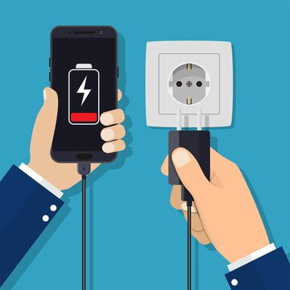
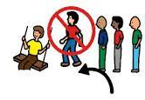

Application
Present Perfect have/has + past participle V3

Key words :
حتى الآن للـتـو بالفعل
already just yet

1- already
تأتي في نهاية الجملة أو السؤال, بين have …… v3.
They have already painted the room .
They have painted the room already .

2- just
تأتي في الوسط بينhave + just + p.p.
He has just gone out .
We have just written homework.
She has just cooked the food .

3- yet

تأتي في نهاية الجملة الخبرية المنفية و السؤال
Has he written homework yet ?
I haven’t studied the lesson yet .
We haven’t seen the new car yet .

* Complete using already, just or yet:

a- We haven't written the lesson …………………… .
b- Have you done the duties ………………… ?
c- Has Ahmed ………………….. come home ?
d- I have ………………. arrived.
e- They don't attend the lecture …………………… .

