المملكة العربية السعودية  وزارة التعليم  الإدارة العامة للتعليم بـن  مدرسة مستقبل ن الابتدائية | بسم الله الرحمن الرحيم    اختبار الفصل الدراسي الثالث  للعام الدراسي 1443 هـ | المادة | لغة انجليزية
 |  | الصف | السادس
 |  | الزمن | ساعة ونصف
 |  | الفصل | ----- /6
https://t.me/abokhaledamer
اسم الطالب رباعيا: .............................................................................................................
السؤال | 1 | 2 | 3 | 4 | 5 | 6 | المجموع  30
الدرجة
الدرجة | 6 | 4 | 5 | 6 | 4 | 5 | 30
المصحح



Q1 A. Choose the suitable answer:

6
1: What's the name of your school?

Future ( Hospital – School – Market ).
2: What should you do to be healthy?
I should get up ( early – late – Najran ).
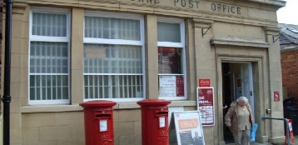
3: Excuse me. Where's the post office?
It's ( seven o'clock – a shop – near here ).
B. Answer
1- How many students are there in your school? ………………………………..
2- Did you get up early this morning? …………………………………..…….
3- Why are you going to the bookstore? …………………………..

4

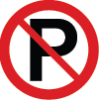
Q2 A. Match the sentence with a picture:
1. There was a little green house. ( )
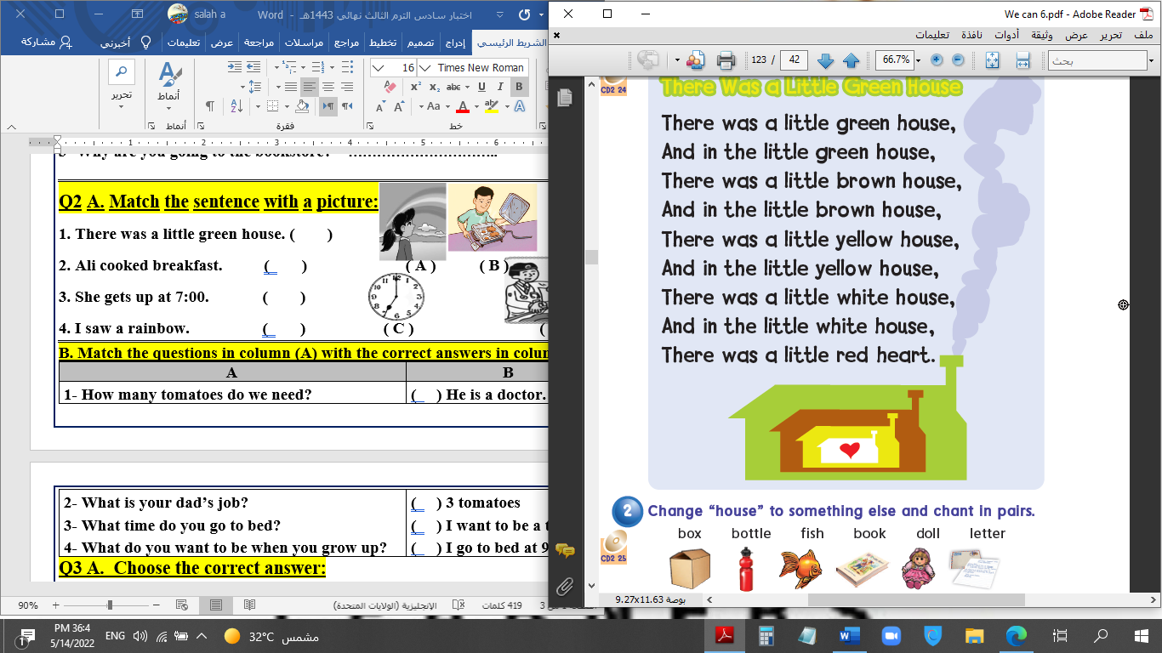
2. Don't park your car here. ( ) ( A ) ( B )
3. I'm going sightseeing. ( )
4. My school is cool. ( ) ( C ) ( D )
B. Match the questions in column (A) with the correct answers in column (B):
B | A
( ) I shouldn't skip meals.  ( ) No, we don't.  ( ) Yes, please. I want a pen.  ( ) I liked PE and Art. | 1- Do you have a school uniform?  2- Which subject did you like most last year?  3- What shouldn't you do to be healthy?  4- Can I help you?
Q3 A. Choose the correct answer:

5
1. She is (go – goes – going) to the stationery store.
2. (Who – What – How) long does it take to get there?
3- Don't shout; speak (clearly – clean – clear).
B. Put in the verb column: had / make / went / follow
past | present
/ | /
Q4: A. Write the correct number under each picture:

6
1- burger 2- shirt 3- glue 4- skirt 5- scarf 6- globe
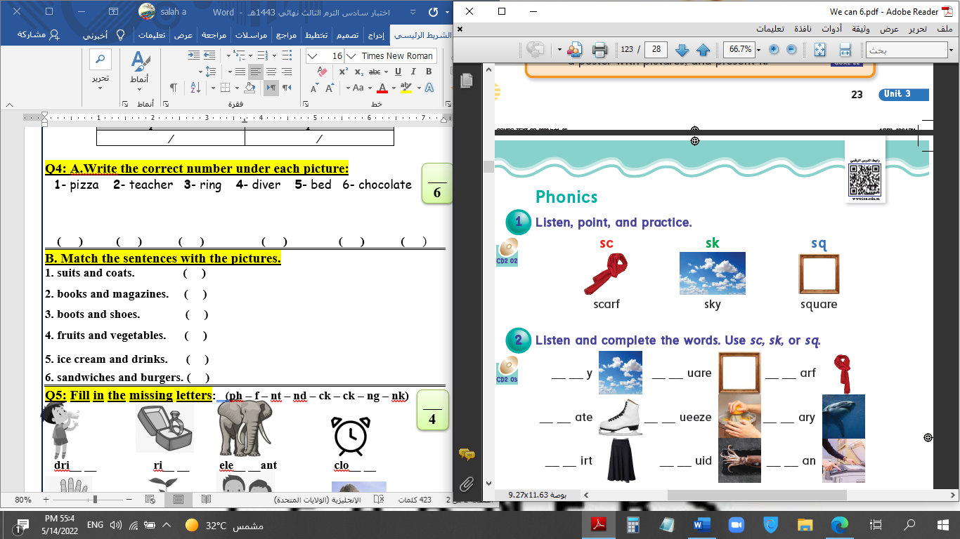

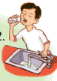
( ) ( ) ( ) ( ) ( ) ( )
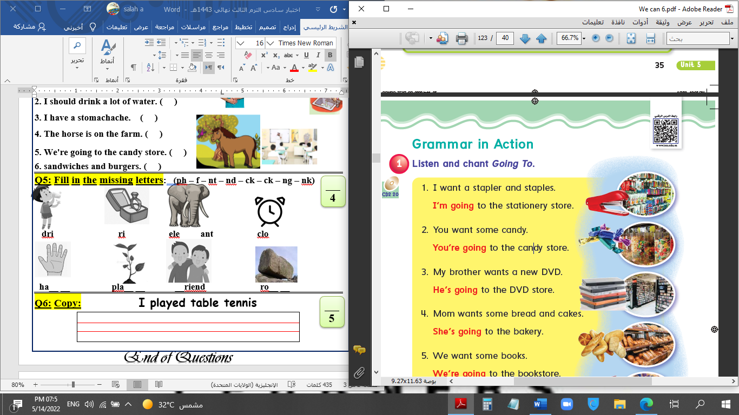
B. Match the sentences with the pictures.
1
1. Listen to the teacher. ( )
3
2
2. I should drink a lot of water. ( )
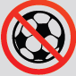
3. I have a stomachache. ( )
6
5
4. The horse is on the farm. ( )
4
5. We're going to the candy store. ( )
6. No balls. ( )
Q5: Fill in the missing letters: (sq /qu /sk /sc /ue /u-e /ir /ur)

4

_ _y g _ _ l barbec_ _ c_t_

t_ _ tle _ _ary mos_ _e _ _ueeze
Q6: Copy: What would you like to eat ?

5
End of Questions

