المملكة العربية السعودية  وزارة التعليم  الإدارة العامة للتعليم بـن  مدرسة مستقبل ن الابتدائية | بسم الله الرحمن الرحيم  اختبار الفصل الدراسي الثالث  للعام الدراسي 1444 هـ | المادة | لغة انجليزية
 |  | الصف | الخامس
 |  | الزمن | ساعة ونصف
 |  | الفصل | ----- /5
اسم الطالب رباعيا: .............................................................................................................
السؤال | 1 | 2 | 3 | 4 | 5 | 6 | المجموع
الدرجة
الدرجة | 6 | 5 | 4 | 5 | 6 | 4 | 30
المصحح


I- General Questions:

6
Q1: Answer the following questions correctly:
1. Where's Hashim? -------------------------------.
2. Can I have some candy? -------------------------.
3. What time do you eat lunch? ---------------------- .

5

II- Controlled Writing:
Q2: Do as shown between brackets:
1. many - are – How – there?(Rearrange)>____ _____ ___ ____?
2. How do you spell "box"? (Answer) >. ______.
III- Reading Short Sentence:

4
Q3: Match the sentence with the pictures:
1. Can I use your scissors?
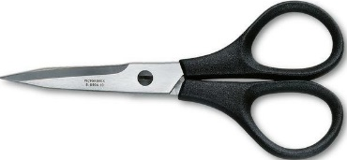
2. The mouse is on the chair.
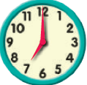
3. What's this? It's a wallet.
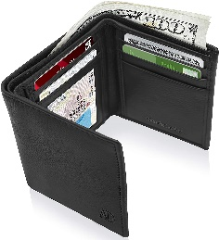
4. What time do you get up? At seven.

IV- Grammar:

5
Q4: Choose the correct answer:

1- This (am – is – are) the living room.
2- Nora is (in – on – under) the kitchen.
3- (When – Where – What) is the boy?
4- Let's (counts – counting – count) them.
5- What are (this – that – these)?

V- Vocabulary:

6

Q5: Write the number under picture:

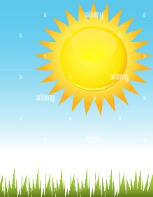

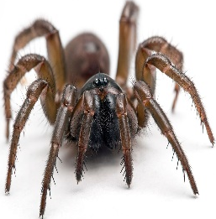
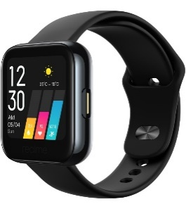
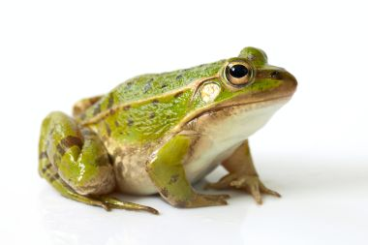
1. spider 2. sunny 3. frog 4. teacher 5. watch 6. bedroom

( ) ( ) ( ) ( ) ( ) ( )
VI- Orthography:

4

Q6: Fill in the missing letters:

sp / oo / ou / sw / fr / sm / pr / ow


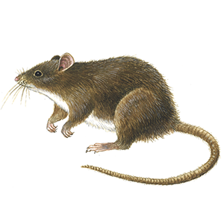


bathr_ _m _ _ize m_ _se _ _ile _ _ing _ _ies _ _ort sn_ _y

End of Questions
المملكة العربية السعودية  وزارة التعليم  الإدارة العامة للتعليم بـن  مدرسة مستقبل ن الابتدائية | بسم الله الرحمن الرحيم  اختبار الفصل الدراسي الثالث  للعام الدراسي 1444 هـ | المادة | لغة انجليزية
 |  | الصف | الخامس
 |  | الزمن | ساعة ونصف
 |  | الفصل | ----- /5
اسم الطالب رباعيا: .............................................................................................................
السؤال | 1 | 2 | 3 | 4 | 5 | 6 | المجموع
الدرجة
الدرجة | 6 | 6 | 4 | 5 | 4 | 5 | 30
المصحح


I- General Questions:

6
Q1: A- Choose the correct answer:
1. Would you like to come in?

( Yes, please – Yes, I'm Ali - Yes, I am fine )

2. Where is Nora?
(He is in the kitchen – She is in the kitchen - We are in the kitchen).
3. Can I use your scissors?
( I'm Ali - It's hot - Here you go ).

B- Match the questions in column (A) with the correct answers in column (B):

6

6
B | A
( ) Yes, I do.  ( ) F-O-X  ( ) It's a cellphone. | 1. How do you spell "fox"? 2. What's this? 3. Do you watch TV?

Q2: A Write the correct number under each picture:
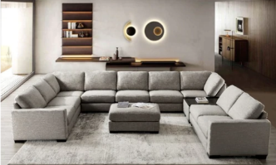
1.house 2.wallet 3.smile 4.living room 5.swan 6.present

( ) ( ) ( ) ( ) ( ) ( )
Q3: Put ( ) or ( X ):

4
1. The mouse is behind the table. ( )
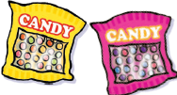
2. Can I have some candy? ( )
3.What are these? They're MP3 players. ( )
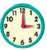
4.It's four o'clock. ( )
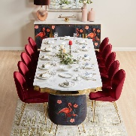

5
Q4: A. Choose the correct answer:
- This ( am – is – are ) the dining room?

- (Where – When - What) is Ali? He is in the yard.
- Can I have (a – an – some) pens, please?

- B – Change into plural
  One book | Four ----------
  One watch |   Five ----------

4
Q5: Choose the missing letter:
_ _ ider | _ _ eater | _ _ acks | m_ _ ntain
sp / sw | sp / sw | sm / sn | ou / uo

Q6: Copy:

5
Tell me about your day.

End of Questions


التاريخ: / / 1444هـ
الصف: الخامس الابتدائي
المادة: اللغة الإنجليزية


وزارة التعليم
الإدارة العامة للتعليم بمنطقة ................
مكتب .............
مدرسة .....................................

اختبار اللغة الإنجليزية نهائي – الدور الأول – للصف الخامس – الفصل الدراسي الثالث 1444هـ
اسم الطالب:........................................................ الفصل:.............
I- General Questions:
A- Answer the following questions correctly:
6

1- What time is it?
A – It's seven o'clock. B – It's fife o'clock.

2- Do you watch TV in the evening?
A – Yes, I does. B – Yes, I do.

B- Match the questions in column (A) with the correct answers in column (B):
B | A
( ) I get up at 6 o'clock.  ( ) He's a teacher.  ( ) They are 7 days.  ( ) Sure. Here you go. | 1- How many days in the week?  2- Can I use your pen?  3- What does he work?  4- What time do you get up?
II- Controlled Writing:
5
A- Complete the sentences with the correct word:
summer
sunny
fly

1- Ostriches can run but they can't ………………
2- It's ………………………… and very hot in ……………………
B- Rearrange the words to form a sentence:
1- play / I / friends / . / my / with
………………………………………………………………………………………………………………………….
2- is / a / This / . / watch
………………………………………………………………………………………………………………………….

III- Reading Short Sentence:
4
A- Read the sentences and match them with the correct pictures:

1-They are wallets. 2- It's a sheep. 3- It's snowy and cold. 4- They're cooks.


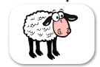
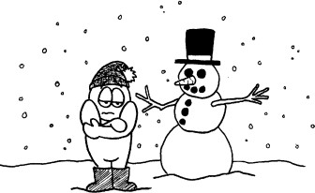


IV- Grammar:
5

A) Choose the correct word:
1- They ( is – are ) pencils.

2- What ( do – does ) she do?

3- ( That – These ) is my eraser.
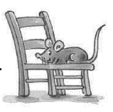
4- What are ( this – these )?
5- The mouse is ( under – on ) the chair.
V- Vocabulary:
6
A) Write the correct number under each picture:
1- candy 2- watch 3- meat 4- kangaroo 5- scissors 6- firefighter








( ) ( ) ( ) ( ) ( ) ( )
VI- Orthography:
4
ea - sp - sm - sw

A) Choose the correct letter:

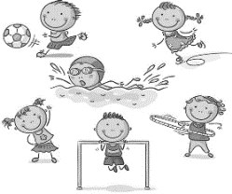



1- _ _ an 2- h _ _ d 3- _ _ ort 4-_ _ ile
المادة: اللغة الانجليزية
الزمن : ساعة ونصف
المدرسة:
مدرسة : .....................

اختبار مادة اللغة الانجليزية للصف الخامس الفصل الدراسي الثالث الدور الأول لعام1444

المملكة العربية السعودية
إدارة تعليم الطائف

30
الاسم : ......................................................

ك

/

Q1. General Questions :

A)- Match:
1-What is the weather like?

2- Would you like to come in?

3- What time is it?

3

7
A- 35 _____37______ 39______41______43

B- 50 ______ 70 _______ 80 _______

Q3. Complete numbers :

اقلب الصفحه
It's 7:00 o'clock. please
m / ee / ea / o / h

5
Q2. Controlled Writing :
A)- Complete with words from the box:

1-gr _ _ n. 2- s_all . 3- h_ _ d
4- ro_m 5-fis_
Yes, please.

It's rainy.

These | This | 1 – ……… are wallets.
are | is | 2- These ……… books.
Q6. Writing :
A)- Copy 4 times :
I am playing football and tennis.

C)- Read and write the suitable word :

.............../................../.................../.................../ .................. /....................

6
Q5. Vocabulary:

Q4. Grammar:
A)- Complete :
{ behind / on/ next to }
1-The elephant is………………………….. the board .
2- The mouse is …………………………the chair.
3-The cat is ………………………………..the box.
B)- Choose the correct answer :

.

5

4
انتهت الأسئلة
Good Luck

bedroom / door / watch / sunny / scissors / doctor

