20
اختبار مادة اللغة الإنجليزية الفترة الثانية للصف السادس الفصل الدراسي الثالث لعام 1443
اسم الطالبة : ........................................... الصف : ..........................

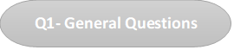

3
A ) – Match :
I shouldn't stay up late . |  | 1-What should you do to live in a healthy life ?
Yas, I drank milk this morning. |  | 2-Did you drink milk this morning ?
I should drink a lot of water. |  | Bad thing I shouldn't do 3-

2

Q2. Controlled Writing

Rearrange : A ) -
EAT – BREAKFAST – MORNING – THIS – DID – MORNING – YOU - ?

.................................................................................................................
Q3. Grammar

3

A)- Choose :
1 - You ( should – were) get up early .
2 - The past of ( drink ) is _________ . ( drank – drinking )
3 - The past of ( eat ) is _________ . ( ate – eating )
(1)
Q4. Reading short sentences

3

A) - Complete the sentences with words from the list :
Early – healthy - wealthy

…………… to bed
and early to rise ,
makes you ……………… , ……………… and wise .

5
Q5. Vocabulary

A) - Circle the odd word :
( white – black – candies – blue ) 1 –
B) - Read and write the matching number :
1 – headache 2 – toothache 3 – stomachache 4 - earache

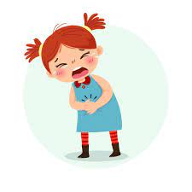
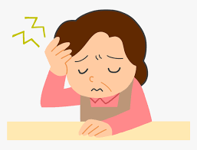
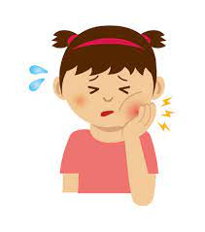
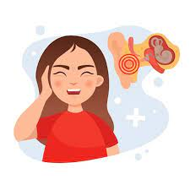
Q6. Orthography

4

A) - Fill in the missing letters with : ( ur – ir )




Good luck T \
(2)
P _ _ ple b _ _ d sh _ _ t g _ _ l

