المملكة العربية السعودية  وزارة التعليم  إدارة تعليم منطقة الرياض |  | اسم الطالبة:  ............................................
مدرسة: ابتدائية أبناء الامه الأهلية للبنات |  | رقم الجلوس: ( )
اليوم: .............................  التاريخ: ............................. |  | عدد الأسئلة: (6) أسالة
الزمن: ساعة ونصف |  | درجة الاختبار من: (30)
عدد الصفحات: (4) صفحات |  | الصف: السادس الابتدائي
اسم المصححة: | التوقيع: | الدرجة رقما:
اسم المراجعة: | التوقيع: | الدرجة كتابة:
الاختبار النهائي لمادة اللغة الإنجليزية الفصل الدراسي الثالث / الدور الأول للعام الدراسي 1443 هـ
Total _____
30

________________________________________________________________________________________

6
Q1. General Questions:

Choose:

1 - How many students are there in your school? ---------. .................................................................................................................................................................................................. _________

2-What would you like to drink? ---------.

3- What time does your school start? ---------. ................................................................................................................................................................................................... _______ ___________

---------. 4 –Where is the post office? ................................................................................................................................................................................................... ___________

5 – Where are you going? ---------.
__________

6- Did you brush your teeth this morning? ----------------------------------------------.
.





1- Flowers 2- bus stop 3- no bicycles 4-toothache 5- bookstore 6- business

Q2. Vocabulary:
Choose:

6
( ) ( ) ( ) ( ) ( ) ( )
____________________________________________________________
Q3. Grammar:
Choose:

5
1-This year I (like – liked) Math.

2- I should (eats – eat) three meals a day.

3- There (were – was) two floors.

4- I (is going – am going) to the stationery store.

5-Last year we (go – went) to Riyadh.

6-This year I (am – was) in the 6th grade

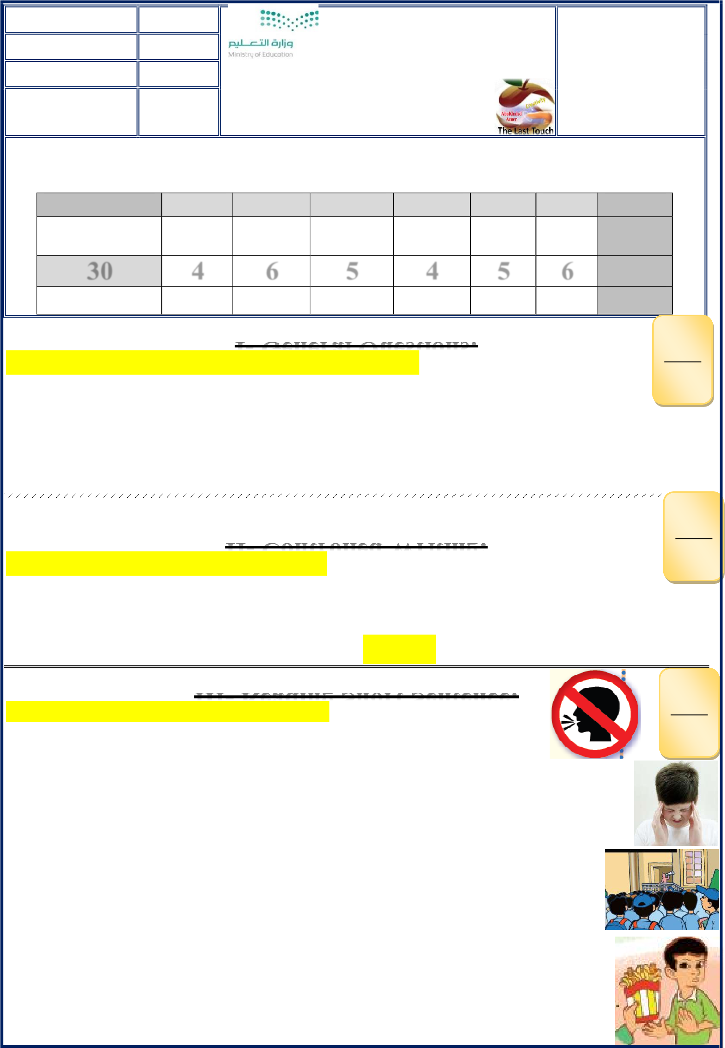
- There are about 200 students. ( )

4
Q4. Match:

- Don't shout speak clearly. ( )

- You shouldn't eat junk food. ( )

4. I have a bad headache. ( )

__________________________________________________________
Q5. Orthography:
Fill in the missing letters:

4

(ir _sq _ ir _ sk _ ur _ sc _ u-e_ ue _ng)
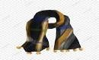

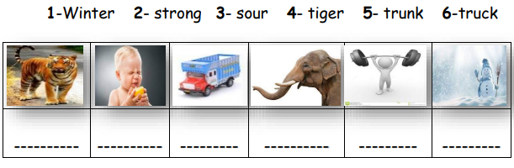
1-G _ _l 2-B _ _d 3-B_ _ger 4- _ _uare 5- _ _irt 6-_ _arf 7-h _g _ 8-mosq_ _
اسم المؤوء

____________________________________________________________
Q6. Do as shown between brackets: ___
5

1- you? - I – Can –help (Rearrange)> ____ ____ _____ ___ ___?

2- (complete) Sunday, ………………., Tuesday.

5

3- e _ t _ s _ u _ s_i (rearrange) >. ----------------------------------.

4-bakery. _ to _ the_going_She's (rearrange) > ----------------------------------.
_

5- (complete) I shouldn't -------------to many computer games.?

* انتهت الأسئلة

Good luck my sweet
T. Ebtsam Aldosari

