6

Q1-Choose the correct answer:

- What’s the name of your school?
36th elementary school. About 600 students .

- Do you have a school uniform?
Yes, we do. It starts at 7:00.

- How much is the scarf?
It is 80 SAR . Here you go .

- How long does it take?
I’d like some juice. It takes 3 hours.

- Where is the supermarket?
I play outside. It’s near here.

- Which subject do you like?
I go to Riyadh. I like English.
5

Q2-Answer the following question

- Re arrange
Abha - I - live - in. ………………………………………………………………………………..

- Read the sentence and say if it is (✔️ ) or (❌ ) :

1- | I should drink a lot of water .
2- | I sleep in your bed because, I was very sleepy.
3- | Sunday, Monday, Tuesday are days. |  | .
4- | He wants new DVD. He is going to flower store . |  | .

4

Q3- Match the sentence to the suitable picture:

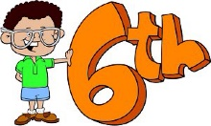
- I shouldn’t play too many computer games.

- Listen to the teacher.
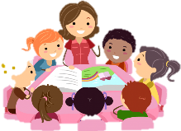
- I want some candy. I am going to candy store.
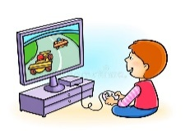
- I’m in the 6th grade.
5

Q4- Choose the correct answer:

- Last year, I (was – is) in the 5th grade.
- (There is – There are) books on the table.
- I (are – am) going to Jeddah.
- (What – Where) is your school? It’s in Abha.
- I (should – shouldn’t) brush my teeth.
6

Q5- Write the correct word:

Bus stop - head ache - math - No balls - flower store - Library
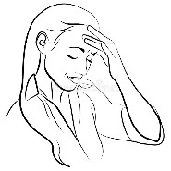
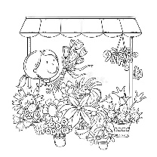
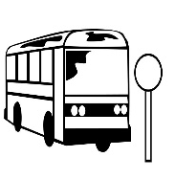
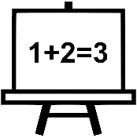
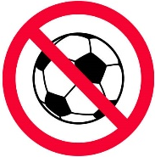
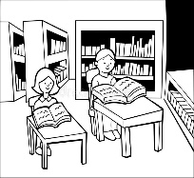

Page 2 - Next
4

Q6- Choose the correct letters:

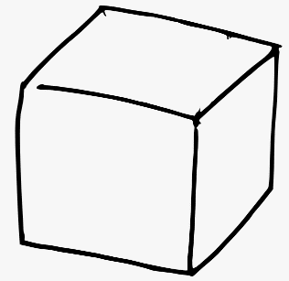
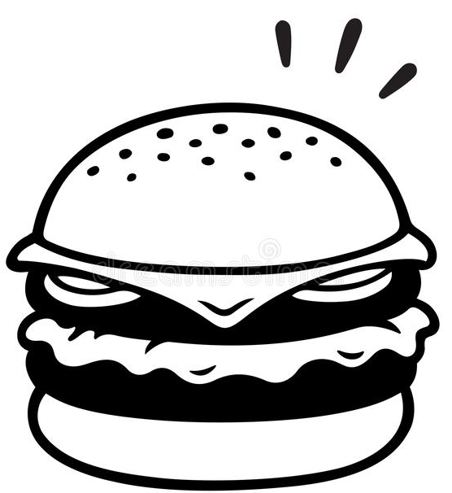

B …… …… ger c …… b ……
( u r / i r ) ( u - e / e _u )

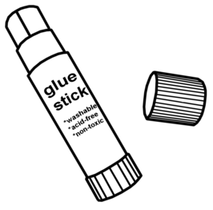
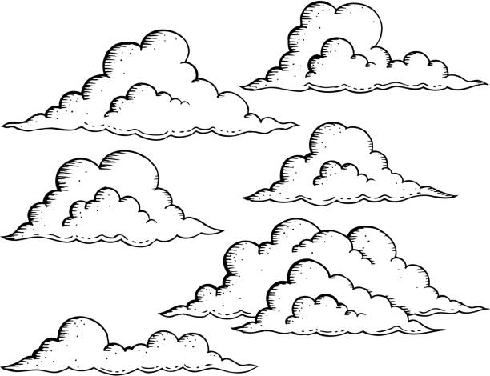

…… …… y g l …… ……
( s k / s q ) ( w e / u e )

End of question
Good luck my sweet girls
Page 3 - End

