المملكة العربية السعودية  وزارة التعليم  إدارة تعليم  مدرسة ابتدائية |  | المادة : لغة انجليزية  الصف : السادس الابتدائي  الزمن : ساعة و نص
اختبار النهائي الفصل الدراسي الثالث – ) الدور الأول ( – للعام الدراسي 1444هـ
س | المهارة | الدرجة | بالارقام | الدرجة بالاحرف | المصححه |  | المراجعه | المدققة
1 |  | 6
2 |  | 4
3 |  | 6
4 |  | 4
5 |  | 5
6 |  | 5
المجموع |  | 30
اسم الطالبة  6 |  | ------------- |  |  | الفصل |  | رقم الجلوس
Q1. General Questions: Choose:

- Does your school have a school bus ? ---------
- I don’t have. B- About 1000. C- It has a big yellow bus.
- What time does your school start? ---------
A- No, it doesn’t. B- It has a big yellow bus. C- It starts at 7:00.
- What should you do to live a healthy life? I should-------.
- stay up late. B- watch too much TV. C- drink a lot of water.
- How much is it?---------
- Yes,I did . B- Yes, thanks C-It’s 30 SAR.
- Where are you going? ---------
A-I’m going to Dubai. B- Apple juice,please. C- We bring our own.
- Where is the post?--------
A- It’s near here. B- Do not litter. C- No, we don’t.

Q2. Reading: (Match)
4
Because
1-It made the children laugh. he ate a whole pizza .
2
1
4
3
2-He has a stomachache.. to see a lamb at school.
3- We‘re going to the bookstore it’s so cute
4-Why did you take my panda? we want some books.

Q3. Vocabulary:
A-Match the numbers with the pictures:
6
6-  no ball | 5-  Flowerstore | 4-  toothache | 3-  no bicycles | 2-  earache | 1-  DVD store
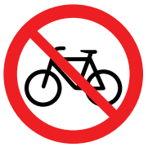
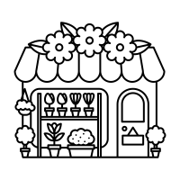
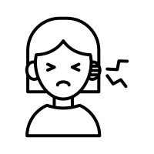



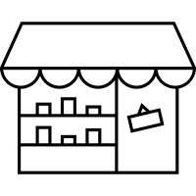

3
1
4
5
6
2
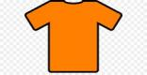


B-Circle the correct word :
wealthy | Bakery | school | Turn left | grumpy | PE
poor | Book store | mosque | Turn right | wise | Maths

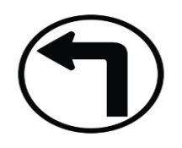

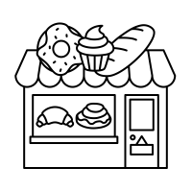

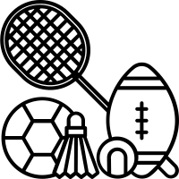


Q4. Orthography A-Complete the missing letter:
4
(ir _sq _ ar _ sk _ ur _ sc _ u-e_ ue )
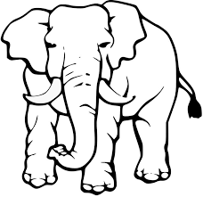



Park | huge | Burger | Girl
 |  | 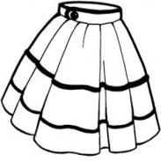 |     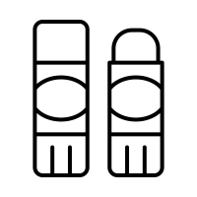  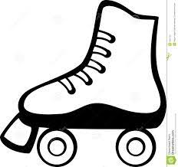
glue | skate | scarf | square

B-Choose the right spelling
_ _ueezing |  |  | 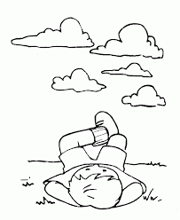  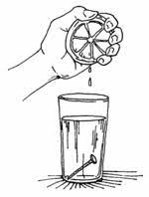 | Sh_ _t |  |  | 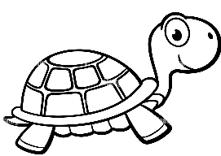  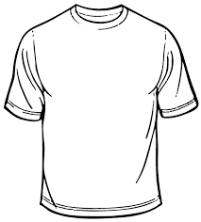
Sq | Sc | Sk |  | ur | ir | or
_ _y |  |  |  | t_ _tle
Sq | Sc | Sk |  | ur | ir | or
C-Unscramble the letters and write
tsrki | 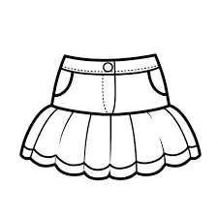  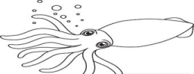 | uecb. |   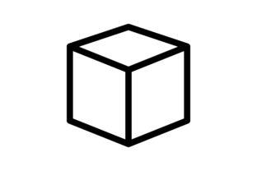
skirt |  | cube
sdqui |  | stuesi.
squid |  | tissue

Fill in the missing letter:

.

Q5. Writing :
5
A-(Rearrange)>
- you? - I – Can –help Can I help you?
2.had-Rana - lamb. -a little Rana had a little lamb.
3. Bakery. _ to _ the_going_She's She’s going to the bakery.
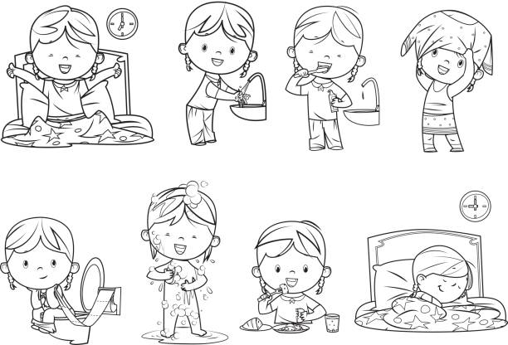
B-(Complete)> ( go - take - eat )
1- I eat my breakfast.
2-I go to bed early.

5

Q6. Grammar:
1-This year I (like –likes– liked) Math..
2- I should (eats – eat– ate) three meals a day.
3-Did you (brush - brushed - brushes ) your teeth ?
4- There (be – was – were ) two floors.
5- I (is – are – am ) going to the stationery store.
6-Last year we (goes – go – went) to Riyadh.
7-This year I (be – am – was) in the 6th grade.
8- She (is – are – am ) going to shop in Dubai.
9-He‘s going (to visit -visit - visited)the Children‘s Art Show .
10-( Does– Do – Did ) you get up early this morning?
Good luck

