Unit : 9 My School is Cool !
General Questions
A)- Match the questions in column A with the answers in column B:
B | A
About 1,000 students( ) | 1- What’s the name of your school
( )Yes, it does. It has a big yellow bus | 2- How many students are there in your school?
) It starts at 7:00 ) | 3- Does your school have a school bus?
( ) Rhadah Elementary School | 4- What time does your school start?

Reading short sentences
B) Read the following sentences then Put ( T ) or ( F )
X | √ | 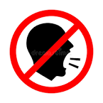 | 1- Don't shout; speak clearly
X | √ | 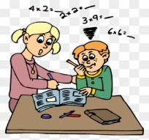 | 2- Ask for help when you have a problem.
X | √ |  | 3-Don't listen to the teacher
Grammar :
C) Choose the correct answer:
1-Which subject ( do – did ) you like most this year?
2-This year I ( liked – like ) math.
3-Which subject ( did – do ) you like most last year?
4-Last year I ( like – liked) PE.
5-( Who – Which) city do you live in? I live in Makkah.
6-Last year we ( go - went ) to Riyadh.

D) Write the past tense of the verbs :
Has---------- is------------ Follow------------ Make------------ Go--------------

Vocabulary
E) Write the correct word under each picture :
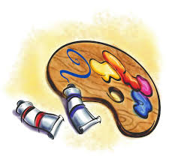
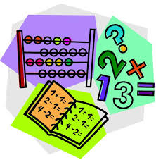

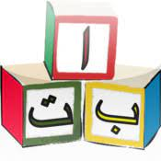


1-English 2-Science 3- Math 4- Art 5- Geography 6- Arabic

------------------ ---------------------- ----------------------- -------------------- -------------------- --------------------

F) Fill in the missing letters : sc , sk, sq
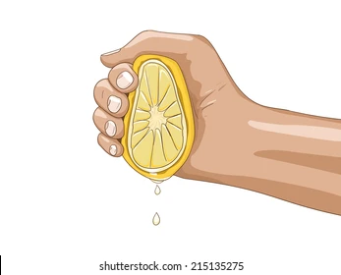
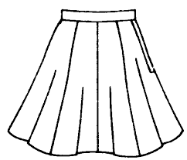
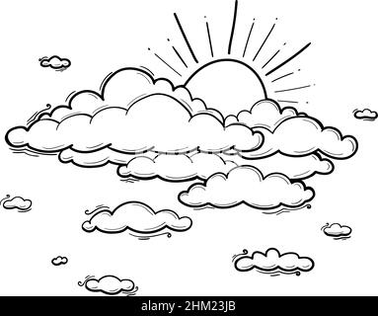

ueeze---- ---- uare ---- --- y ---- ---- irt ---- ----
Controlled writing
G)- Do as shown between brackets :
1-There are about ______ students in my school. (Complete the sentence)
2-Our school starts at ___________ . (Complete the sentence)

H) Copy
Rana had a Little lamb
----------------------------------------------------------------------------------------------------------------
----------------------------------------------------------------------------------------------------------------

I)Rearrange the sentences
Math – like – I---------------------------------------------------------------------------------

Unit : 10 (A Healthy Life . ) Revision .
General Questions
A)- Match the questions in column A with the answers in column B:
I shouldn‘t drink too much soda. |  | 1- What should you do to live a healthy life?)
I have a headache. |  | 2- Bad Things I Shouldn‘t Do
It’s 60 SAR. |  | 3- What‘s the matter?
I should drink a lot of water. |  | 4- How much is the sweater?

Reading short sentences
B) Read the following sentences then Put ( T ) or ( F ):
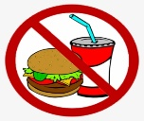 |  | 1- I shouldn't eat too much junk food.
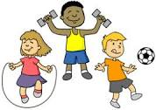 |  | 2- I should do some exercise.
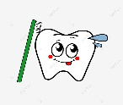 |  | 3- I brush my teeth this morning.
 |  | 4- I ate breakfast this morning.

Grammar
A-Choose the correct answer:
1-Did you ( got up - get up) early this morning?
2-I ( got up - get up) early this morning.
3-I didn‘t ( drank – drink) milk this morning.
4-I ( brush – brushed) my teeth this morning.
5- I didn‘t ( brush – brushed) my teeth this morning

B-Write the past tense of the verbs :
Play-------------- get up------------------ Talk------------------ eat---------------------

Vocabulary :
C) Write the correct word under each picture :
What's the matter?
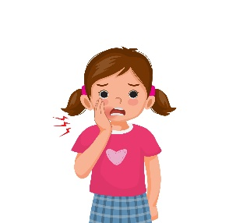 | 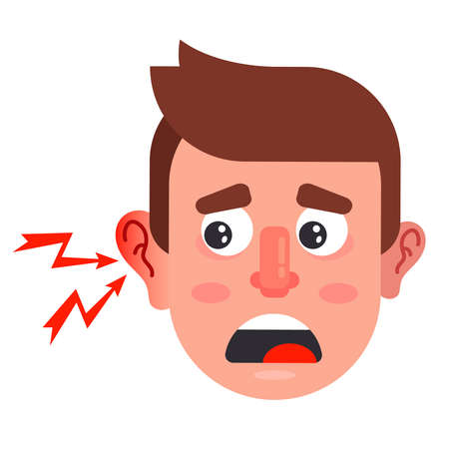 | 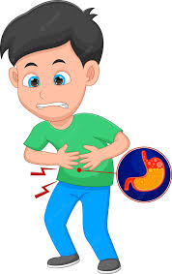 | 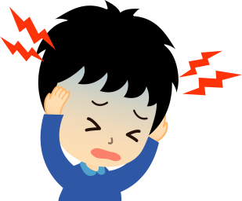
Toothache – Stomachache- Earache – Headache
D) Fill in the missing letters : ur - ir
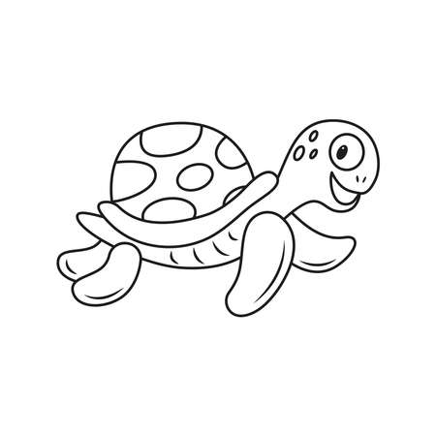 | 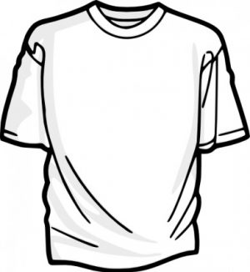 | 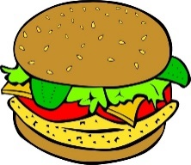 | 
t---- ---- tle | Sh---- ---- t | b--- ---- ger | g--- --- l

E) Write the correct word under each picture
1-uniform 2- trousers 3- belt 4- scarf 5- jacket 6- skirt
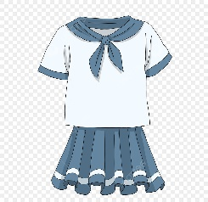 | 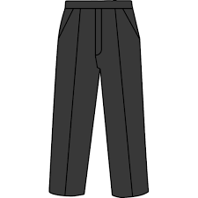 |  | 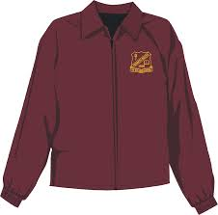 | 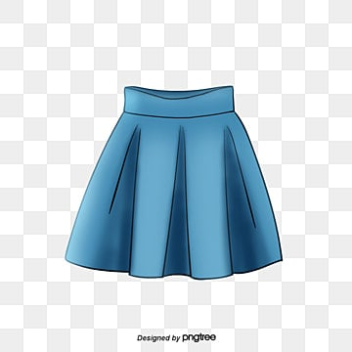 | 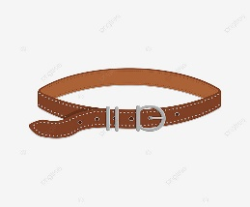
Controlled writing
A)- Do as shown between brackets :
Late to bed makes you _________ and tired. ( Complete the sentence)
drank – I – milk ------------------------------------------ ( Rearrange )
I want a sweater B) Copy :
------------------------------------------------------------------------------------------------------------------------------------------------------------------------------------------------------------------------------------------------------------------------------------

Unit : 11 (Hanging Out in Town )
General Questions
A)- Match the questions in column A with the answers in column B:
B | A
( )I'm going to the bakery | 1- Where’s the post office?
( )Go to the candy store | 2- Mom wants some bread and cakes
I'm going to Jizan( ) | 3- Where are you going?
Go straight and you’ll find it ( ) | I want some candy
Reading short sentences
B) Read the following sentences then Put (✓ T ) or ( ⎦ F )
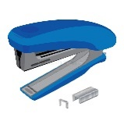  ( ) | 1- I want a stapler and staples
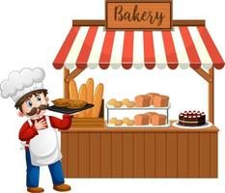  ( ) | 2-We are going to the bookstore
  ( ) | 3-MY grandpa and grand ma want some flowers and pots
( ) | 4-We are going to the bookstore

  a-do not litter .  b-No Balls .  c-No eating or drinking. | 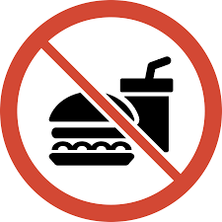  a-No parking.  b-No Balls  c-No eating or drinking.
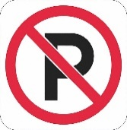  a-No parking.  b-No Balls .  c-No eating or drinking | 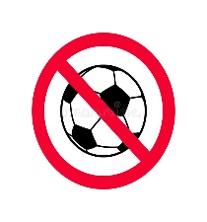  a-No parking.  b-No Balls  c-No eating or drinking
C) Circle the correct meaning for each sign:

Grammar
D) Choose the correct answer:
- I ( am – is – are ) going to the stationery store.
- You ( am – is – are ) going to the candy store.
- He ( am – is – are ) going to the DVD store.
- We ( am – is – are ) going to the bookstore.
5-There ( was – were ) a big white house.
6-There ( was – were) two floors.
7- There (was -were) two bedrooms.
8- There (was – were ) one living room .

F) Complete the sentences :
1- The supermarket is.........................the coffee shop.
2- The supermarket is.............................the school .
3-The kids are ................................the school.

Vocabulary
G) Write the correct word under each picture :
DVD store- coffee shop – candy store - post office - supermarket -train station

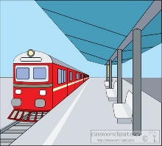 | 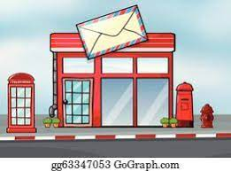 | 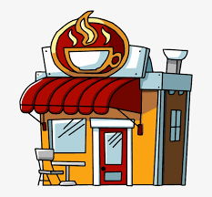 | 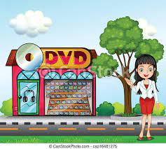 | 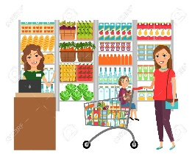 | 

H) Unscramble the letters and write:
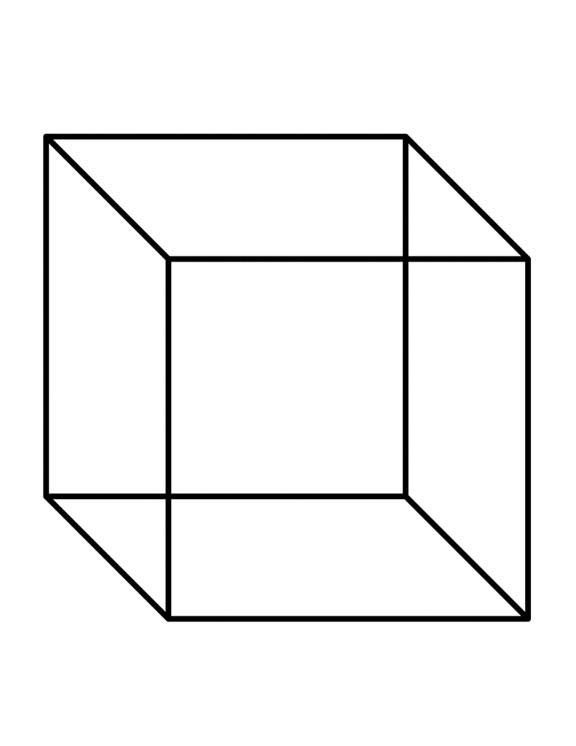  1- uecb  ---------------------- | 2- stuesi.  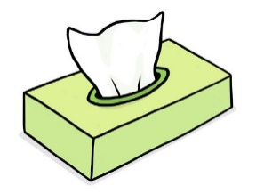  --------------- |   3- deTsuya.  --------------------- |   4- ubel  ------------------

Controlled writing
I)- Do as shown between brackets :
1- Where is the supermarket ? ( answer the question ) It's __________ the school.
2- We‘re going to the ___________. (complete the sentence)
J) Copy :
I like to have barbecue in our garden .
--------------------------------------------------------------------------------------------------------------------------------------------------------------------------------------------------------------

Unit : 12 (My Dream Vacation. )
General Questions
A)Match the questions in column A with the answers in column B
A | B
1- How long does it take to get there? | ( ) You’re welcome
2- What are you going to do there? | ( ) I’d like some juice, please
3- What would you like to drink? | ( )I’m going skiing
4- Thank you. | ( ) It takes about two hours
Reading short sentences
B) Read the following sentences then Put ( T ) or ( F )
1- This man is a flight attendant. |   ( )
2- This shirt is too small . | 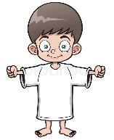  ( )
3- This black shirt is not big enough | 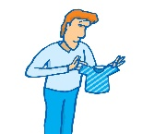  ( )
Grammar
C) Choose the correct answer:
1- I ( am – is – are ) going (to visit – visit ) the city of Abha .
2- You ( am – is – are ) going ( to watch- watch) camel races .
3- She ( am – is – are ) going (to shop – shop ) in Dubai.
4- They ( am – is – are ) going (eat - to eat traditional dishes in Lebanon.

Vocabulary
F) Write the correct verb under each picture:
What are you going to do ?
1- camp 2- eat 3- climb 4- drive 5- shop 6- swim
 |  | 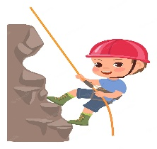 |  | 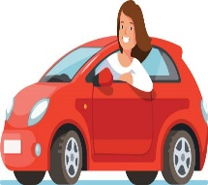 | 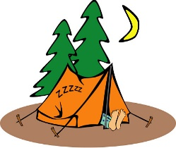
G) Classify the words under the correct column :
Sunday – May –Thursday – seas - He – Her – February- Saturday - scarf - April -clouds - They
Sounds and Letters | Days | Months | Pronouns
Control writing
Do as shown between brackets
H) Write the missing words:
1- __________ , Monday ,_________ , Wednesday, ___________, Friday,________________.
I-Choose
1- This shirt is (too- enough) big.
2- This shirt is not big (too- enough)

I) Copy :
Our future will be strong and bright.
--------------------------------------------------------------------------------------------------------------------------------------------------------------------------------------------------------------

