

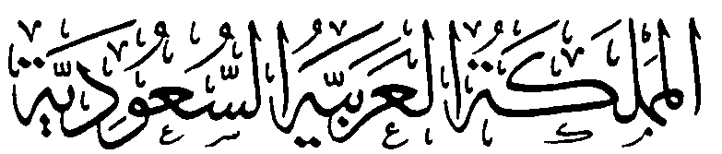
وزارة التعليم
الإدارة العامة للتعليم بمنطقة ........
مكتب ............
مدرسة .....................
التاريخ : / / 1444هـ
الصف: السادس الابتدائي
المادة : اللغة الإنجليزية

اختبار اللغة الإنجليزية نهائي – الدور الأول – للصف السادس – الفصل الدراسي الثالث 1444ه
اسم الطالب: ..................................................... الفصل: .........
6
I- General Questions:
A- Match the questions in column (A) with the correct answers in column (B):
B | A
( ) I'm going to Jeddah.  ( ) Yes, I got up early this morning.  ( ) I'm going diving.  ( ) I should drink a lot of water.  ( ) I have a headache .  ( ) Go straight and you'll find it. | 1- Did you get up early this morning?  2- What's the matter?  3- Where are you going at weekend?  4- Where's the post office?  5- What are you going to do there?  6- What should you do to live in a healthy life?

II- Controlled Writing:
5
A- Complete the sentences with the correct word:
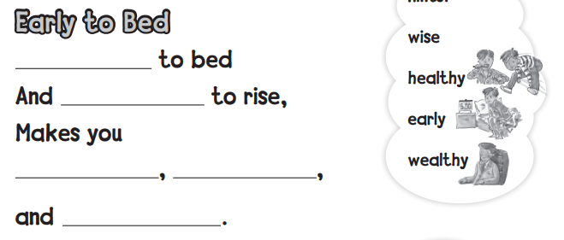

4
III- Reading Short Sentence:
A- Read the sentences and match them with the correct pictures:

1- I should brush my teeth. 2- No bicycles 3- I have an earache 4- I shouldn't eat junk food.
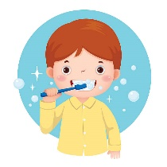

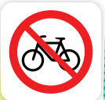
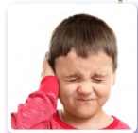

IV- Grammar:
5
A) Choose the correct word:
1- Yesterday, I ( play - played ) computer games.
2- He ( am - is ) going to the book store.
3- We are going to ( visit - visited ) Abha.
4- You should ( drink - drank ) milk.
5- What are ( she - they ) doing?

6
V- Vocabulary:

A) Write the correct number under each picture:
1- butcher shop 2- shower 3- stomachache 4- burger 5- candy store 6- flower store



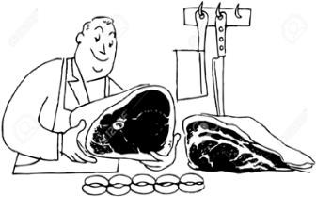
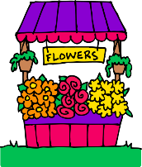
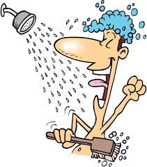
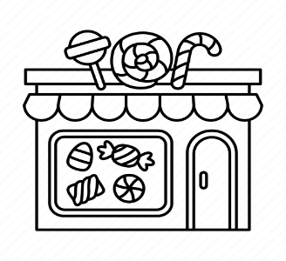

( ) ( ) ( ) ( ) ( ) ( )

VI- Orthography:
4
A) Choose the correct letter:
ir ue u_e ur

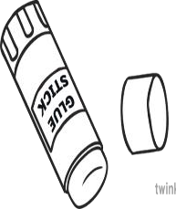
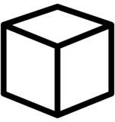
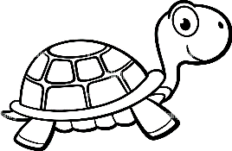
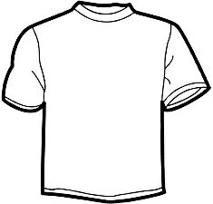

4- sh_ _ t 1- t _ _ tle 2- c _ b _ 3- gl _ _

