
4thperiod Revision we can الاولي مراجعة الفترة
- Match
- Do you have a pet ? a- 16 cats
- What is this ? b- yes , I have a rabbit.
- How many cats ? c- It’s a farm.
- Choose
- Yes , I ( do – don’t )
- No , I ( do – don’t )
- I have 6 ( bird – birds )
- ( Do – Are ) you have a cat .
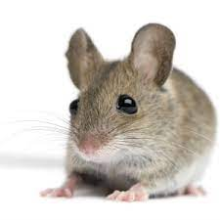
3- Match
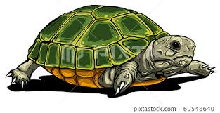
- Farmer

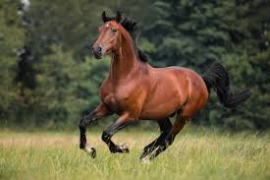
- Sheep


- Mouse

- Turtle
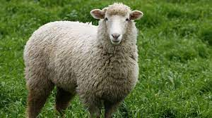
- Horse
4- Complete the numbers :-
….., 12 , ….., 14 ,….., 16 , 17 , ….. , 19 , …..
- Read and answer
My name is Ali. I’m nine. I have a nice pet . It is a fish . Its name is Nemo . It is red
- Ali is nine . ( true- false )
- Ali has a pet . ( true- false )
- Ali has a ( cat - fish )
- Nemo is ( red - green )
- supply the missing letters:-

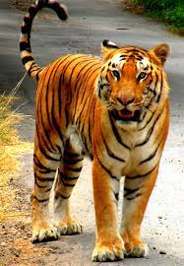


( T - S - V - U )

…un ….iger …..mbrella ….ase

Goodluck
Teacher/ Mr. Islam Moustafa

