Grade 5 Final Revision 3rd Term.

1) Answer the following questions correctly:

1- Can you spell box ? .. ( b- o- x / Thank you )

2-Welcome to our house?.. ( Thank you / Hello )

3-Food is cooked in the … ( Kitchen / bedroom )

4-My dad is watching TV in the . . . ( Living room / bathroom)

5-My sister brush her teeth in the. . . (bathroom / bedroom )

6-We play football in the . . . (kitchen / Yard )

7-Where do you eat breakfast? . . . I eat breakfast in the. . . (front door / dining room)

8-How do you spell hot? . . . (Hello / h-o-t)

9-Can I use your pen? . . . (Thank you / Here you go)

10-What time do you get up ? . . . I get up at ( comic book / 5:30 AM )
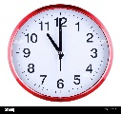
11-What time is it ? . . . It is (ten / eleven) o’clock.
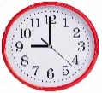
12- What time is it ? . . . It is (nine / seven) o’clock.

13-School days are ( 3 days / 5 days ) a week.

14-There is no sun today , It is ( sunny / cloudy )

15-It’s sunny and hot in ( winter / summer )

16- They can run , but they cannot fly. They are ( Snakes / Ostriches )

17-He cook in a restaurant , he is a ( teacher / cook )

18-This is a ( man / women)

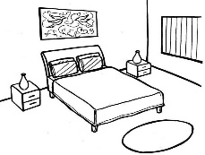

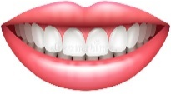
2) Match:
12
1-Cupboard
10
14

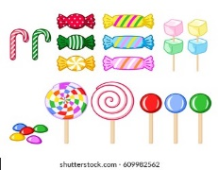
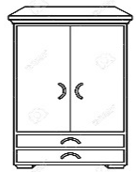
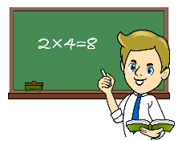
2-Seasors
18
6
1
3-Bed
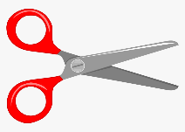

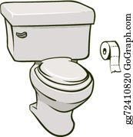
4-Bathroom
2
9
4


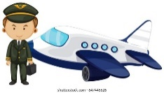
5-Glue stick
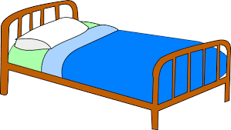
17
11
3
6-Candy


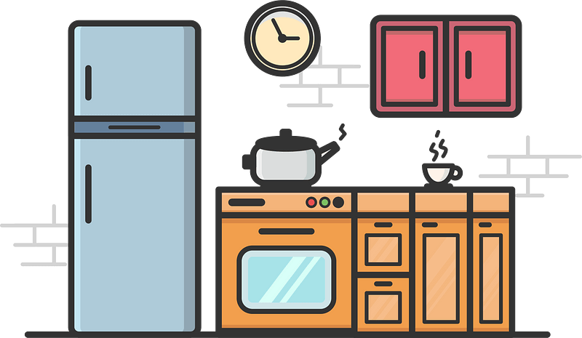

7-Kitchen
8
16
7
8-Tooth
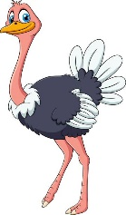
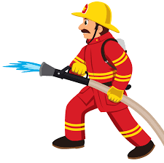
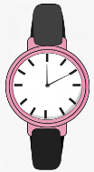
9-Paper
20
19
21
10-Astronaut
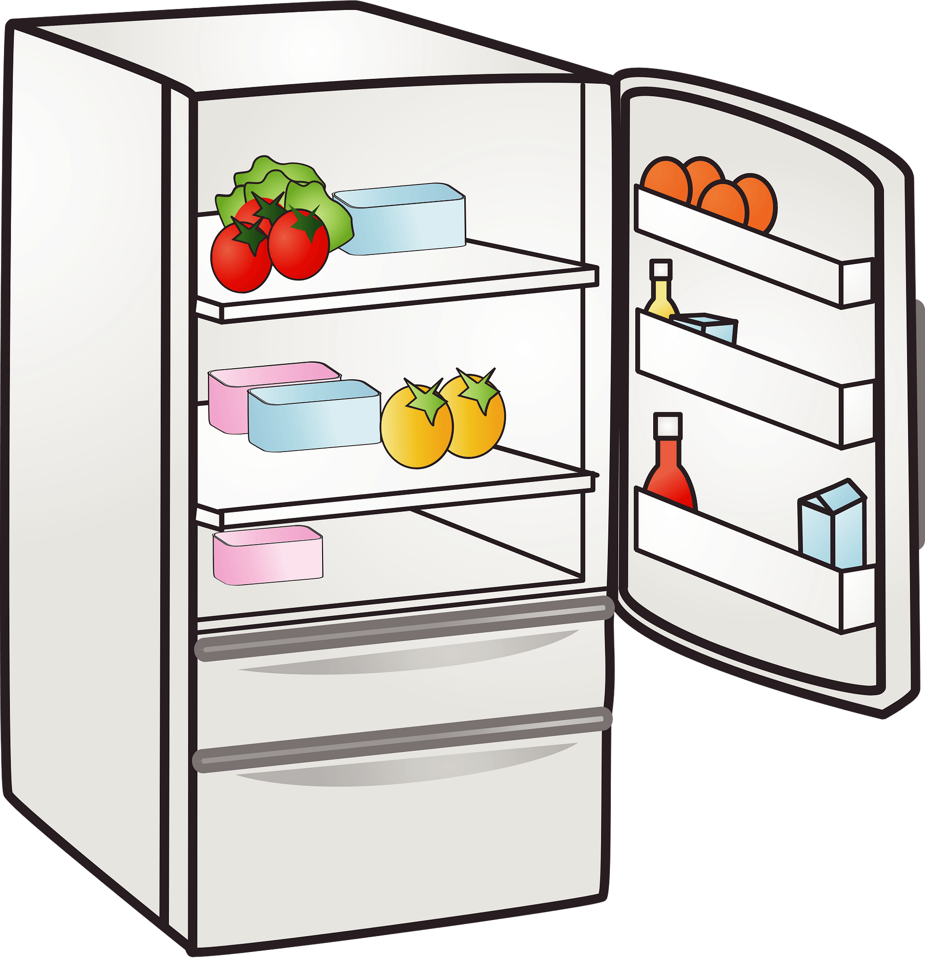

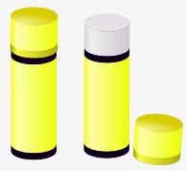
11-Farmer
13
5
15

12-Teeth

13-Fridge 14- Bedroom 15- Wallet

16-Eraser 17- Pilot 18- Teacher

19- Watch 20- Firefighter 21-Ostrich

3) Choose:

1- He is = ( She’s , He’s ) .

2-Where is = (Where’s , Who’s )?
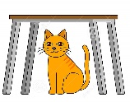
3-The cat is ( on / in / under ) the chair.
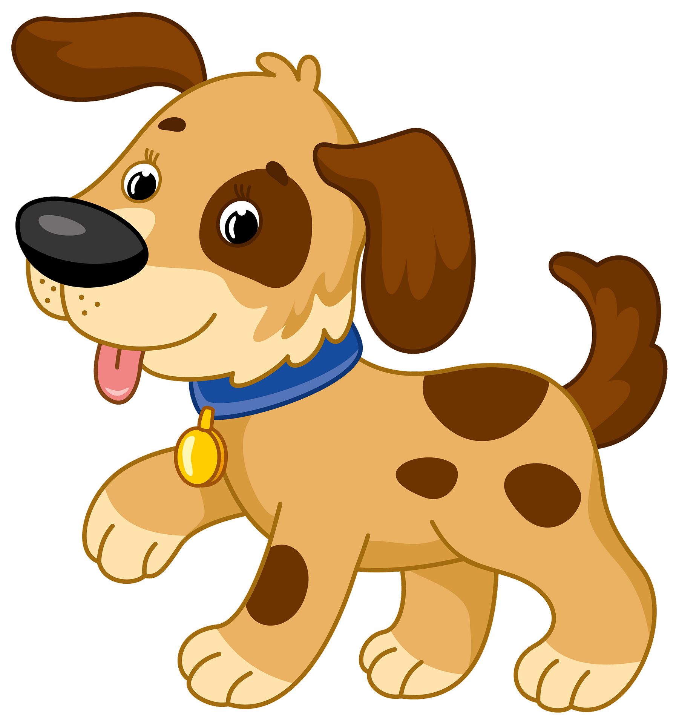

4-The dig is ( behind / under / next to) the table .

5- The pen is ( in / next to /on ) the bag .
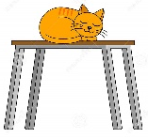
6- The cat is (behind / in / on ) the table.
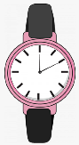
7- What are ( this / these )? .

8-These ( is / are ) pens .
9-What is ( this / these) ?
10-( These / Those) are teeth.
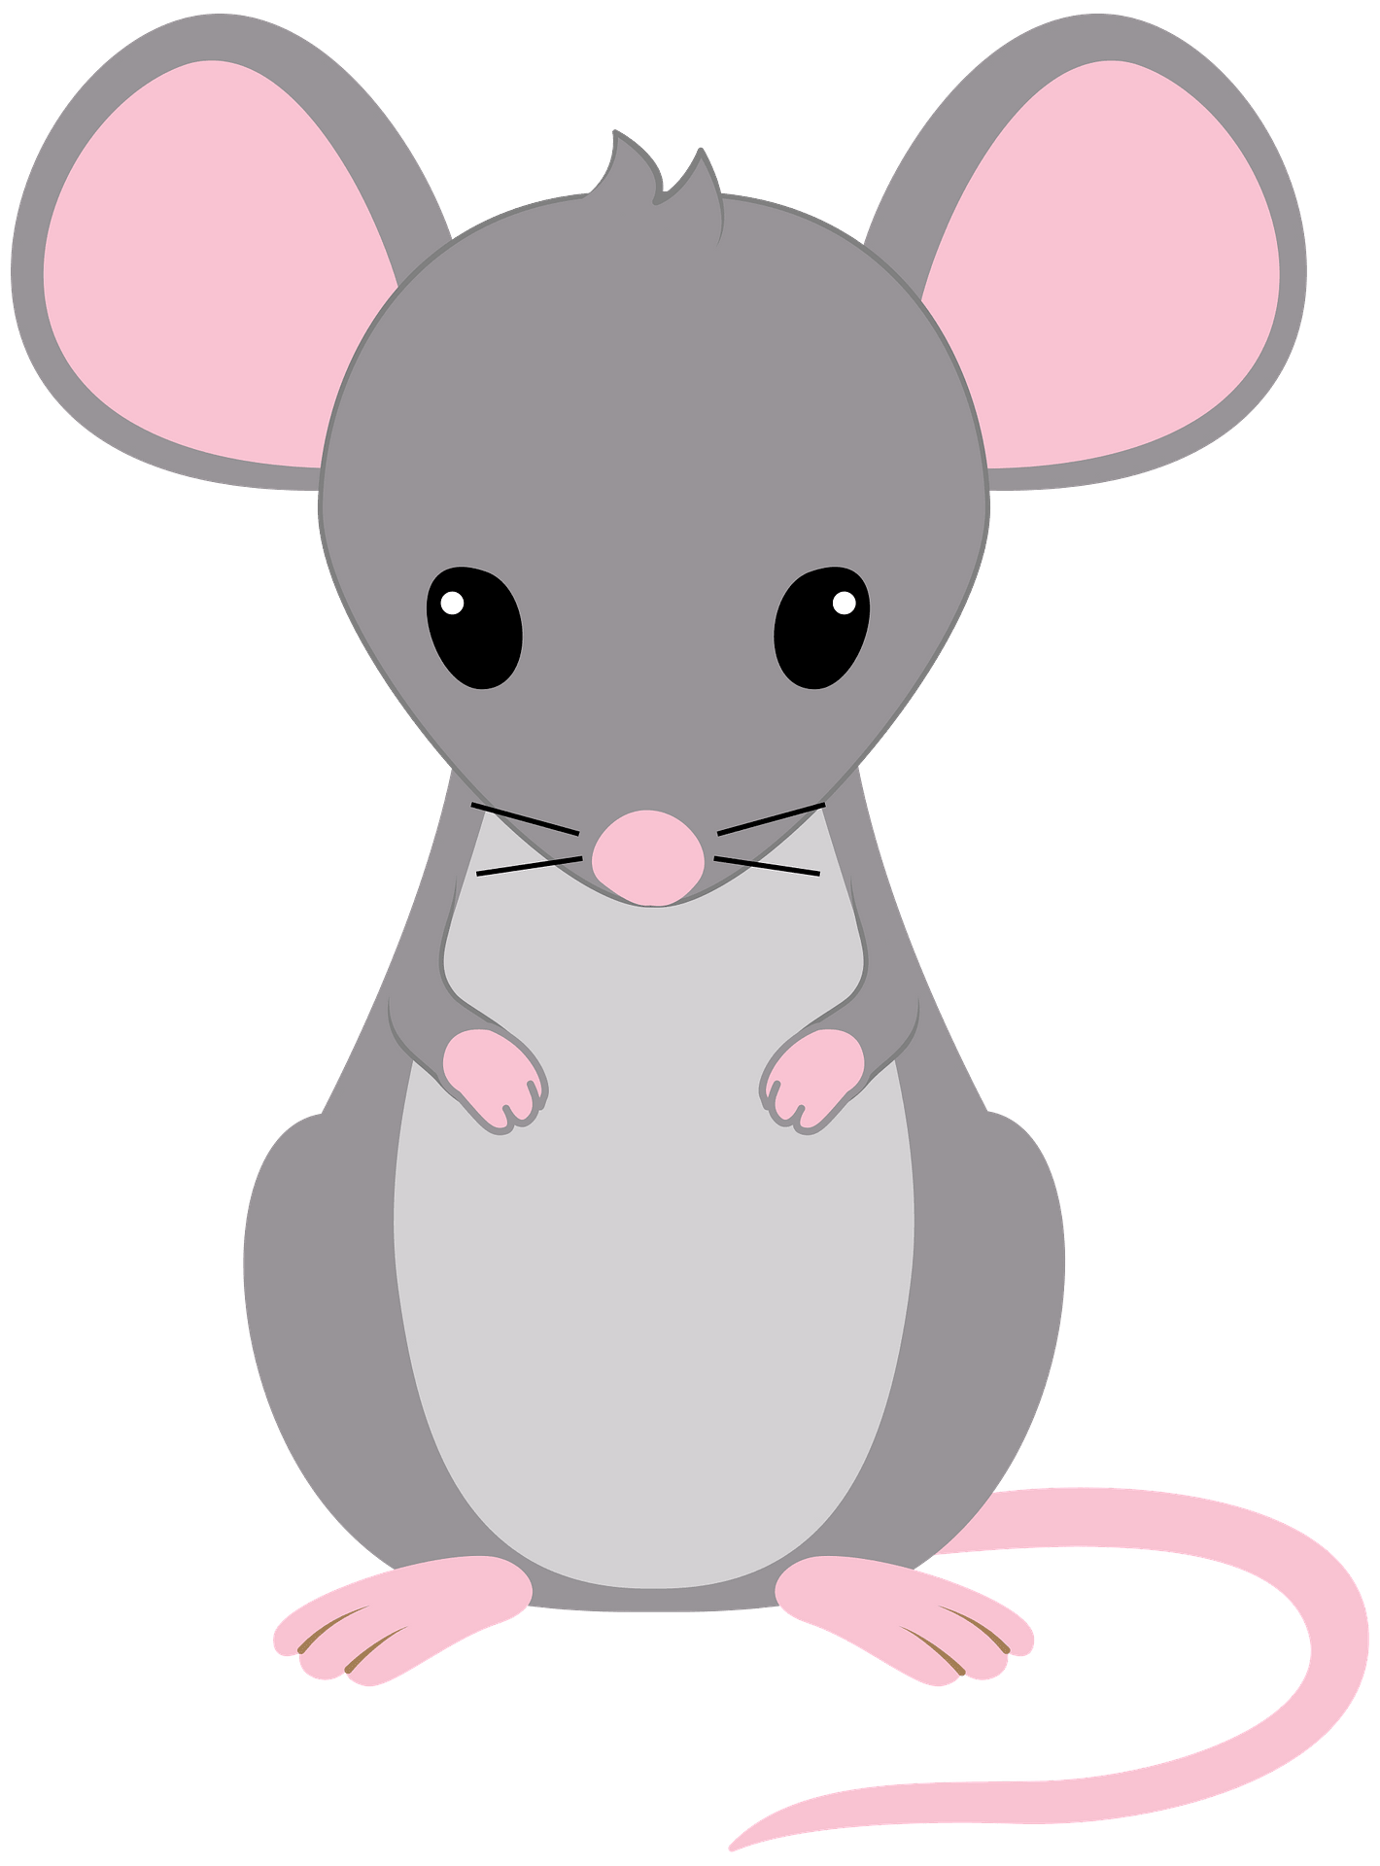
11-( This / That ) is a mouse.

12-Does ( They / he ) work in an office ?


13-Is he a teacher ? . . . Yes, ( he / she ) is.

14-(She / He/ They) is a doctor.


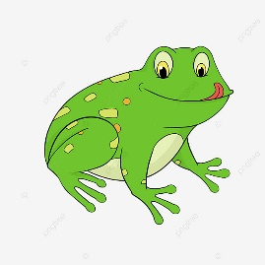

4 ) Fill in the missing letter:
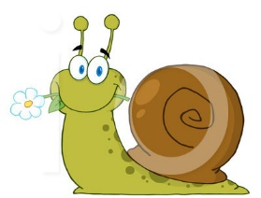


br_ea_d
M_ea_t
Cl_ou_d
M_ou__se
M__ou_ntain
H__ou_se
_Pr_esent
_Fr_ies
_Fr_og
_Pr_rize
Sh_ee_p
H_ea_d
R_ea_d
Sl_ee_p
_Sw_an
_Sw_ing
_Sp_ort
_Sp_ring


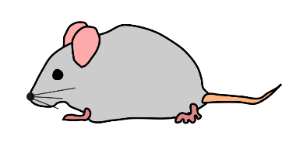


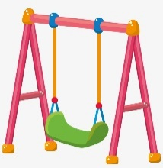

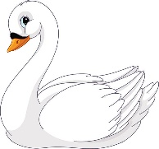
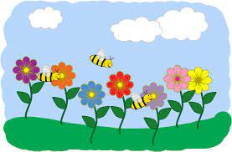

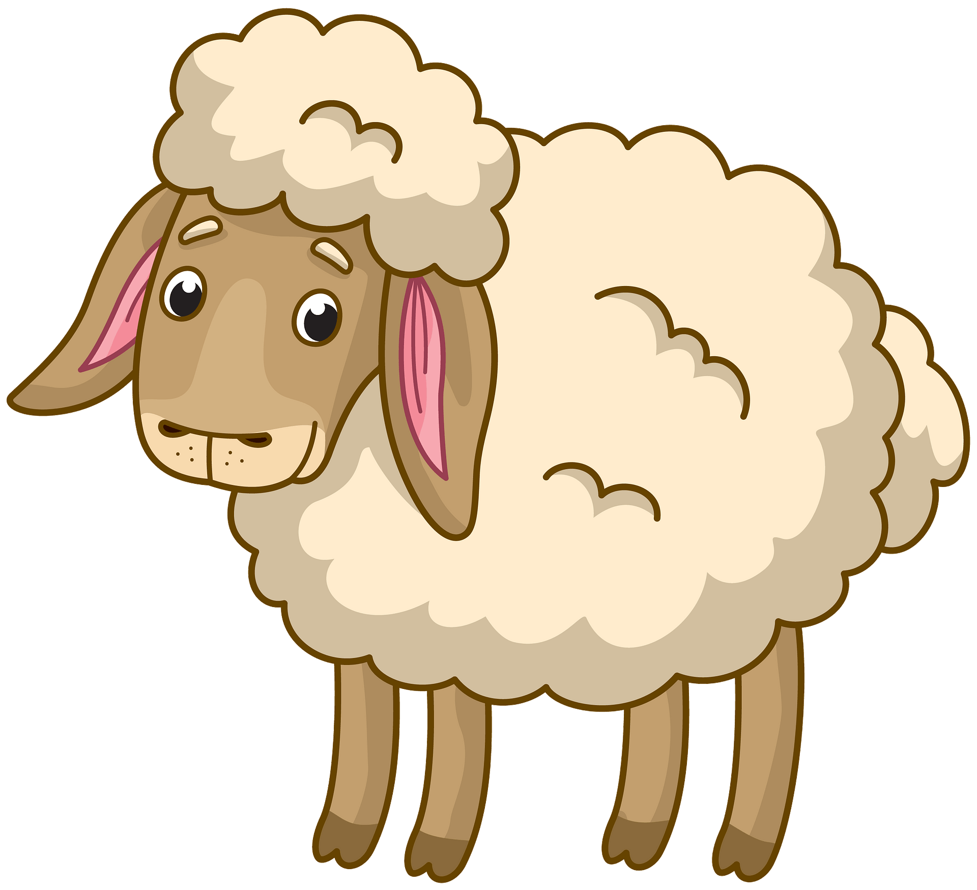
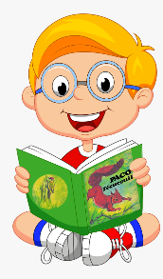
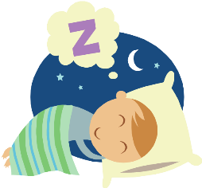
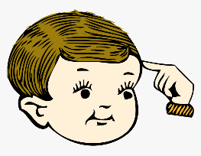

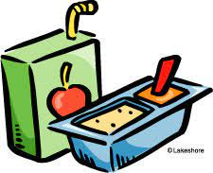
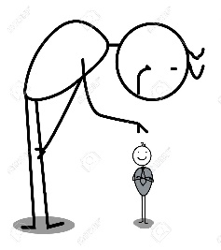


Sn__ack
Sm__all
_Sn_ail
_Sm_ile

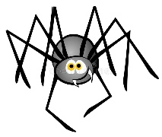
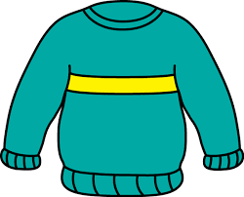
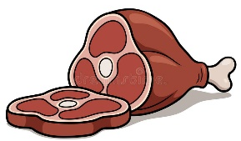


Sw__eater
Sp__ider

All the best of luck

