General Questions
1-Would you like to come in?______________________________________
2- Can I have some candy? _______________________________________
3-What time do you get up?________________________________________
4- What time do you go to school?____________________________________
5-What time do you have your lunch?_______________________________
6-Do you watch TV in the morning?________________________________
7-Do you brush your teeth before sleeping? __________________________
8-Can monkeys fly?_______________9-Can monkeys jump?___________________
10-Can ostriches speak?________________11-Can ostriches run? _________________
12-Can crocodiles fly? ________________ 13- Can crocodiles swim? _______________



Choose: True or False:
1- He works in a farm. ( True – False)
2-He works in a fire station. ( True – False)
Jobs | Places
Astronaut | Space station
Architect | Office
Pilot | Airport
Cook | Restaurant
Teacher | School
Doctor | Hospital
Farmer | Farm
Firefighter | Fire station
Businessman | Office

Controlled Writing:
Rearrange:
1-have- Can I - some - candy?_______________________________________
2-the bathroom- She- in- is._______________________________________
3-computer -are -technician- We.______________________________
4- 20- 25- 19-33.______________________
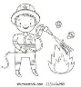

Answer:
5- Is he a fireman?____________ 6- Is she a teacher?_______________
7-Does a computer technician work in a fire station?_________________________
Does a cook work in a restaurant? _____________________
Grammar:
1-I (am- is – are) in the kitchen. 2- He (am- is – are) at school.
3- We (am- is – are) in the yard. 4-It (am- is – are) a wallet.
5-They (am- is – are) watches. 6- He (does – have -has ) short hair.
7- We ( do – have – has) great teachers.
Write the short form: He is =________ She is = ______



Where is the ball?


______ ______ __________ ___________ _________ _________
Fill the table:
Singular=1 | Plural
eraser
 | men
woman
child
 | feet
tooth
mouse

Vocabulary:
Name the pictures:
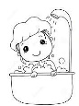 | 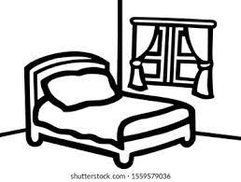 | 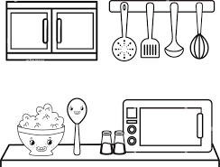 | 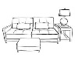 | 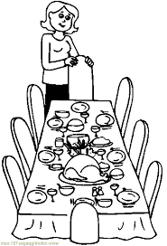
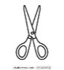 |  |  | 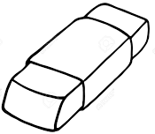 | 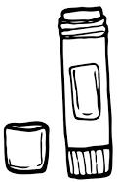
 | 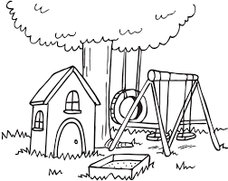 | 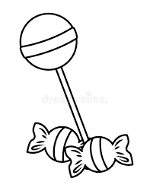 | 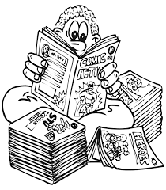 | 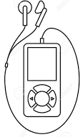
 |  |  |  | 
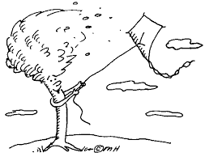 |  |  |  | 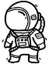
 | 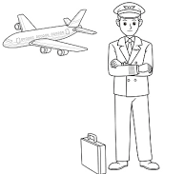 | 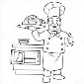 | 
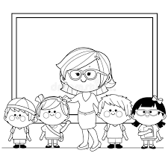 | 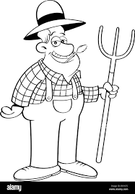 | 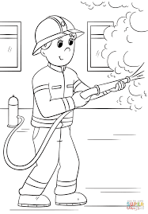
Orthography:
Fill in spaces:
pr – fr- ou -sm -sn sp -ee -ea -bl -pl

__ize __og __ies __esent m___se h__se
cl___dlue m____ntain ____ile ____ail ____all
___ider ___ack sl___p sh___p h___d
Br___d ___ue ___ay ___ate ___ouse
Find odd:
1-hot- dot- sun- hot
2- ox – box – fox -but
3-dot -fun- sun -run
Unscramble the word:
l-a-F-l = _________
o-M-d-y-a-n=______
c-o-r-D- r-t =__________
P-p-a-r-e=_________
Good luck…Fadiah Melebari

