
اختبار الفترة الثانية.
الفصل: الدراسي الثالث 1443ه.
الصف السادس الابتدائي.
المادة : انجليزي.
We Can 6
المملكة العربية السعودية.
وزارة التعليم.
إدارة التعليم
مكتب تعليم
المدرسة الابتدائية

الاسم / .....................................................................................الفصل: ..../.....
General questions: (5m)

5
1 – Answer the following questions :

1 - What time does your school start?
A . We bring our own.
B . It starts at 7:00.
2 – What is the matter?
A . I have a headache.
B . I have a toothache.

3 – Where is the post office?
A . It's next to the school.
B . You're welcome.
4 - Can you read the sign?
A . Stand up
B . Don’t shout.

5 – What subject do you like most?
A . I like English.
B . I like ice cream.

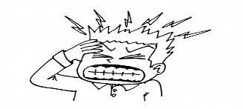

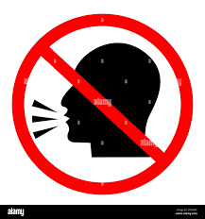

3
Reading short sentences: (3m)
2 – Read and put or :

4

1. She's going to the bakery.

2. We have a school bus.

3. You should eat too much junk food.



3
Grammar: (3m)
4 – Read and choose the correct answer:

liked | like | 1 – Last year, I ……….Math.
There were | There was | 2 – ……… a little green house.
are | is | 3 – We …..going to the bookstore.

5
Vocabulary: (5 m)

5 – Write the correct word under each picture:

No Bicycle - burger - square
1 – stationery store - candy store - zoo – flower store
2 – bank - hospital - school - Arabic
6 – Circle the odd word:

4
7 – Copy the following:
……………………………………
I have a bicycle.
………..……. | ………..……. | ………..…….

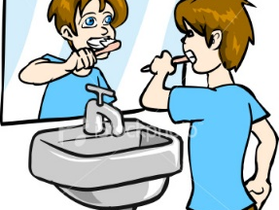
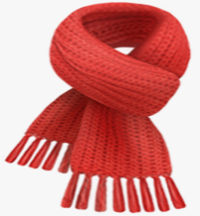


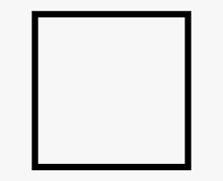
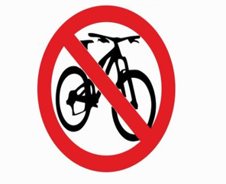

4
Drin…  ( h - k ) | __arf  ( sc - sq) | __rush  (b – f ) | C …be  ( v– u )

7 – Choose the correct letter:
Orthography (Spelling): (4 m)

