المملكة العربية السعودية  وزارة التعليم  الإدارة العامة للتعليم بـن  مدرسة مستقبل ن الابتدائية | بسم الله الرحمن الرحيم    اختبار الفصل الدراسي الثالث  للعام الدراسي 1443 هـ | المادة | لغة انجليزية
 |  | الصف | الخامس
 |  | الزمن | ساعة ونصف
 |  | الفصل | ----- /5
اسم الطالب رباعيا: .............................................................................................................
السؤال | 1 | 2 | 3 | 4 | 5 | 6 | المجموع
الدرجة
الدرجة | 6 | 5 | 4 | 5 | 6 | 4 | 30
المصحح


I- General Questions:
https://t.me/abokhaledamer

6
Q1: Answer the following questions correctly:
1. Where's Hashim? -------------------------------.
2. Can I have some candy? -------------------------.
3. What time do you eat lunch? ---------------------- .

5

II- Controlled Writing:
Q2: Do as shown between brackets:
1. many - are – How – there?(Rearrange)>____ _____ ___ ____?
2. How do you spell "box"? (Answer) >. ______.
III- Reading Short Sentence:

4
Q3: Match the sentence with the pictures:
1. Can I use your scissors?
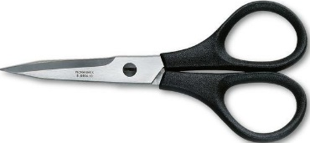
2. The mouse is on the chair.
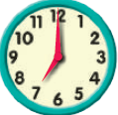
3. What's this? It's a wallet.
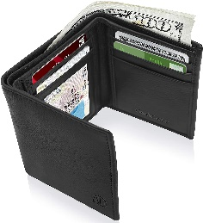
4. What time do you get up? At seven.

IV- Grammar:

5
Q4: Choose the correct answer:

1- This (am – is – are) the living room.
2- Nora is (in – on – under) the kitchen.
3- (When – Where – What) is the boy?
4- Let's (counts – counting – count) them.
5- What are (this – that – these)?

V- Vocabulary:

6

Q5: Write the number under picture:

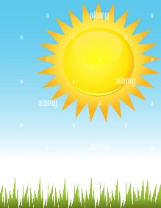
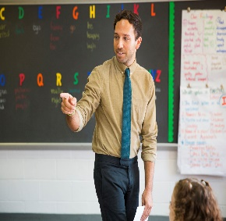
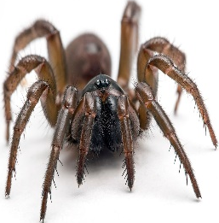
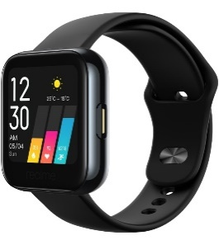
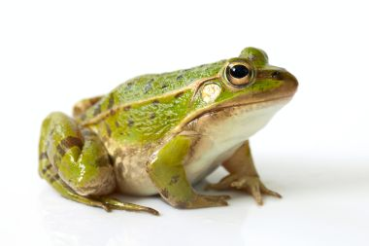
1. spider 2. sunny 3. frog 4. teacher 5. watch 6. bedroom

( ) ( ) ( ) ( ) ( ) ( )
VI- Orthography:

4

Q6: Fill in the missing letters:
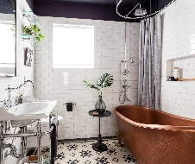
sp / oo / ou / sw / fr / sm / pr / ow


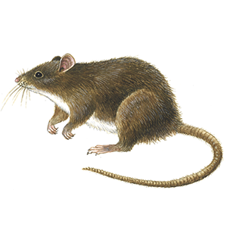


bathr_ _m _ _ize m_ _se _ _ile _ _ing _ _ies _ _ort sn_ _y

End of Questions

