

التاريخ: / / 1444هـ
الزمن: ساعة ونصف
المادة: اللغة الإنجليزية


وزارة التعليم
الإدارة العامة للتعليم بمنطقة مكة المكرمة
مكتب شرق مكة
مدرسة أجيال الوفاء الاهلية (ابتدائي)

اختبار اللغة الإنجليزية نهائي – الدور الأول - للصفين الرابع والخامس ابتدائي – الفصل الدراسي الثالث 1444هـ


I- General Questions:
6
A- Answer the following questions correctly:
1- What time is it? It's ……………………. o'clock.
2- Do you watch TV in the evening? Yes, ……………….
3-What is your favorite animal? ……………………….
B- Match the questions in column (A) with the correct answers in column (B)
B | A
( ) I get up at 6 o'clock.  ) Twenty.)  ( ) There are 7 days.  ( ) blue. | 1- How many days in the week?  2- What time do you get up?  3-The 20 its name……….
II- Controlled Writing:
5
A- Complete the sentences with the correct word:
1-A fat………………….sat…………………a box.
(animal) (preposition)
B-How do you spell ( Fun) and ( not)?
………………………………………………………………………………………………………………………………………
C- Copy the sentences:
1- She works in restaurant .
……………………………………………………………………………………………………………………………………………
2- She is a cook.
……………………………………………………………………………………………………………………………………………

III- Reading Short Sentence:
4
A- Read the sentences and match them with the correct pictures:

1-They are wallets. 2- It's a sheep. 3- It's snowy and cold. 4- They're cooks.
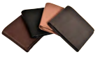
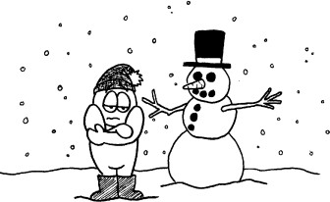

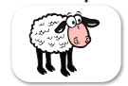

B- .Read the following sentences, then choose the answer below:
1-which animal is jaws are huge and can swim and walk?
a-cat b-crocodile c-fish
2-which animal its skin is green and eyes pop out?
a-frog b-snake c-ostriches
3-can jump but can't fly.
a-bear b-kangaroo c-dog
4- I have many things like.
a- pen b-bag c-all the above.
IV- Grammar:
5
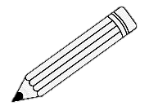
A) Choose the correct word:
1- They ( is – are - am ) pencils.
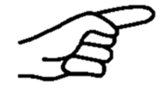
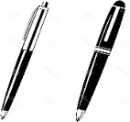
2- ( That – These - Those ) is my eraser.
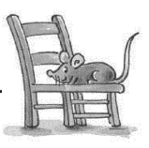
3- What are ( this – these - he )?
4- The mouse is ( under – on - in ) the chair.
B- Rearrange the words to form a sentence:
1- play / I / friends / . / my / with
………………………………………………………………………………………………………………………….
2- is / a / This / . / watch
………………………………………………………………………………………………………………………….
Plural | Singular
C-Classify the following words in the table:
Walt – comic books – watch – pencils
V- Vocabulary:
6
A) Write the correct number under each picture:
1- candy 2- watch 3- meat 4- kangaroo 5- scissors 6- firefighter





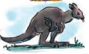


( ) ( ) ( ) ( ) ( ) ( )
B-Circle the odd one out:
1- Livingroom – bedroom – hand – kitchen.
2- pen – paper – glue – teacher.
3- loin – cat – face – monkey.
4- sofa - cook - doctor – businessman.
C- Complete the sentences with the correct word:
sunny- run - summer
1-It's ………………………… and very hot in ……………………
VI- Orthography:
A- Choose the correct word:
4
(mile - wan – ead - port))(

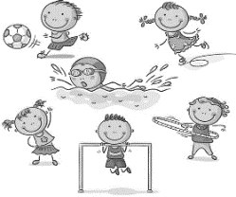
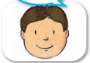
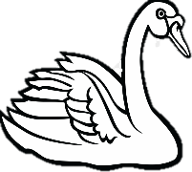

1- S………… 2- h……….. 3- S………… 4-S………..
B-Choose the correct letter:
1-s….ider (p-f) 2-su…. (t-n) 3-t….ee (r-s) 4-c..oud (m-l)
5-s…ack (n-g) 6-do…tor (v-c) 7-pil….t (o-n) 8-p…ize (a-r)

