I General Question

6
  a- He is in the yard.  b–He is in the diningroom.  c–He is in the bathroom. | 1- Where is Omar?
  a- welcome.  b- Sure .here you go.  c- great. | 2-Can I have some candy?
  a- It's a wallet.  b- It's a watch.  c- They 're books. | 3- What's this ?
  a-I get up at 6 o'clock.  b-I eat lunch in my home.  c- Yes, Ido. | 4-What time do you get up?
  a- Yes, he does.  b- Yes,Ido.  c- No, they don't. | 5-Do you watch TV ?
  a-They are 10.  b-They are 20.  c- They are 5. | 6-How many ice-creams are there?

5
II Controlled Writing
A- Rearrange the words to form sentences:
 | 1- eating/ my friend /fries/is.
 | 2- are / snails / quite.


B – Put (√ or ×) :

1- She has long brown hair. ( ).

2- He is a farmer. ( ) .
3- Their skin is green. ( ).

III Reading short Sentences

4
A- Match:
 |  | 1-a fat cat sat on a mat.
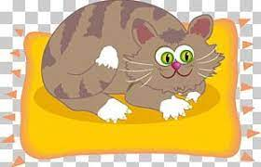 |  | 2-Its jaws are huge.
 |  | 3- It's sunny and hot.
 |  | 4-Would you like to come in ?
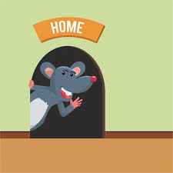
IV Grammar

5
A – Choose:
1-The mouse is …………. the house.
A | on | B | in | C | under


2- ………. You eat lunch?

A | Does | B | Do | C | Done


3- How do you spell " box":

A | b-o-x | B | o-x | C | h-o-t


4- …………….. I use your sissors?
A | There | B | Have | C | Can

B- Choose the correct sound:
1 – To shorten " He is " we write: { She is - He's }.
_______________________________________________________
V Vocabulary

6
A- Write the correct word under each picture:
( snack – papers – mp3 player - ostrich )

 | 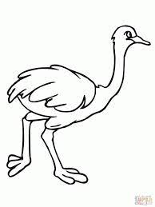 |  | 

B- classify the words :
[ bedroom – kangaroo – pilot – kitchen – giraffe – astronaut]
Jobs | Animals | Rooms

C- Choose the right plural of the following:
1- man # ( men – women ). / 2- foot # ( teeth – feet ) .
_____________________________________________________
VI Orthography
Fill in the missing letters :
 | 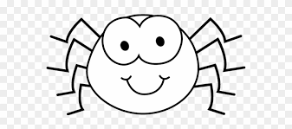 |  |  |  |  |  | 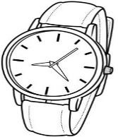
Coo_ | Spi_er | Frid_e | P_esent | Mounti_ | _x | S_ile | Wa_ch

The End
With my best wishes / Tr. Abeer Nasser

