Unit: 5 (My day, Animal, places)
Question 1: general questions
- Answer the following questions
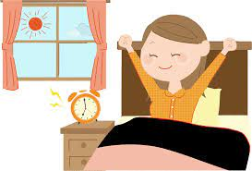
- What time do you get up?

…………………………………………………
- What time do you eat lunch?
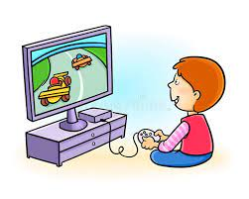
…………………………………………………
- What do you do on Friday?

…………………………………………………..
- What do you in the evening?
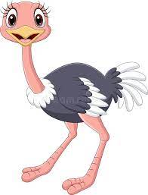
…………………………………………………….
- Can ostriches fly?

……………………………………………………
هذه الصورة بواسطة كاتب غير معروف مرخصة بالاسم CC BY-NC
- What dose she do?
……………………………………………………..

Question 2: controlled writing
- Rearrange the sentence:
- I / school / to / go / 6 o'clock / at / .
…………………………………………………………………………………………………..
- It / sunny / hot / is /and / .
…………………………………………………………………………………………………..
- Answer the following question
Tell me about your day . what time do you :
- Get up 2- go to school 3- eat lunch 4- come home
- I get up at ……………………….
- I ………………………………………..
- ……………………………………………
- ……………………………………………

Question 3: Reading short sentences
- Read the sentence then choose T (√ ) or F (×)

- She has long brown hair ( )

- He is a farmer ( )

- He works at the school ( )

- There is no sun today its cloudy ( )
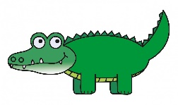
- It can walk and swim ( )

Question 4: spilling
- choose the missing letters
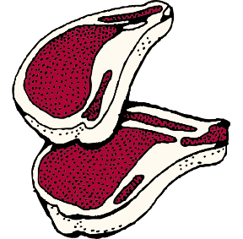  m…………t |  |   r………..d |  |   Sl……..p |  |   h…………d
ee | ea | ee | ea | ee | ea | ee | ea

Question 5: Vocabulary
A - fill in the blank with the following words :
- pilot 2– architect 3-cook 4- businessman
 |  |   هذه الصورة بواسطة كاتب غير معروف مرخصة بالاسم CC BY-ND |   هذه الصورة بواسطة كاتب غير معروف مرخصة بالاسم CC BY-NC-ND

Question 6: Grammar
A-choose the correct answer :
1- ( Do – Dose ) you watch Tv in the evening ?
2- Dose he work in an office? No, she ( dose- doesn't ).
3- She ( work – works ) in a school .
4- What ( do – dose ) he do ?
5 - Do you get up at 5 o'clock ? yes I ( do – dose ) .
6 - I ( eat – eats ) lunch at 3 o'clock .
7 - She ( has – have ) short black hair .

إعداد المعلمة: عهود سالم باوزير
مراجعة وتدقيق مشرفة المادة: داليا إبراهيم فرغل

