Unit: 3 (My House )
Question 1: general questions

- Answer the following questions
- Where is he watching Tv ?
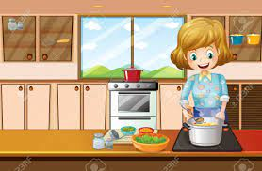
…………………………………………………
- Where is she cooking the dinner ?

…………………………………………………
- Where is the mouse ?
…………………………………………………..
- How do you spell box ?
…………………………………………………….
Question 2: controlled writing
- Rearrange the sentence:
- mouse / on / The / is / the / chair/ .
…………………………………………………………………………………………………..
- in / She / kitchen / is / the / .
…………………………………………………………………………………………………..
- Copy the sentence on the four lines :

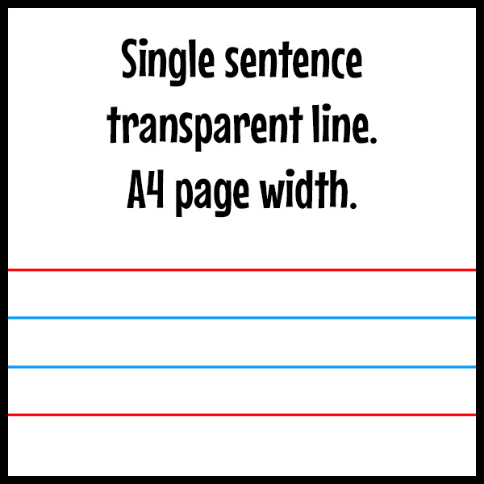
The ox is on the box .

Question 3: Reading short sentences
- Read the sentence then chose T (√ ) or F (×)

هذه الصورة بواسطة كاتب غير معروف مرخصة بالاسم CC BY-SA
- He is sleeping in the bedroom ( )


- The books are in the bag ( )
هذه الصورة بواسطة كاتب غير معروف مرخصة بالاسم CC BY-SA-NC

- choose the correct answer

1- My sister brushes her teeth in the (bedroom-bathroom) .

2- We eat the breakfast in the (dining room –front door ).

Question 4: spilling
- choose the missing letters
  ……..og |  |  |   …….esent
pr | fr | ou | pr | fr | ou
  m…………..se |  |  |   cl……….d
pr | fr | ou | pr | fr | ou

Question 5: Vocabulary
A - fill in the blank with the following words :
1-chair 2- bed 3- cupboard 4-fridge
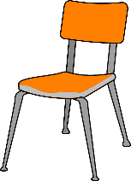 |  | 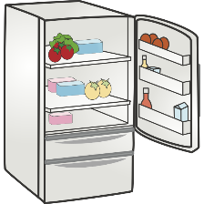 | 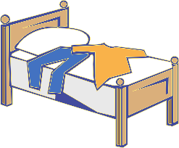

B –match the picture with the suitable word :
A |  | B
- House |  | 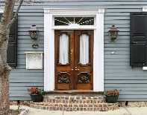  هذه الصورة بواسطة كاتب غير معروف مرخصة بالاسم CC BY-SA
- Front door |  | 
- Ox |  | 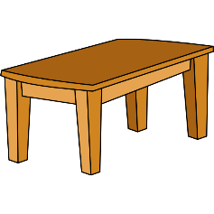
- Table |  | 

Question 6: Grammar
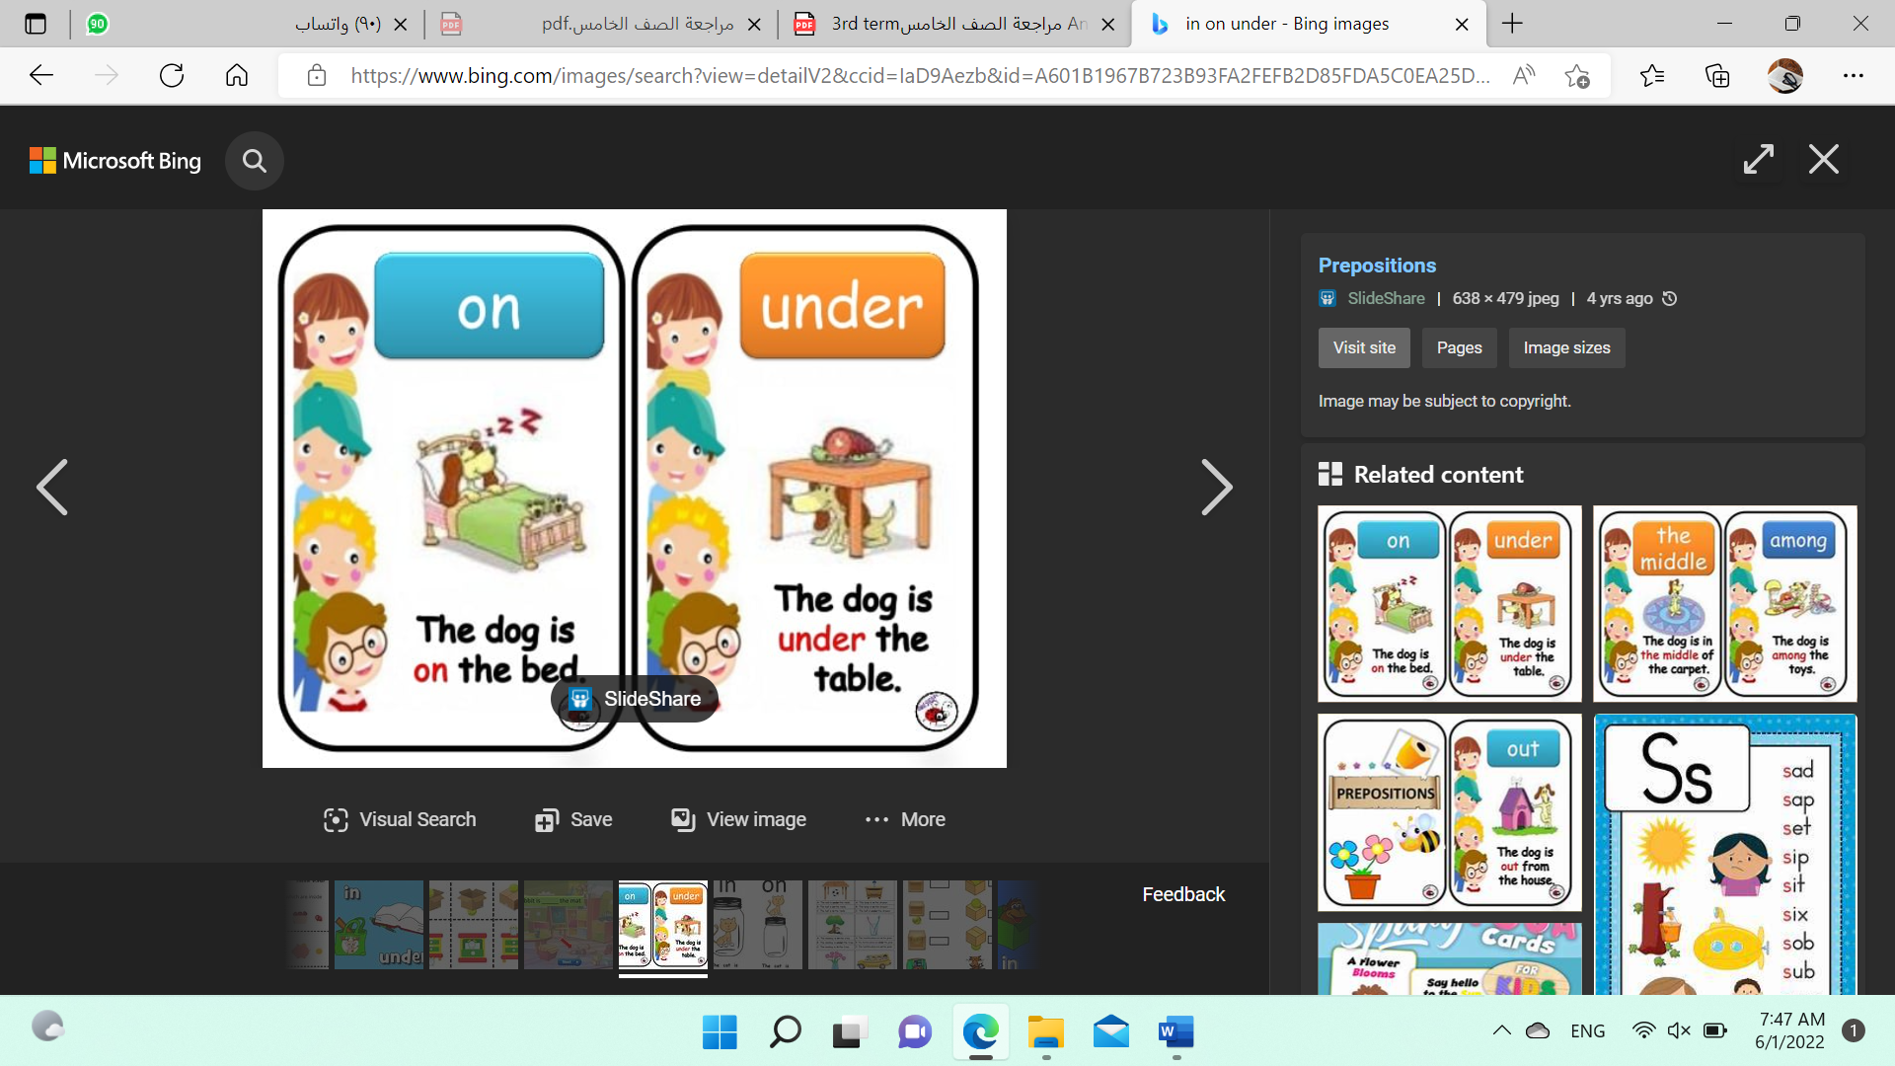
A-choose the correct answer :
- The dog is ( in – on ) the bed .
- The dog is ( under- behind )the table .
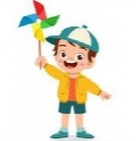
- ( He – She ) is playing
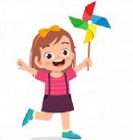
- ( He – She ) is playing

إعداد المعلمة: عهود سالم باوزير
مراجعة وتدقيق مشرفة المادة: داليا إبراهيم فرغل

