  REMARK TEST GRADING  4th & 5th PRIMARY GRADES- THE SUMMATIVE TEST  E LANGUAGE SUBJECT – (WE CAN 2)  3rd TERM - 2022 / 2023 -1444 TIME: AN HOUR AND A HALF – FIRST SESSION |  | MINISTRY OF EDUCATION  ……………EDUCATION DIRECTORATE  …………………………PRIMARY SCHOOL


MULTIPLE CHOICE & TRUE - FALSE TEST- 30 GRADES - 1 GRADE FOR EACH
 | الفصل: |  | الصف: |  | اسم الطالب:

CHOOSE THE CORRECT ANSWER FROM A, B, C OR D:
1. Would you like to come in?
A I know! It's Rana. | B I'm a pilot. | C It's very cold. | D Yes, please.
2. Do you do your homework in the evening?
A No, It can't fly. | B In the kitchen. | C Good morning. |   D Yes, I do.

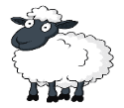
3. What are __________? They're sheep.
A this | B that | C those | 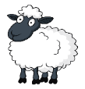  D him
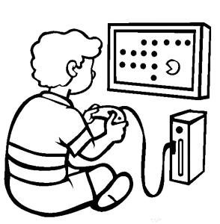
4. What do you do on Saturday?
A I go to school by car. | B I go to school. | C Yes, we are. | D I play with my friends.

5. ___________ and erasers.
A Pens | B Erasers | C Pencils | D Scissors

6. It is cloudy and __________ today.
A sunny | B very hot | C rainy | D hot

7. This is an ____________.
A MP3 player | B wallets | C MP3 players | D wallet

8. How do you spell fun?
A f - u- n. | B n - o - t . | C b - o - x. | D b - y - e.
9. Odd-One-Out:
A smart | B snap | C snack | D snail

10. He is an __________.
A businessman | B astronaut | C architect | 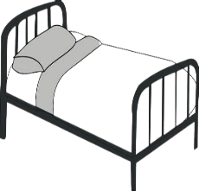  D farmer
11. There is a bed in the ____________.
A living room | B dining room | C bathroom | D bedroom

12. Can I have some candy? Sure! ________________.
A Where's Hashim? | B They're mice. | C Here you go. | D Hello!
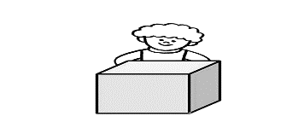
13. The boy is __________ the box.
A behind | B on | C next to | D in
14. They are eyes.
  A |   B |   C |   D

15. ___ies
A th | B gl | C fr |   D pl

16. The cat is ____ the box.
A in | B on | C next to | D under
17. It can walk and swim. It can hunt for food.
  A |   B | 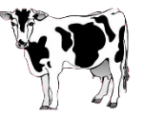  C | 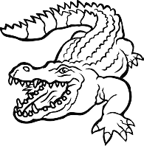  D
18. __________ long, black hair and black eyes.
A She has | B She is | C He is | 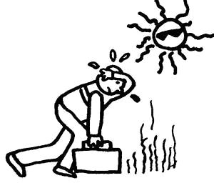  D It has
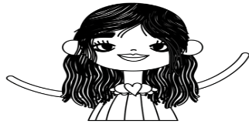

19. It's sunny and h_t in summer!
A h | B o | C g | D m
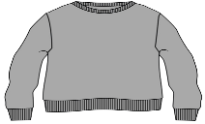
20. __ __eater
A sm | B sn | C sw | D st


PUT T FOR TRUE AND F FOR FALSE FOR EACH OF THE FOLLOWING STATEMENTS:
  21. He is a cook. |   T |   F
    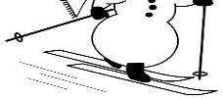  22. Kangaroos can jump but they can't dive. |   T |   F
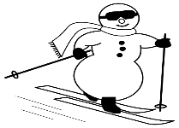  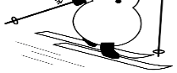  23. It's snowy. | T |   F
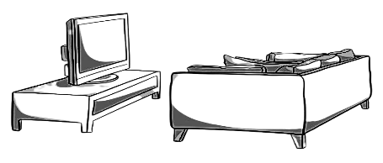  24. There is a sofa on the TV. | T | F
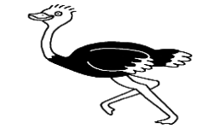  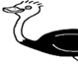  25.Ostriches can swim but they can't run. |   T |   F
  26. They're feet. |   T |   F
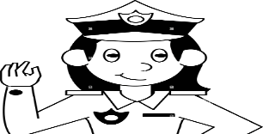  27. Sunday and Monday are school days in my country. | T |   F
  28.She works in a hospital. |   T |   F
  29.They're children. |   T | F
  30. I get up at 6 o'clock.  بحمد الله |   T | F

