المملكة العربية السعودية  وزارة التعليم  إدارة تعليم  مدرسة ابتدائية |  | المادة : لغة انجليزية  الصف : ________ الابتدائي  الزمن : ساعة و نص
اختبار النهائي الفصل الدراسي الثالث – ) الدور الأول ( – للعام الدراسي 1444هـ

س | المهارة | الدرجة | بالارقام | الدرجة بالاحرف | المصححه |  | المراجعه | المدققة
1 |  | 6
2 |  | 4
3 |  | 6
4 |  | 4
5 |  | 5
6 |  | 5
المجموع |  | 30
اسم الطالبة |  | ------------------------ |  |  | الفصل |  | رقم الجلوس

Q1. General Questions:
6
Match
1-Where's Ali? ( ) They are 3 .
2-How many candies are there? ( ) it's a wallet.
3-What's this? ( ) She‘s a teacher.
4-Can I use your eraser ? ( ) he is in the kitchen .
5-Can ostriches fly? ( ) Here you go .
6- What does she do? ( ) Yes, they can.

Q2. Reading:
4


Match

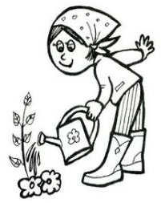
- The cat is under the cotton thread.

- Its jaws are huge.
- She has long black hair .

- He is a farmer.

Q3. Vocabulary:
6
A-Match the numbers with the pictures:
6-  cloudy | 5-  MP3player | 4-  rainy | 3-  a wallet | 2-  kitchen | 1-  livingroom


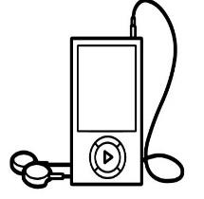

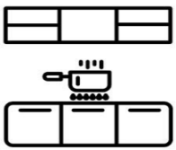




B-Circle the correct word :
park | doctor | pilot | tub | pencil | Glue
cgym | astronaut | teacher | bed | pen | paper





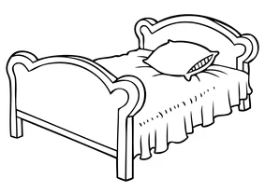


_____is Hashim? He is in the bedroom.

Q4. Orthography A-Complete the missing letter:
4
(ee _ea _ sp _ sw _ pr _ oo_ ou _ fr )




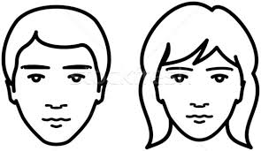


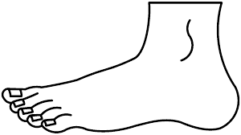
_ _an | _ _ies | _ _esent | _ _ider
 |  | 
f_ _t | h_ _se | sl_ _p | h_ _ d

B-Choose the right spelling
b__ g |  |  |     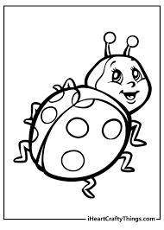  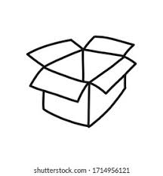 | _ _ile
a | u | o |  | sl | sm | sn
b__ x |  |  |  | _ _ ail.
a | u | o |  | sl | sm | sn
C-Unscramble the letters and write
b u p c d a o r | 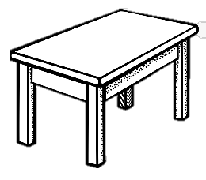  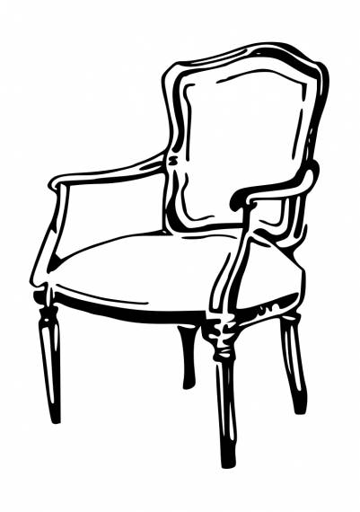  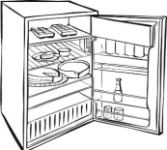  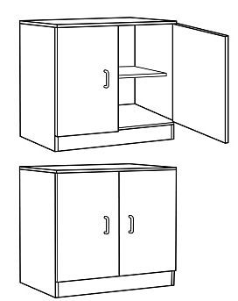 | e a l b t
d i r e g f |  | r a i c h

Fill in the missing letter:
.

_____is Hashim? He is in the bedroom.

Q5. Writing :
5
Do as shown between brackets:
A.(rearrange)
1- In the bathroom / He / is. ………………………………………………………….
2-he/ a firefighter / Is /? ……………………………………………………

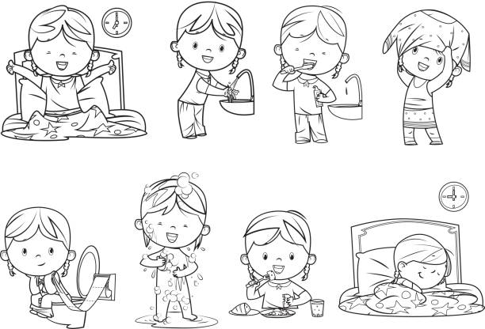
C-(Complete)> ( get- eat - those - these )
1- I _______ lunch.
- I _______up early.


- What are _______ ?

5

Q6. Grammar:
- (She – They- I) is in the kitchen.
- She ( work – works– working) in a school.
- They ( go – goes – going) to school in the morning.
- I go to school ( in – on – at ) morning.
- (Which - Where - What) is Hashim ? He is in the bedroom.

Good Luck

