
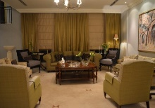
Unit 3
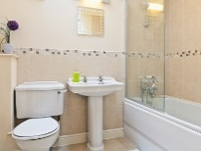

غرفة النوم bedroom الحمام bathroom غرفة المعيشة living room

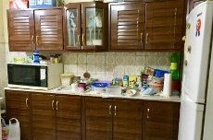
غرفة الطعامdining room المطبخ kitchen الحديقة/الساحة yard
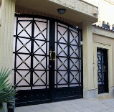
الباب الأمامي front door الباب الخلفي back door
ما الفرق بين .....؟
منزلhouse home بيت/وطن
مرحباً بك في منزلي. Welcome to my house.
هل تريد أن تدخل؟ Would you like to come in?
نعم من فضلك Yes, please.
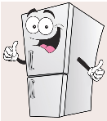
في in على on تحت under بجوار next to خلف behind
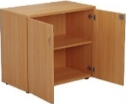
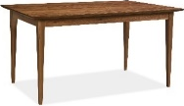
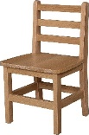
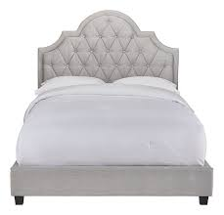

سرير bed كرسي chair طاولة table ثلاجة fridge دولاب cupboard
أين Where is …? هو He is هي She is
* Where is Ali? He is in the bathroom.
* Where is Nora? She is in the kitchen.
Frog prize
Fr fries Pr present
house cloud
mouse ou mountain
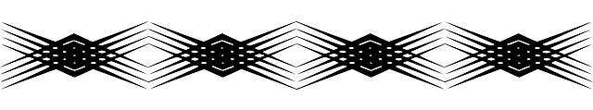

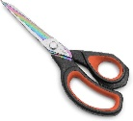
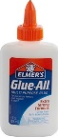
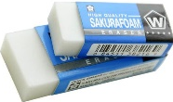

Unit 4 الوحدة الرابعة
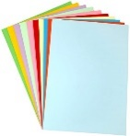
حلوىcandyصمغ glue ورق paper مساحة erasers مقص scissors
0 zero 10 ten 20 twenty 30 thirty
40 forty 50 fifty 60 sixty 70 seventy 80 eighty 90 ninety 100 hundred 1000 thousand 1000000 million
ممكن أخذ ....؟ Can I have some…candy...?
بالتأكيد. تفضل. Sure. Here you go.
شكراً Thanks.
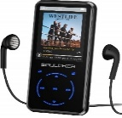
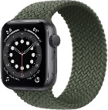
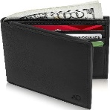
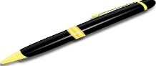
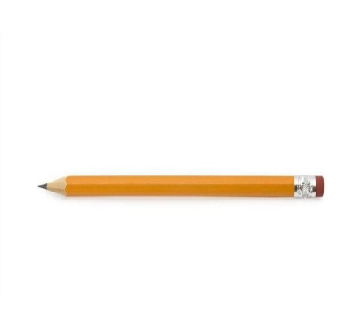
قلم pen مرسمة pencil محفظة wallet ساعة watch مشغل موسيقى mp3 player كتاب book
كم عدد...؟ How many are there? Can I use your pen?
هيا نعدهم. Let's count them. Here you go.
هذا كثير. That's a lot.
small snack
sn
sm
smile snail
sport sweater
sw
sp
spider swing
spring swan

قاعدة الجمع Plural
مفرد singular جمع plural (s)
- book > books - pen > - wallet > - car >
مفرد جمع (es) o x s ch sh
- potato > potatoes - fox > - bus > - watch > - dish >
مفرد جمع (ies) ساكنy
- cherry > cherries - city
مفرد جمع (ves) f
- wolf > wolves - shelf
الشواذ Irregular
رجل man > men رجال امرأة woman > women سن tooth > teeth أسنان قدم foot > feetأقدام
فأر mouse > mice فئران طفل child > children اطفال

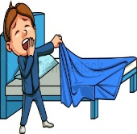
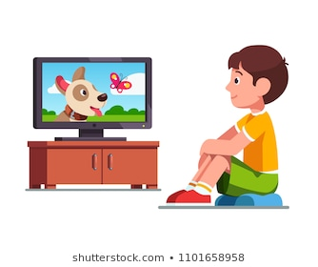

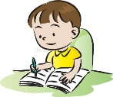


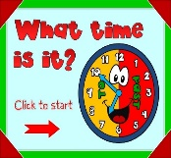
Unit 5

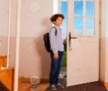

What time...? – get up – go to school – come home – eat lunch – do homework – play with friends –watch TV –go to bed











doctor teacher cook farmer pilot businessman firefighter architect astronaut technician

الأيام Days (Sunday – Monday – Tuesday – Wednesday – Thursday – Friday – Saturday)
الشهور Months (January – February – March – April – May – June – July – August – September – October – November – December)
الفصول Seasons (spring – summer – winter – fall = autumn)
أوقات اليوم Time (morning – afternoon – evening – night)
الساعات Clock (1 o'clock – 2 o'clock – 3 o'clock – 4 o'clock..
الأرقام NO. (one – two – three – four – five – six – seven – eight – nine – ten – eleven – twelve)
الوجبات Meals (breakfast – lunch – dinner – supper)
الطقس weather (sunny – windy – rainy – snowy – cloudy)
الاستفهام Question Words: (What – Where – How – What time…)
حروف العلة Vowels: (a e i o u)
الضمائر Pronouns: I am , He is , She is , It is , We are , You are , They are.

الإشارة
المفرد
هذا (قريب) This is a book. مفرد هذا (بعيد) That is a book. مفرد
الجمع
هؤلاء (قريب) These are books. sجمع هؤلاء (بعيد) Those are books. sجمع
Yes/No Questions السؤال الذي اجابته نعم/لا
أي سؤال يبدأ بـ Do you…? لابد أن تكون اجابته Yes, I do. أو No, I don't.
Do you get up at 5:00? Yes, I do.
No, I don't.
لاحظ فكرة المقص في السؤال والجواب بـ هل

Can they >> they can Can we >> we can
Do they >> they do Do we >> we do
Does he >> he does Does she >> she does
Is he >> he is Is she >> she is
Are they >> they are Are we >> we are


Third Term

WE CAN 4

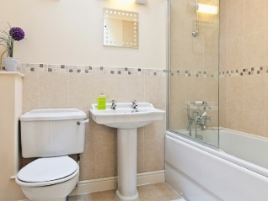
Write:(bedroom – bathroom – dining room – living room)
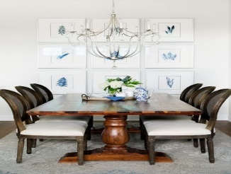
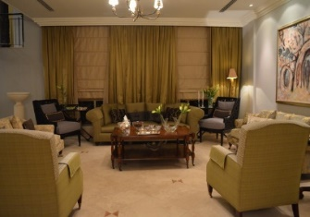
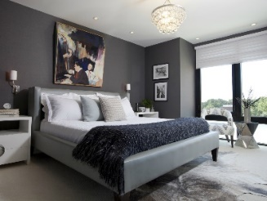

------------------- ----------------------- --------------------- ----------------------
Write:( kitchen – house – yard – front door – welcome)



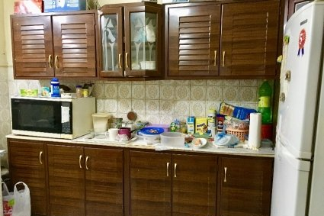
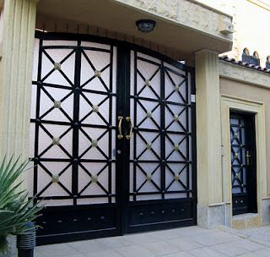

----------------- ---------------------- -------------------- --------------------- -------------------
Supply the missing parts:
Kit__hen bat__room b__droom ya__d ho__se liv__ng room fr__nt
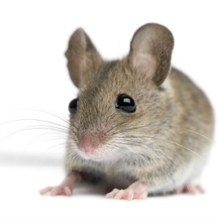
Write:( Where – mouse – chair – bed – table – fridge – cupboard)
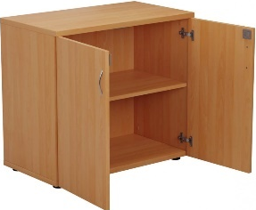
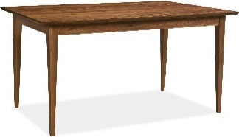
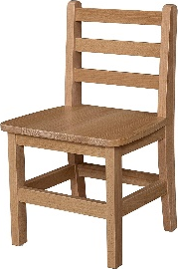


-------------- -------------------- ---------------- ------------ ------------------- -------------
Supply the missing parts:
mo__se wher__ n__xt to beh__nd und__r tab__e cha__r frid__e
Write:( prize – present – frog – fries – cloud – mountain)

-------------- ------------- ------------------ ------------ ------------- -------------
Supply the missing parts:
ho__se mou__e fr__g clo__d mounta__n
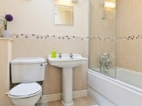
pr__ze fri__s pres__nt f__og hous__

Complete the missing parts:
1) Where is Ali? He's in the ------------------.
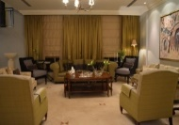
2) Where is Mona? She's in the -----------------.
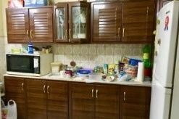
3) Where is Fahad? ---------------------------------.
4) Where is Lamia? ---------------------------------.
5) ----------------------? He's in the yard.
Write:( under – on – in – behind – next to )

-------------- -------------- -------------- ------------------- --------------
Where is the mouse?

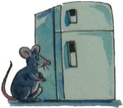
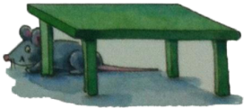
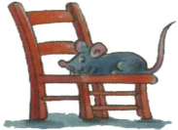
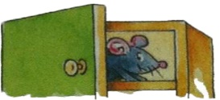
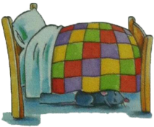

----------------- -------------------- -------------------- ---------------- ------------------

Write:(candy – How many – ready – count – Here you go)
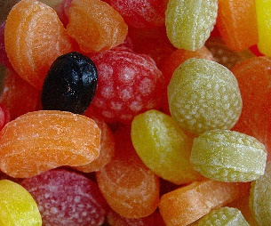
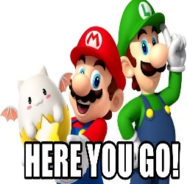
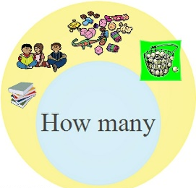
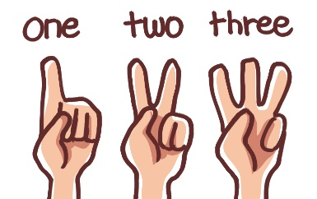

---------------- ---------------- -------------- -------------- -------------
Supply the missing letters:
H__w ma__y som__ can__y cou__t Gre__t hav__ re__dy
Complete the following:
1) Can I have some -----------------? 1- How many ------- there?
2) Can I have -------------- books? 2. -------- many are there?
3) Can I --------------- some pens? 3. How many are ----------?
4) ----------- I have some cats? 4. How --------- are there?
5) Can I have some -----------------? 5. How many are there ----
6) Here --------- go. 6. Let's ------------- them.
7) Here you -----------. 7. Let's count -------------.
8) --------- you go. 8. --------- count them.
9) Are you -----------? 9. That's a ---------.
10) -------- you ready? 10. ---------- is a lot.
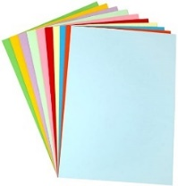
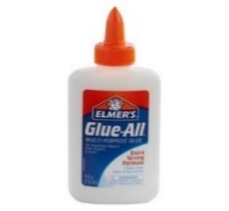
Write:(pens – glue – erasers – scissors – paper – candy)
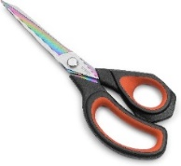
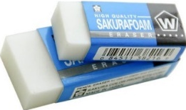

------------ ------------- ------------ -------------- ----------------- ----------------
Supply the missing letters:
p__n erase__ ca__dy sciss__rs gl__e penc__l us__
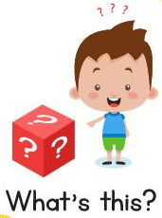
Write:( wallet – watch – MP3 player – cell phone – book – What's this?)
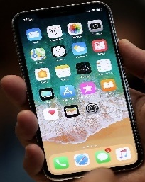

----------------- --------------- -------------- -------------- --------------- ----------------
Supply the missing letter:
b__ok phon__ wat__h wa__let c__ll com__c pla__er
Wh__t wall__t pl__yer w__tch boo__ th__s ph__ne cel_
Write:( sweater – sport – spider – swan – spring – swing)

----------------- --------------- ---------------- -------------- --------------- -----------
Supply the missing letter:
sw__ater sp__rt spid__r s__an s__ring sw__ng Fun__y d__y f__t ca__ s__t m__t h__n pe__ f__x bo__ b__g ru__
Write the correct number:
seventy = ------ fifty = ------ ten = -------- eighty = ------ forty = --------- hundred = ------ninety = ------ twenty = ----- thirty = ------- sixty = --------- thousand = ------- zero = --
Write the correct number under the correct picture:
1.get up 2.eat lunch 3.watch TV 4.go to bed 5.come home

6.go to school 7.play with friends 8.do homework
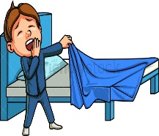

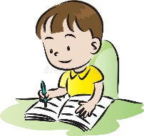

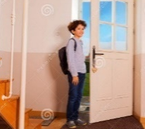


( ) ( ) ( ) ( ) ( ) ( ) ( ) ( )
Match the Questions with their answers:
1) What time do you get up? a. I go to bed at 10:00.
2) What time do you eat lunch? b. I watch TV at 9:00.
3) What time do you go to bed? c. I get up at 6:00.
4) What time do you come home? d. I play with friends at 4:00.
5) What time do you do homework? e. I eat lunch at 2:00.
6) What time do you play with friends? f. I come home at 12:00.
7) What time do you go to school? g. I go to school at 7:00.
8) What time do you watch TV? h. I do my homework at 6:00.
Write ( a ) or ( an ):
___ dog __ orange __ cat __ ant
__ eye __ ball __ elephant __ book
__ egg __ tomato __ cake __ mouse
Make plural:

1. I have two -------------------------. (box)
2. I have three -------------------------. (apple)

3. Ann ha pretty -------------------------. (dress)

4. Travis has four -------------------------. (watch)
5. He has six -------------------------. (cat)

Write: What's this?
(It's a pen – It's a pencil – It's a book – It's a bag – It's a desk – It's an eraser)

-------------- ---------------- -------------- ---------------- ------------- ---------------
(It's a cake – It's a bus – It' an apple – They're cars – They're birds – They're lions)
What is this? -------------------- What is this? ----------------
What is that? ------------------ What are these? ----------------
What are those? ---------------- What are those? -----------------
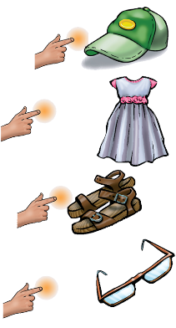
Fill in with: (This – That - These - Those):
1-……………… is a cap. 2-……………… is a dress. 3-………………… are sandals. 4-……………… are glasses.
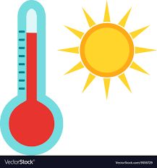
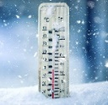
What can you see?
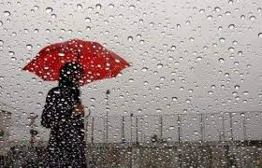

1. (hot – cold – weather) 2. (hot – cold – weather)


3. (sunny – rainy – windy) 4. (sunny – rainy – windy)
5. (sunny – rainy – windy) 6. (cloudy – snowy – weather)

Write the missing letter: rai__y wi__dy sn__wy su__ny clo__dy
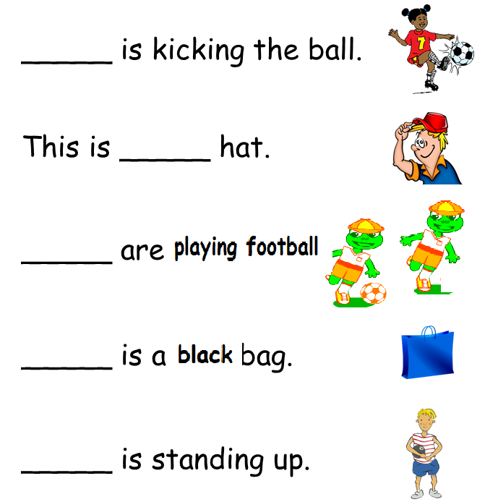
Choose the right pronoun: (He – She – It – They)

1- ------- is kicking the ball.
2- ------- is a hat.
3- ------- are playing football.
4- ------- is a blue bag.
5- ------- is standing up.
Write the correct job:







--------- ------- --------- -------- -------- --------
Job | Place |  | Job | Place
doctor | ------------------ |  | ----------------- | school
teacher | ------------------ |  | ----------------- | restaurant
businessman | ------------------ |  | ----------------- | hospital
Cook | ------------------ |  | ----------------- | airport
pilot | ------------------ |  | ----------------- | office

Fill in under the suitable picture: ضع الكلمة تحت الصورة المناسبة
bread | sleepy | read | summer | winter | autumn
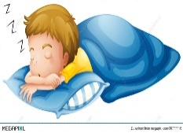
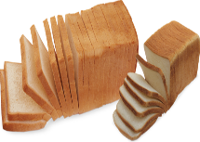
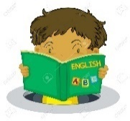
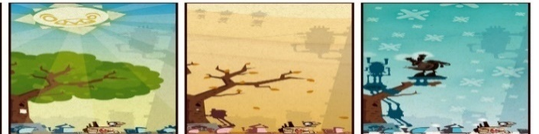


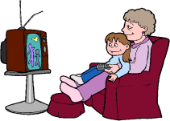
Answer the following: 1- What time do you get up? …………………………………………………………………
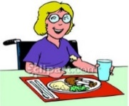
2- Do you watch TV in the evening? …………………………………………………………………
3- Where do you eat lunch? ……………………………………………………………
4- What does your dad do? …………………………………………………………………

