Unit 4
Real Talk

Something very pleasant and enjoyable | A real treatشيء سار
To answer "Yes" in a strong way | Of courseبالطبع
explanation of what one has said | I meanأعني
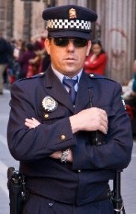
After Reading
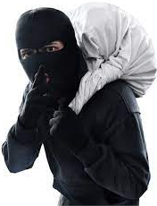
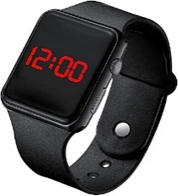
Meaning | Word | No
being poor | povertyالفقر | 1
depend on | rely onيعتمد على | 2
money you borrow | loanقرض | 3
create | establishينشأ / يقيم | 4
lack of jobs | unemploymentالبطالة | 5
make less | reduceيقلل | 6

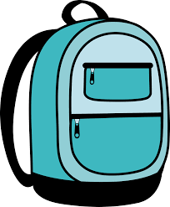
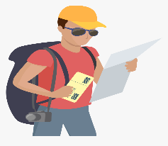
Watch thief police officer
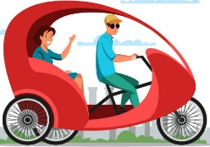

Grammar

tourist in a hurry pedal cab backpack
Relative pronouns

Examples | Relative pronoun
Ali who plays football, is my friend. | عاقلwho
The car which I bought, is black. | غير عاقلwhich
 | غيرعاقل عاقل /that

ضمائر الوصل والربط الذي/التي

The man who was talking to the tourists was friendly.
The horse which pulled the carriage was black.
Past Simple & Progressive
Past Progressive
Simple Past

* يعبر عن: حدث استمر لفترة في الماضي * يعبر عن: حدث تم وتنتهى في الماضي
* يتكون من: was, were + ing * يتكون من: التصريف الثاني للفعل (ed)
We played football last Friday. We were watching TV.
I went to school yesterday. He was reading English.
*علاماته: When, While, As *علاماته: yesterday, last, ago, in the past
* النفي نستخدم not * النفي نستخدم: مصدر didn't +
* السؤال مقص * السؤال نستخدم: مصدر Did +
* They played football yesterday. * They were helping mom.
They didn't play f yesterday. They weren't helping mom.
Did they play f yesterday? Were they helping mom?
Yes, they did. No, they didn't. Yes, they were. No, they weren't.
When / While

قاعدة: عندماWhen
When + ماضي بسيط , ماضي مستمر ماضي مستمر when ماضي بسيط
When he arrived home, I was watching TV. I was watching TV when he arrived home.
قاعدة أثناء / بينما While
حدث قطع الحدث المستمر
While + ماضي مستمر , ماضي بسيط
ماضي بسيطwhile ماضي مستمر
While I was studying English, he arrived home.
He arrived home while I was studying English.
استمر الحدثان سوياً ولم يقطع أحدهما الآخر
While + ماضي مستمر , ماضي مستمر
ماضي مستمرwhile ماضي مستمر
While I was studying English, she was cooking lunch.
She was cooking lunch while I was studying English.

ماضي مستمر Past progressive + when + Past simple ماضي بسيط
مستمر past progressive + while + past progressive مستمر

Past simple  [ took – walked] | when
Past progressive  [was/were + V- ing] | while

NOTEلاحظ :
I was looking in the store window when the thief grabbed my bag.
He was driving while he was talking on his cell phone.
do the dishes
feed the fish
can't stand listening
use my toothpaste
Real Talk

Finally | At long lastأخيراً
This has gone too far | That's a bit too muchهذا كثير

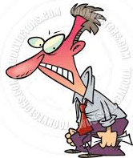
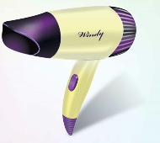
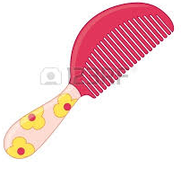
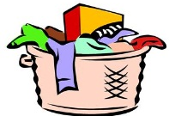

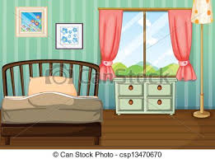



bedroom two sisters dirty clothes hair brush hair dryer annoy scissors
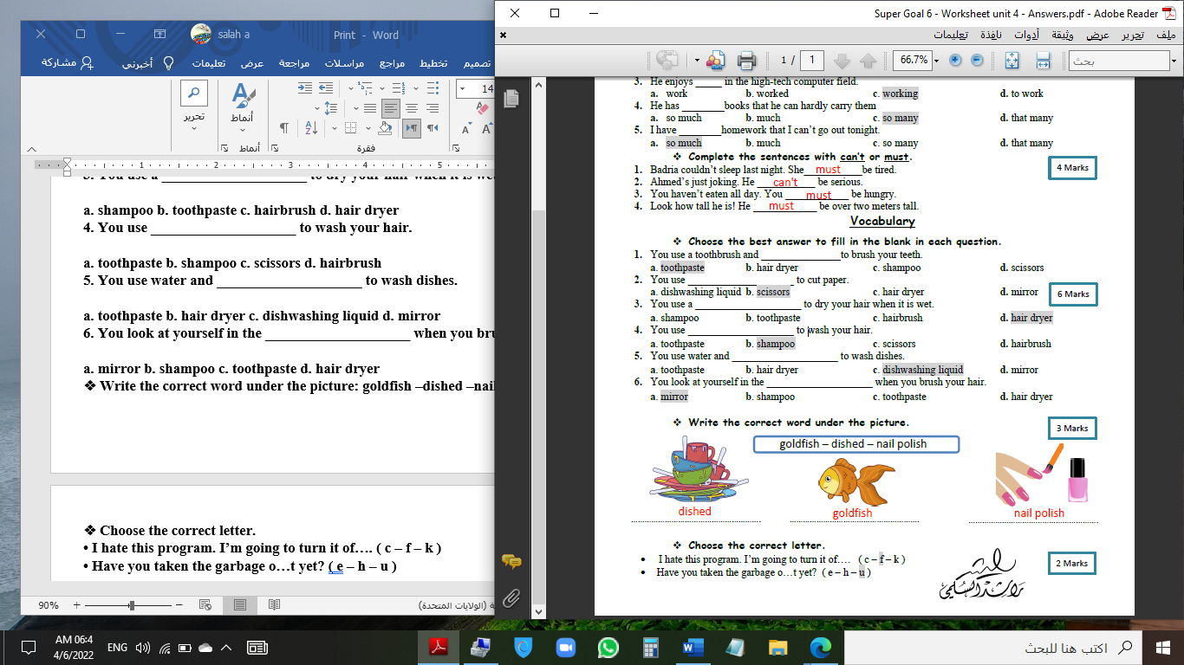

golden fish exercise nail polish dishwashing dishes mirror iron funny

just = a short time ago
not yet = something expected hasn’t happened but we expect it will
yet = in questions, this asks whether something expected has happened.
already = something happened before we expected it to
Grammar

Present perfect

مفرد has='s
+ P.P التصريف الثالث
جمع have='ve
He has played football.
Has he played football? Yes, he has.
No, he hasn't.
They have watched TV.
Have they watched TV? Yes, they have.
No, they haven't.
بالفعل
have / has already P.P
just
حالا / تواً
I have already played football. She has just cooked lunch.
نفي / سؤال yet.
He hasn't watched TV yet. Have you played football yet?
Verb + Gerund
stop – finish – enjoy – avoid – miss – mind – keep – hate imagine – suggest – give up – can't stand – can't resist
+ ing

We stop eating sweets. She enjoys watching TV.
Object pronouns always come between the verb and the particle
Turn on the TV. = Turn the TV on. = Turn it on.
Rewrite the following in a different way:
Turn on the TV. Turn the TV on. Turn it on.
Professional
Tennis player
Real Talk

undecided | up in the airغير مقرر
decide | make up your mindيقرر
a way to introduce an opinion | It seems to meيبدو لي أنه ..

Cool Clothes

Meaning | Word | No
work to succeed | studyيدرس | 1
be similar to | fit inيتلاءم مع | 2
fine | ticketغرامة / مخالفة | 3
advantage | benefitفائدة | 4
with beautiful views | scenicمناظر | 5

Quick Check

After Reading
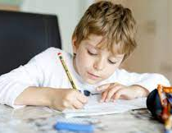
Meaning | Word | No
didn't have enough money | could not afford لا يقدر على شراء | 1
reach an agreement | work out a pactيصل لاتفاق | 2
Do what he wants to do | fulfill his ambitionيحقق طموحه | 3

study

environment
scenic route
speed
Gold bracelet

pollution airshow mine scenic bracelets

Grammar
If [ Conditional Sentences]

Main Clause | IF – Clause | TYPE
Simple Present مضارع | Simple Present مضارع | 0 Present Facts
Future: will+مصدر | Simple Present مضارع | 1st Future Facts
would+مصدر | Past Simple ماضي | 2nd Imaginary

IF - CLAUSE
MAIN CLAUSE
If + S + V + ……. , S + V + ……

Present Facts

Present Facts
Examples:
1. If you heat water, it turns into steam. 2. If you don’t eat long time, you die.
3. If metal gets wet, it rusts. 4. If we put sugar in water, it dissolves.

Examples: Future Facts
1. If you play well, you will win. 2. If you help me, I will thank you.
3. If the sun shines, we will go to the beach. 4. If I feel better, I will go out tonight.
5. If I don’t feel better, I will stay at home. 6. If he comes late, I won't let him in.

Real Talk
to be honest لأكون صادقاً معك = used to state something more directly
to get the hang ofيعتاد على = to get used to doing something the right way
kind of الى حد ما= rather
No kidding! لا تمزح= an expression of surprise and disbelief
After Reading

Meaning | Word | No
able to change | flexibleمرن | 1
annoying because you cannot do it. | frustratingمحبط | 2
missing home and family | homesickالحنين للوطن | 3
Level / stage | stageمرحلة / مستوى | 4
person who has arrived recently | newcomerوافد جديد | 5
new and interesting | noveltyحداثة / جديد | 6
beliefs | valuesقيم | 7
  remember a pleasant feeling. | cherishيتذكر | 8

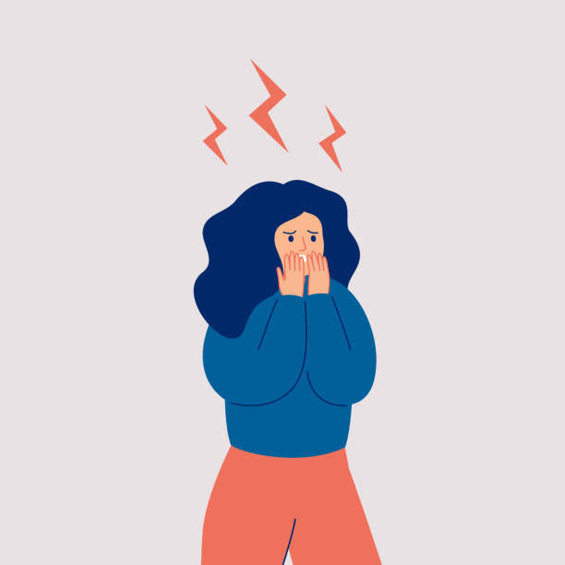
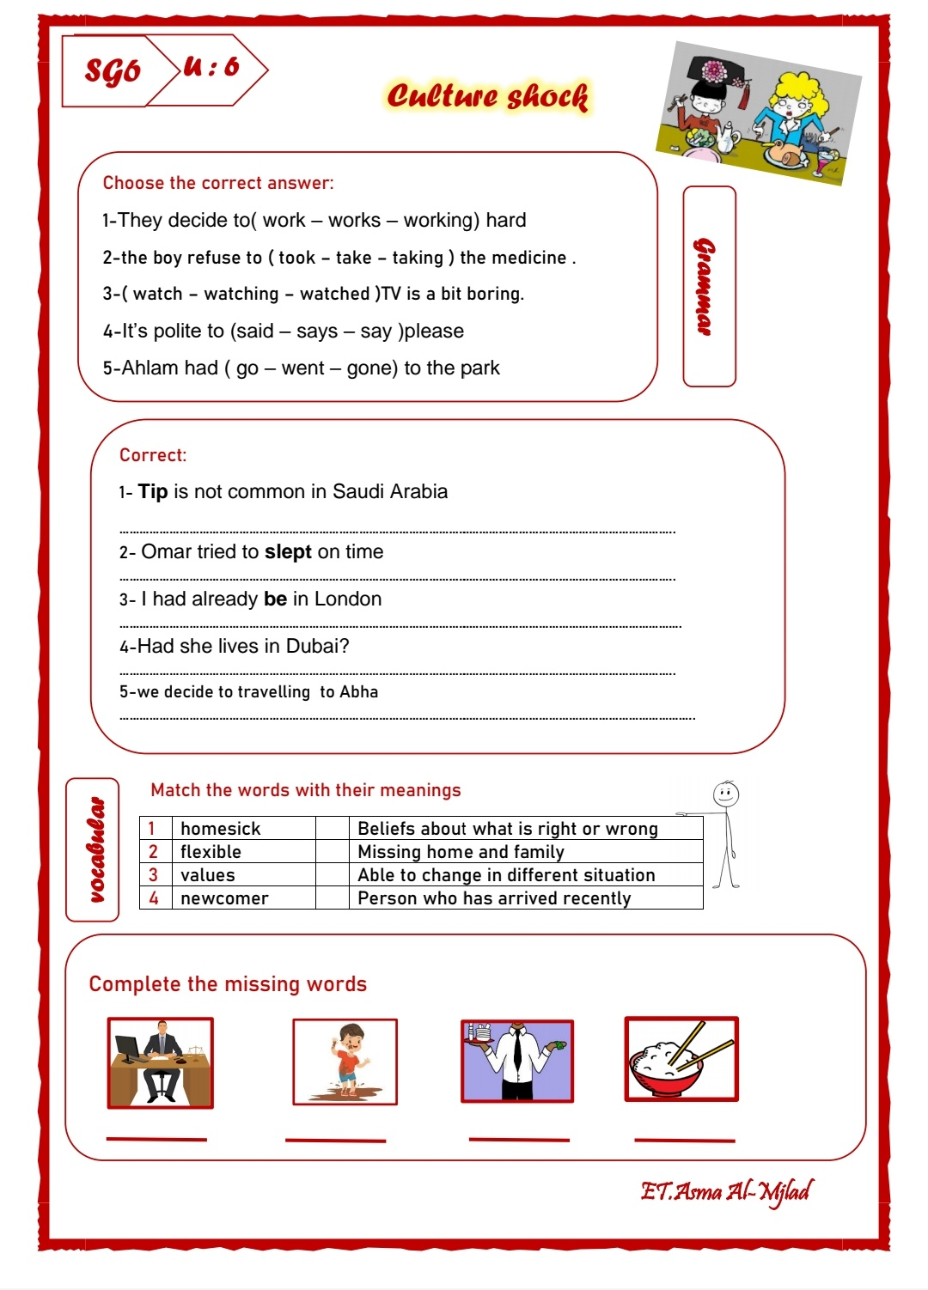

Lawyer mud waiter chopsticks porter shock

Weather in London - Late dinner - exchange cards - eat with chopsticks - remove shoes - tip driver
Grammar

to + inf المصدر
try to
remember to
expect to
manage to
refuse to
allow to
1. I expect to (plays – play – playing) football.
2. They managed to (go – goes – going) out tonight.
3. He refused (too – two – to) run in the park.
4. They tried to (come – comes – coming) home on time.
5. We remember ------------ help Khaled.

1. (Been – Be – Bees) sure to come.
Be sure to
Make sure to
Don't forget to
Try to
Remember to
2. Be (surly – sorry – sure) to eat.
3. Be sure (toe – two – to) make here.
4. Be Sure to (helps – helping – help) Khaled.
5. Make sure to (study – studied – studying).
6. Try to (work – works – worked) hard.
7. Be sure --------- eat fish.
8. --------- sure to sleep early.
It's a good idea to
It's polite to
It's rude to
It's wrong to
It's common to
It's advisable to

1. (It's – He's – She's) polite to help others.
2. It's rude (to – toe – too) raise your voice.
3. It's wrong to (cheat – cheats – cheating) in exams.
4. It's Common ----------- study hard before exams.
5. It's advisable to ------------ football.

1. (Eat – Eats – Eating) fish is good for you.
الفاعل في أول الجملة
ing

2. (Swim – Swimming – Swims) is fun.
3. (Help) Mom is good.
eat > eating
go > going
read > reading
work > working

4. (Play) tennis is difficult.
5. -------------------- TV is fun.

المراجعة النهائية Final Revision
Choose
1. A quiz show host is a person (who – which – why) asks questions.
2. A crime drama is a show (who – which – why) many people like.
3. A microphone is something (who – which – why) we use to talk.
4. A daytime series is a program (who – which – why) aired during the day.
5. A TV documentary is a program (who – which – why) is considered true.
6. A forensic scientist is a person (who – which – why) is someone who solves crimes.
7. A poem is something (who – which – why) we recite.
8. A remote control is something (who – which – why) we use for TV.
9. The Mango Festival in Jizan is an event (who – which – why) occurs every year.
10. August is the month (who – which – why) we wear light clothes.
11. The waiter (who – which – where) is serving the customers is friendly.
12. My uncle works in a factory (who – which – when) makes cars.
Choose the correct answer:
1. While it [ is – was – were] raining, I was [ walk - walked - walking].
2. We were sitting in the café when a thief (stole – was stealing – stealing) my bag!
3. Jack was talking on the phone (when – while – what) he was driving.
4. When I (started – was starting – were starting) the exercise, I looked at the pictures.
5. While I (was doing – were doing – did) the exercise, Ali was watching TV.
6. She was cleaning the dishes when her father (coming – came – was coming) home.
7. I was cooking pizza when Sara [ break – broke – broken] the egg.
8. We were sitting in the café when a thief (grabs – grabbed – grabbing) my bag!
9. Jack saw the old man while he (drove – driving – was driving.)
10. She was cooking dinner (when – while – which) I arrived.
11. I (looked – was looking – looks) at the monument when someone called my name.
12. I finished reading the book (while – when – what) I was riding the bus.
13. He (eating – was eating – eat) lunch when we visited him.
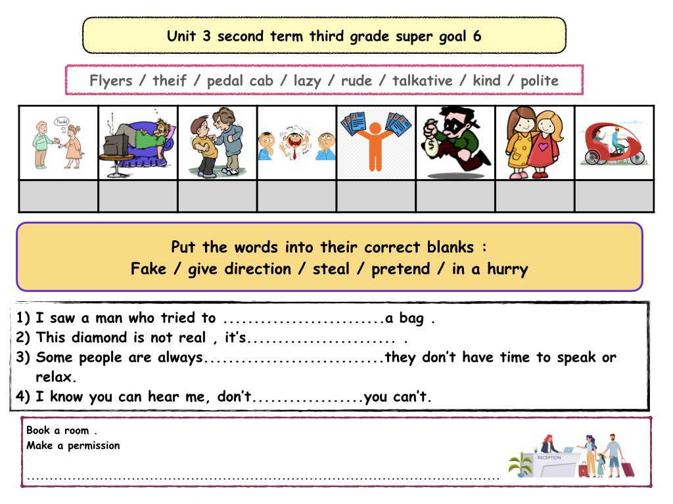
Flyers – thief – pedal cab – lazy – rude – talkative – kind – polite

-------- ------------- ------------ ------------ --------------- -------------- ------------ -------------
Choose the correct answer:
1. You have (yet – no – already) done the dishes.
2. You haven't done the dishes (never – just – yet).
3. Amal has (already – yet – no) washed the clothes.
4. Amal (have – has – hasn't) washed the clothes yet.
5. The boys (have – hasn't – haven't) done their homework yet.
6. Ali hasn't come home (already – yet – just).
1. We miss (be – been – being) with our friends.
2. I don't enjoy (sit – sitting – sits) in the sun.
3. My sister has to stop (use) my toothpaste. (Correct)
4. live/ Our grandparents/ enjoy/ in the country.(Rearrange
Match the two-word verbs with meanings.
a. ___ call up 1. learn
b. ___ find out 2. return
c. ___ clean up 3. phone
d. ___ give back 4. make things
❖ Write the correct word: goldfish – dishes – nail polish – thief – watch – hair dryer

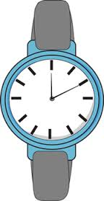


------------------ -------------------- --------------------- ---------------- ------------------ -----------------
Match the following:
1. At long last! a. This has gone too far.
2. That’s a bit too much. b. Finally!
3. call up c. return
4. clean up d. make things net
5. give back e. phone
Rearrange
1. The workers / painting / the house / finished 2. eating / mom’s food / We / miss
3. turn / the TV / Please / off 4. dishes / Have / done / the / you / yet?
5. have / We / cleaned / already / the room. 6. used / toothpaste? / Who / my
7. Has / nephew / left / your / yet?
Supply the missing letter:
c__mplaint liq__id hairb__ush mes__ mirr__r nephe__ scissor__ sha__poo

Choose the correct answer:
1. If you sleep early, you (will – would – could) get up early.
2. If he is thinner, he will (runs – run – running) faster.
3. If they (stayed – stay – staying) up for late hours, they will be late for school.
4. If I arrive earlier, I ('ll – 'd – 'm) meet the manager.
5. If you put water in the freezer, it (turned – turns – would turn) into ice.
6. If she (heats – heated – will heat) water, it turns into vapor.
7. If you dive into this river, you [will hurt - hurt – hurting] yourself.
8. If the sun [shines – shine – shined], the children will play outside.
9. Richard will walk to school if he [ miss – missed – misses] the bus.
10. If I [ study - studies – studied], I will pass the exams.
Look at the picture, and match the parts of the sentences.
1. If she leaves the food on the ground, ___ a. he’ll be pleased.
2. If the cow crosses the road, ___ b. the boy won’t be happy.
3. If the boy doesn’t stop hitting their nest, ___ c. the ants will take it.
4. If the man catches a fish, ___ d. it’ll be good for the farmer’s crops.
5. If it rains on the farm, ___ e. the truck might hit it.
6. If the toy plane crashes, ___ f. the wasps will sting him.
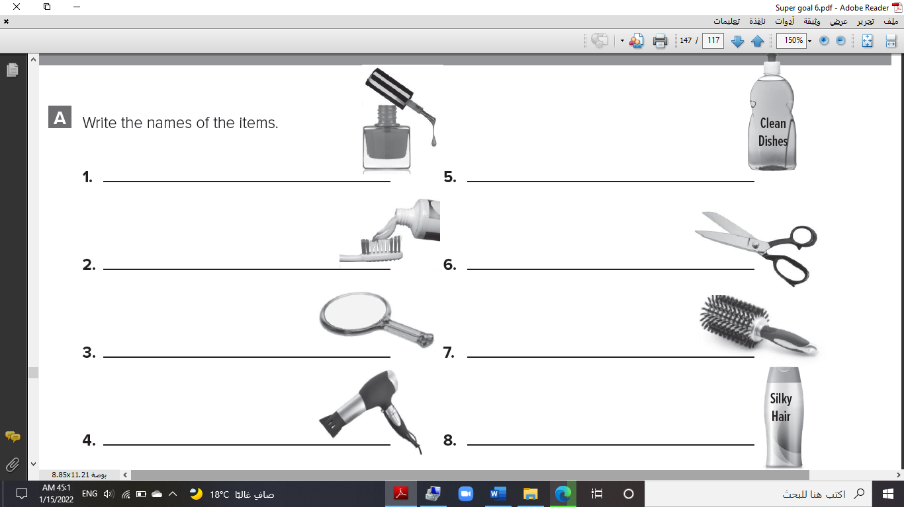
Match: nail polish – toothpaste – mirror – hairdryer – dishwashing liquid – scissors – hairbrush – shampoo

-------------- ------------- ----------- - ----------------- ---------- ------------ ------------- ------------
Match the following:
1. ____ up in the air a. decide
2. ____ make up your mind b. undecided
3. ____ It seems to me c. a way to introduce an opinion
4. ____ could not afford d. reach an agreement
5. ____ work out a pact e. do what he wants to do
6. ____ fulfill his ambition f. didn't have enough money
Rearrange
1. Tennis a lot of / traveling. / involves 2. has / his own / personal style. / He
3. will / He / visit / paces. / new 4. He / get / might / caught.
5. a graduation / Sabah / wants / gift. 6. an accident / have / Omar / might.
7. The farmers / don’t want / a lot of / traffic
Supply the missing letter:
airsh__w benef__t choi__e environ__ent farm__r grad__ation pol__ution
Choose the correct answer:
1. We didn’t expect (to – too – toe) arrive so late.
2. The airline refused to (paying – paid – pay) for our hotel.
3. (It’s polite to – To it's polite – Polite it's to) help others.
4. Don’t forget (close – closes – to close) the door.
5. (Travels – Traveled – Traveling) is a good way to learn about other cultures.
6. In Latin America, families allow children to (stay – stays – staying) up late.
Match the following:
1. ___ to be honest a. rather
2. ___ to get the hang of b. an expression of surprise and disbelief
3. ___ kind of c. used to state something more directly
4. ___ No kidding! d. to get used to doing something the right way
5. ___ newcomer e. able to change in different situations
6. ___ homesick f. missing home and family
7. ___ flexible g. person who has arrived recently
Rearrange
1. When in Rome, / as do / Do / the Romans 2. Discuss / in England. / the weather
3. Take off / in Indian homes. / your shoes 4. Carry / in Japan. / business cards / with you
5. Call / in Mexico / a university graduate / Licenciado.
Supply the missing letter:
Cult__re Sh__ck chopstic__ cu__tom grad__ate gue__t h__st surna__e

