Unit 4
Real talk
Actually بالفعل = used to introduce an opposing idea
Off the beaten track بعيداً عن المسار المعروف = not visited by many tourists
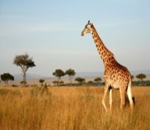
sky diving desert noisy relaxing tombs scuba diving safari
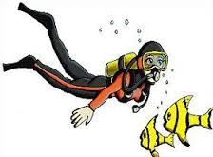
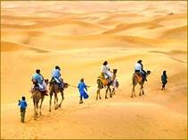
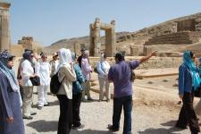
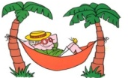
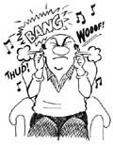
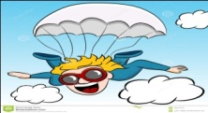

Grammar
نستخدم be going to
للتعبير عن خطط في المستقبل
plan
Future

سوف be going to + مصدر
الكلمات الدالة عليه
tomorrow, next, soon, in the future…

am='m I am = I'm
be is ='s He is = He's She is = She's It is = It's
are='re We are = We're You are = You're They are = They're

He is going to eat fish. He isn't going to eat fish.
Is he going to eat fish? Yes, he is.
No, he isn't.
They are going to sleep. They aren't going to sleep.
Are they going to sleep? Yes, they are.
No, they aren't.
I am going to help mom. I am not going to help mom.
Are you going to help mom? Yes, I am.
No, I am not.
الاستفهامQuestion
ماذا What (غير عاقل) What are you going to do tomorrow?
من Who (عاقل) Who is going to come with us?
متى When (زمان) When are you going to leave?
أين Where (مكان) Where are you going to play?
أي Which (تخيير) Which book are you going to buy?
كيف/ ما How (حال/مواصلات) How is she going to go to Abha?
Real talk
سمعتI hear = a way to introduce news
على حسبIt depends. = a way to say you are not certain

sunny rainy windy cloudy snowy
It's sunny.
I's rainy
ما حال الطقس؟ It's windy
What's the weather like? It's cloudy
It's snowy
It's cold / hot
It's warm / cool
Partly cloudy partly sunny
يأتي مع كلمتين
maybe ربما
probably محتمل
Grammar
نستخدم will
للتعبير عن شيء نعتقد أنه سيحدث في المستقبل ولكن غير متأكدين.

Future
will + مصدر
الكلمات الدالة عليه
tomorrow, next, soon, in the future…

He will eat fish. >> He won't eat fish. Yes, he will.
Will he eat fish? No, he won't.

They will sleep. >> They won't sleep. Yes, they will.
Will they sleep? No, they won't.
لاحظ نستخدم will في الاحتمال عند وجود كلمتان هما: maybe , probably

Real talk
Will you do me a favor? ممكن تعمل لي خدمة= Will you help me with something?
I have no idea.ليس لدي فكرة = I don’t know.
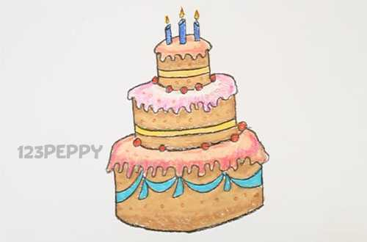
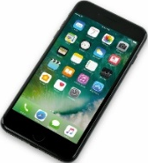
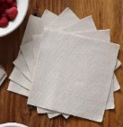

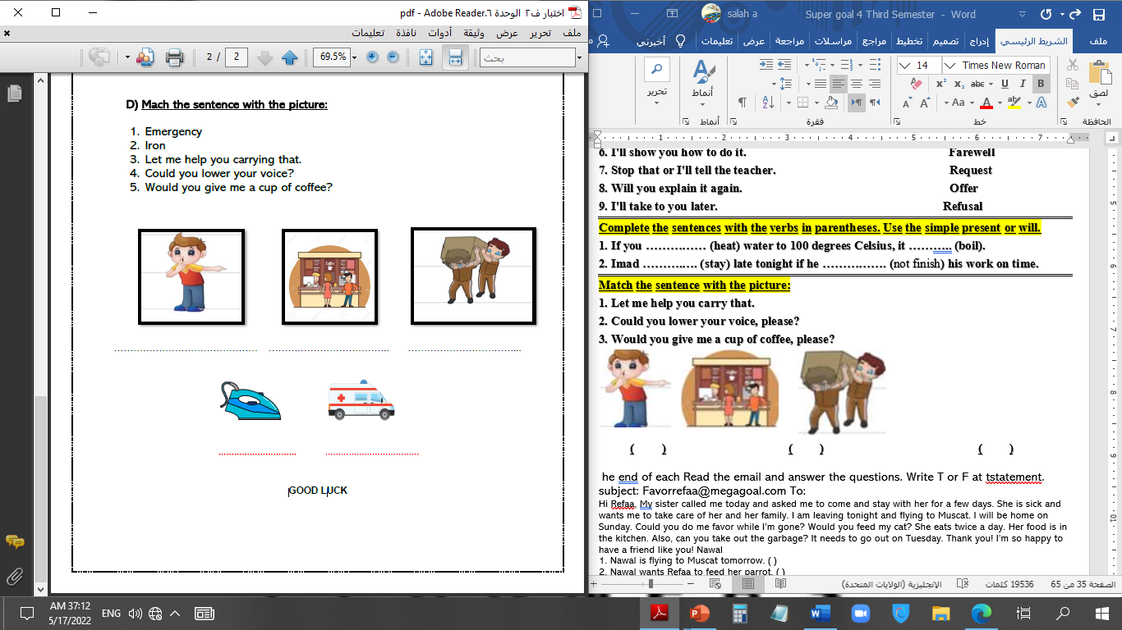


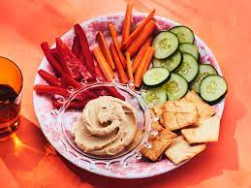

cellphone - cake - graduation - quilt - emergency – message - iron - snacks - napkin

Grammar
Request الطلب
Can / Could / Will / Would you + مصدر?
Can you help me? Sure.
Agree
موافقة
Could you open the door? Certainly.
Will you give me a hand? Of course.
Would you come with me? No problem.
Refuse
رفض
Sorry. I can't.
Not now. I'm busy.
Offer العرض
I'll / Let me + مصدر.
I'll carry that for you. الموافقة Agree: Thank you. / You're very kind.
Let me help you. الرفض Refusing: That's all right. / Don't worry. *******************************************************
want فلان to + مصدر
I want Omar to open the door. I want you to help me.
I ask Ali to come early. I tell her to study hard.
He wants Nora to make a cake. She tells Omar to open the door.

يحتفظ بهدوئه kept my cool = didn’t get stressed
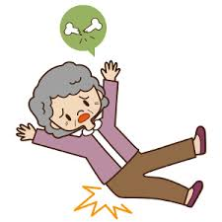
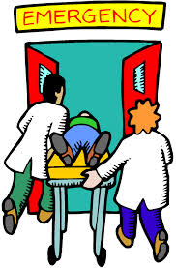
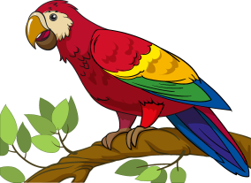

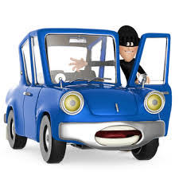
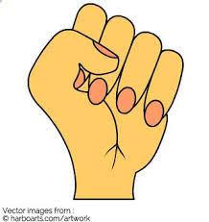

broken hip emergency carjacker fist thief parrot
Grammar

Past Progressive الماضي المستمر
+ ing
مفرد was
جمعwere
يعبر عن: حدث استمر لفترة في الماضي
نفي: not سؤال: المقص
He was reading English. Yes, he was.
He wasn't reading English. Was he reading English? No, he wasn't.

They were sleeping at night. Yes, they were.
They weren't sleeping at night. Were they sleeping at night? No, they weren't.

قاعدة: عندماWhen
When + ماضي بسيط , ماضي مستمر ماضي مستمر when ماضي بسيط
When he arrived home, I was watching TV. I was watching TV when he arrived home.

عندماWhen (past simple الحدث الثاني) , (past Progressive الحدث الأول).
When the phone rang, I was doing homework.
I was doing homework when the phone rang.
What were you doing when the phone rang?

Real talk
Definitely بالتأكيد = expressing a high degree of certainty
You’re out of your mind! أنت مجنون= You’re crazy!
to be honest لأكون صادقاً = to tell the truth
scared to deathمرعوب جداً = very frightened

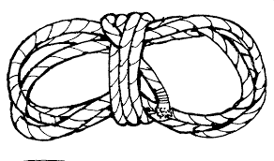
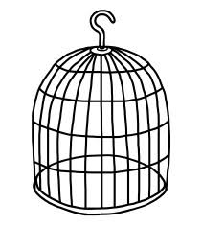
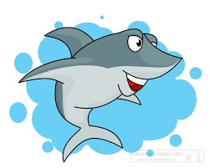
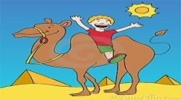
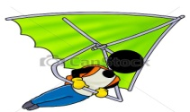
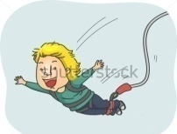


cliff hanging bungee jumping hang gliding camel riding shark cage rope

pilot durian pyramids zorse skiing snails elephant car race parachut

Grammar
المضارع التام Present Perfect

أولاً: صياغتهhave, has + Past Participle
has مع المفرد have مع الجمع
لاحظ اختصار have = 've واختصار has = 's
He has – She has – It has
كل التصريف الثالث آخره ed ماعدا الشواذ
I have – We have – They have – You have

يعبر عن: حدث انتهي منذ فترة قصيرة ولا يزال أثره موجوداً.
نفي: not سؤال: المقص
He has played football. Yes, he has.
He hasn't played football. Has he played football? No, he hasn't.

They have watched TV. Yes, they have.
They haven't watched TV. Have they watched TV? No, they haven't

المراجعة النهائية Final Revision
Choose the correct answer:
1. Jane is going to [ plays – playing – play] basketball
2. Paul [ is – are – am] going to travel to London next week
3. We are going to [travel – travels – traveling] to France next summer
4. My friends and I [is – am – are] going to study German next year
5. Are Kevin and Sheila going to [do - does – did] their homework?
6. [ What – Who – Where] is she going to buy next week?
7. Where [ is - are – am] you going to go in August?
8. Is she going to [ work – works – working] during the holidays?
Choose the correct answer:
1- Sami is going to (helps – help - helping) his father.
2- (Are – Is – Will) they going to watch TV?
3- We are going to (clean – cleaning – cleans) our classes.
4- I (is going to – am going to – are going to) sleep early.
5- Fahd is going to go to Abha (yesterday – last week – next week).
6- Mona (am not – isn't – aren't) going to cook kabsa.
Match the questions with the answers:
( ) I am eating pizza. | 1- How are they going to travel?
( ) They will stay for a week. | 2- When will they go to cinema?
( ) By bus. | 3- Who is your English teacher?
( ) He went to Jeddah. | 4- What are you eating?
( ) Mr. Ibrahim. | 5- Where did he go yesterday?
( ) tomorrow. | 6- How long are they going to stay?
Write the correct word under each picture:
[sky diving - noisy – relax – safari – scuba diving – desert – tombs]

--------- ------- ------- -------- -------- ------- ------ ---------
Do as shown between brackets:
1- She is going to meet them at 6:00 pm. [Ask Wh_ question]
2- I’m so excited! We [move] to a bigger house next month. [Correct]
3- Is mum going to do the laundry? [Answer with: Yes]
4- Hind is going to eat pizza. [Change into negative]
5- I am going to ski in winter. [Ask: Yes, No question]
6-They’re going to visit their grandparents on Saturday. [Make question]
Choose the correct answer:
1. He will (play – plays – playing) football tomorrow.
2. She ('s – 'll – 'd) help Ali next week.
3. They'll (come – comes – coming) home early.
4. He (will – is going to – are going to) probably help us.
5. Maybe, we (will – are going to – is going to) travel to London.
6. I will help my mom (yesterday – tomorrow – last week).
Do as shown between brackets:
1.The teacher will explain this exercise. [Change into negative]
2.She will scream if you show her the spider. [Ask Yes, No question]
3.Will our team win the match? [Answer with: Yes]
4. My mother will be 45 in July. [Ask Wh_ question]
5. She will go to Jeddah next week. [Ask Wh_ question]
File the space with: [winter / fall / summer / temperature / spring]
1- The trees and flowers blossom, and the weather is warm. It's …………
2- The weather is very cold and it often snows. It's …………………
3- The weather is very hot , suuny and dry. It's .....................
4- The weather is cool. It's often cloudy. It's .......................
Write the seasons under each picture:

………………….. ………………... ………………….. ….………………
Match: ( rainy – sunny – windy – cloudy – snowy – cold )

……………… ……………… ……………… ……………… ……………… ……………
Choose the correct answer:
1. Could you (helps – helped – help) me with this bag?
2. Can you (take – takes – taking) a photo for us?
3. Would you (gives – give – giving) me your ball?
4. (Let's – Lot – Let) me carry that for you.
5. I'll (wash – washed – washes) the plates for you.
6. Sorry. (I can – I will – I can't).
7. I want him to (takes – taking – take) out the garbage.
8. Ask Ali (too – to – two) bring some snacks.

Choose the correct answer:
1- Will you [marry – married – marries] me?
2- Could you possibly [shows -show - showed] me the way to the post office?
3- Could you [send – sends – sending] this email, please?
4- Would you (like – liked – likes) a drink?
5- Could you [open – opens – opened] the window, please? It's hot in here.
6- Please, tell him not [smoke – to smoke – smokes].
7- My collage asked me [to send – sends – sending] a fax to the customer.
8- I don’t want [ him – he – his] to go.
9- You want [they – their – them] to try it before they buy it.
10- She wants me [to go – goes – went] to London.

Write the word under the picture: cake – graduation – cell phone – quilt

------------------ ------------------- ----------------------- -------------------
Do as shown between brackets:
1- I'll do the photocopying, if you like." [Refuse the offer]
2- Could you please take me to the airport? [Accept]
3- Make a cake. [Make a request]
4- There are a lot of plates in the kitchen sink. [Make an offer]
5- We don’t know where the library is. [Use "would" to write a request]
6- A friend needs to cook a steak, but doesn’t know how. [Write an offer}
Choose the correct answer:
1. She was [play – plays – playing] hockey.
2. They [was – were – is] swimming in the pool.
3. It was [ raining – rain – rains].
4. The cat was [sleep – sleeping – sleeps] in the basket.
5. [Was – were – are] Aisha working on the computer?
6. Were they [repairing – repairs – repair] the bike?
7. I [not – was not – were not] whispering.
8. The kids were playing in the garden when it [began – was begin – begins] to rain.
9. I [were practicing – was practicing – practicing] the guitar when he came home.
10. (Was – Is – Were) they cooking when he arrived home?

Choose the correct answer:
1. Hans (were walking – was walking – walks) to college when he saw Samir.
2. The family (was eating – ate – is eating) lunch when a visitor arrived at the house.
3. The people (are sleeping – was sleeping – were sleeping) when the earthquake happened
4. Fatima was going home (why – what – when) she saw her friend, Nawal.
5. Majid was looking at the trees when he (sees – saw – seeing) a parrot.
6. The students (were waiting – waited) for the bus when the rain (was starting – started).
7. When he came home, I --------------------------------------------------.
Choose the correct answer:
1. She was [play – plays – playing] hockey.
2. They [was – were – is] swimming in the pool.
3. It was [raining – rain – rains].
4.The cat was [sleep – sleeping – sleeps] in the basket.
5. [Was – were – are] Aisha working on the computer?
6. Were they [repairing – repairs – repair] the bike?
7. I [not - was not – were not] whispering.
8. The kids were playing when it [began – was begin - begins] to rain.
9. I [were practicing - was practicing – practicing] when he came home.
Choose the correct answer:
1.We have [ living – lives – lived] in this city for fifteen years.
2. She [ has not – not has – is not] yet returned from school.
3. Jane has just [ goes – gone – going] out.
4. James (is – have – has) already arrived in London.
5. She [work – have worked – has worked] with me since 2008.
6. I haven’t [sees – seen – seeing] him for two weeks.

Do as shown between brackets:
1- She has [play] tennis. [Correct the verb]
2- She has brushed her teeth yet. [Change into negative]
3- Have you cleaned the bathroom? [Answer with: Yes]
4- The students have booked a flight to Vienna. [Make yes, no question]
5- The cat has just caught a mouse. [Change into negative]
6- Have Jack and Brain drawn this picture? (Answer with: No)
7- The teacher has (lose) the keys so he can't open the door. (Correct)
8- I have just fed the rabbits. (Make Yes/ No question)
Supply the missing letter:
c__ge cam__l dese__t safa__i rop__ vol__ano zeb__a
Write: 1-hang gliding 2-ride a camel 3-bungee jumping 4-cliff hanging

----------------------- ------------------ ----------------- ----------------------
Match with numbers the word with its meaning:
……… a- half horse and half zebra. | 1- awesome
……… b- great. | 2- weird
……… c- strange. | 3- zorse
Classify the items: [hang gliding – camel – horse – cliff hanging – pear]
Food | Sport | Animals
Match:
1- Definitely very frightened.
2- You're out of your mind to tell the truth
3- To be honest you're crazy
4- Scared to death expressing high degree of certainty
Write the correct word under each picture: [shark – cage – rope]

-------------- -------------------- ---------------
Write the opposite of:
1- inside # ...................... 2- death # ……………. 3- throw # ..................

Write the opposite of the following:
1- uncomfortable #………………. 2- familiar#........... 3-sit down #.....
Write the Number under the correct Picture:
1. Desert Safari 2. Cliff Hanging 3. Zorse 4. Fly Planes 5. Pyramids 6. Durian Fruit 7. Hang Gliding

( ) ( ) ( ) ( ) ( ) ( ) ( ) ( )
Match the Real Talk:
1. ___ kept my cool a. didn’t get stressed
2. ___ Definitely b. You’re crazy!
3. ___ You’re out of your mind! c. expressing a high degree of certainty
4. ___ Τo be honest d. very frightened
5. ___ scared to death e. to tell the truth
Rearrange
1. Have / snake? / seen / you / ever 2. flown in / I’ve / a helicopter. / never
3. was / in / Bahrain / last / year. Ali 4. He / to / Bahrain. / has / been
5. I / to / was / scared / death. 6. You / been / a museum. / haven’t / to

