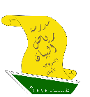



2nd intermediate Grade - Unit 14 Revision
Grammar

- Choose the correct answer:
- Could you ______ me with this bag?
( helping - helps - help - helped )
- Lama will ______ your books.
( carrying - carry - carries - carried )
- Let me ______ you a joke.
( tell - tells - told - telling )
- Nouf wants Sandra to ______ her house.
( decorates - decorate - decorating - decorated )
- If you don't leave immediately, I'll ______ the police.
( calls - calling - called - call )

- Do as shown between brackets:
- Mishaikh won't wears her pink jacket. (Correct)
_______________________________________________________________________
- Rose wants something to write with. (Write a request for this situation)
_______________________________________________________________________
- Match each sentence with its function:
A |  | B
- Will you buy me some snacks? | ( ) | Threat.
- I'll make the salad. | ( ) | Request.
- I'll wear my purple sunglasses. | ( ) | Offer.
- He will tell the teacher if you didn't stop. | ( ) | Instant decision.
 | ( ) | Farewell.
- Write "O" if it's an offer and "R" if it's a request:
- Would you help me cleaning the room? ( ________ )
- Let me wash your car for you. ( ________ )
- I'll fix your laptop. ( ________ )
- Could I have an orange juice please. ( ________ )

Vocabulary

- Write each word under its picture:
Snack - Receptionist - Graduation - Ticket - Meeting - Emergency - Uniform

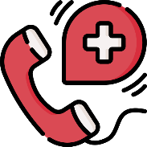
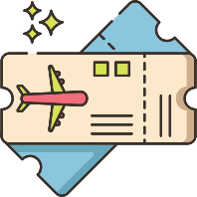

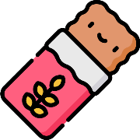


- Match the expressions from column A with their meaning in column B:
A |  | B
- Will you do me a favor? | ( ) | I don’t Know.
- I have no idea. | ( ) | The state of something.
- Condition. | ( ) | Will you help me with something?
 | ( ) | On the day after today.

Dictation Words

Snack – receptionist – napkin – gathering – lend – borrow – graduation – ticket – meeting – emergency

المراجعة لا تغني عن الكتاب.

