Vocabulary:- Q1:
Choose the correct answer:
1-This sleeve is ................ a- broken b- torn c-crashed

2-This computer a- broken b- torn c- crashed

3-It sounds like means : a- It seems to be b- without worry c-clothing

-write the words with the correct picture:
Leaky pipe - cracked windshield - doorknob - dead battery

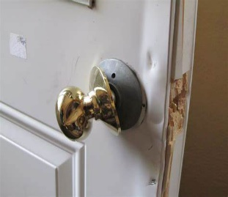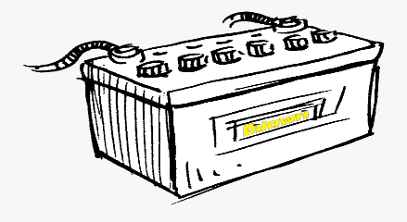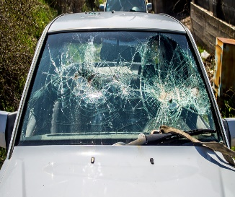

.......................... ................................. .......................................
Q2: Grammar:
1-Choose the correct answer:
a-The windows need to be ( clean – cleaning – cleaned)

b-She can't stand ( cleaning – clean – cleaned )

c-Sandra is never on time . She's ging to tell (it – her -us ) to be more punctual.

-Rewrite the sentence in two ways :
1-please turn off the light . .....................................................

-Write the past participle for each verb:
1-break................. 2-tear ........................
3-fix...................... 4-damage ....................

