
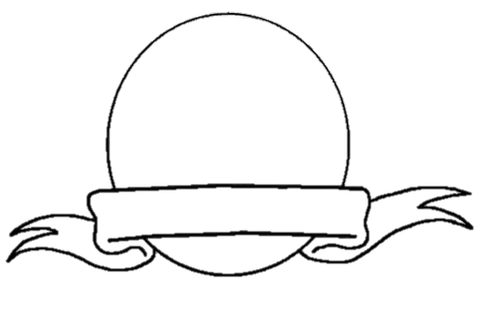
Conditional Sentences: Hypothetical Situations in the Past
Venn
Diagram

