

المملكة العربية السعودية
Kingdom of Saudi Arabia
Ministry of Education
------- Educational Directorate
------- Future Educational Schools
1st Grade High School 2022
3rd Term – Final Exam
وزارة التعليم
الإدارة العامة للتعليم بن
مدارس م ن التعليمية
الصف الأول الثانوي
الاختبار النهائي للفصل الدراسي الثالث1443
Total  written | 5  Vocabulary | 4  Grammar | 3  Free Composition | 2  Guided Composition |  | 1 Comprehension | Q. NO.
 |  |  |  |  |  |  | Mark Given
30 | 6 | 6 | 6 | 6 |  | 6 | Mark
6 |  |  | Reviser |  |  |  | Corrector
زمن الاختبار: 3 ساعات
اسم الطالب: ------------------------------------ رقم الجلوس: ------------- الصف الأول الثانوي

1) Comprehension
Read the following passage then answer the questions
Regrets
My name's Jack and I want to tell you about something I regret. It happened over twenty years ago. I must have been around five years old. It was a summer day and I was in a park playing with some other kids from the neighborhood. There was a boy there named Jeremy who I didn't like very much, but I can't remember why. Anyway, we were playing near a pond. The water was very dirty and it was full of weeds and slime. You can guess what I did, right…? I waited until he was standing near the edge of the pond, and then I crept up behind him and gave him a good hard push in the back. He went flying straight into the filthy, slimy water! His dad rushed over and pulled him out. Jeremy was crying and pointed at me, saying "It was him. He pushed me!" Of course, I denied it. My parents were there, but I insisted I was innocent and without any proof they took my side. The bad thing is that Jeremy's parents and mine used to be good friends, but after that they never spoke to each other again. I should have told my parents the truth, but I didn't. To this day, I still regret pushing that boy into the pond
A) Answer the following questions:
1. What is the name of the writer? ----------------------------------------------------------.
2. Where was the writer playing? -----------------------------------------------------------.
3. How was the water in the pond? -------------------------------------------------------------.
4. Who pulled the young boy out of the pond? -----------------------------------------------.
B) Put ( √ ) or ( X ):
5. There was a boy there named Jeremy. (refer to) in the park. ( )
6. I crept up behind him. (refer to) Jack`s parents. ( )
7. I denied it. (refer to) pushing him in the pond. ( )
8. The writer regrets pushing the boy in the pond. ( )
C) Complete:
9. The story happened over --------------------------------.
10. Without any proof, the writer's parents -----------------------------------.
D) Choose the correct meaning:
11. neighborhood = (nearness – farness – distance)
12. innocent = (guilty – guiltless – faulty)

2) Guided Composition

6

You are living in Najran and you think it is the best place in Saudi Arabia. Write an email inviting your friend to visit you during the weekend.
(Write not less than 150 word (
Guiding words:
(weather – Okhdod Area – Najran Dam – green farms – hospitable people - …)

-------------------------------------------------------
--------------------------------------------------------------------------------------------------------------------------------------------------------------------------------------------------------------------------------------------------------------------------------------------------------------------------------------------------------------------------------------------------------------------------------------------------------------------------------------------------------------------------------------------------------------------------------------------------------------------------------------------------------------------------------------------------------------------------------------------------------------------------------------------------------------------------------------------------------------------------------------------------------------------------------------------------------------------------------------------------------------------------------------------------------------------------------------------------------------------------------------------------------------------------------------------------------------------------------------------------------------------------------------------------------------------------------------

3) Free Composition

6

Choose one topic from the following to write about.
1. Imagine that you are going to have a party for your brother's graduation. Send an email to your friend, invite him to your occasion.

2. You bought a new cellphone, but you found out that it is faulty. Send an email of complaint to the company asking for refund.
(Write not less than 100 word).
-------------------------------------------------------
--------------------------------------------------------------------------------------------------------------------------------------------------------------------------------------------------------------------------------------------------------------------------------------------------------------------------------------------------------------------------------------------------------------------------------------------------------------------------------------------------------------------------------------------------------------------------------------------------------------------------------------------------------------------------------------------------------------------------------------------------------------------------------------------------------------------------------------------------------------------------------------------------------------------------------------------------------------------------------------------------------------------------------------------------------------------------------------------------------------------------------------------------------------------------------------------------------------------------------------------------------------------------------------------------------------------------------------
4) Grammar

6

A: Choose the correct answer:
1. The window needs to be (cleans – cleaning – cleaned – clean).
2. I had my new room (paint – paints – painting - painted).
3. Before we visited friends, we (had called –have called –calling –call) them.
4. Nora is abroad with her family. she (can't – must – may – might) be home.
5. If they had slept early, they would have (be – been – bees – are) on time.
6. Ahmad said that she (cooks – cook – cooked - cooking) a delicious meal.
Do as shown between brackets:
1. Nora asked, "Does he like watching TV?" (Reported Speech)
-------------------------------------------------------------------------------------------------.
2. They didn't study for the final exam. (Use: should have)
-------------------------------------------------------------------------------------------------.
3. I'm not sure, it has wings. It (must) be a bird. (Correct)
-------------------------------------------------------------------------------------------------.
4. After Ali (clean) his room, he went out to play. (Correct)
-------------------------------------------------------------------------------------------------.
5. The vase is broken. Please, throw the ------------------------------- vase away.
(Write the adjective)
6. If Hassan (visit) me, I would have told him the whole story. (Complete)
-------------------------------------------------------------------------------------------------.
5) vocabulary:

6
A- Match the words with the pictures:
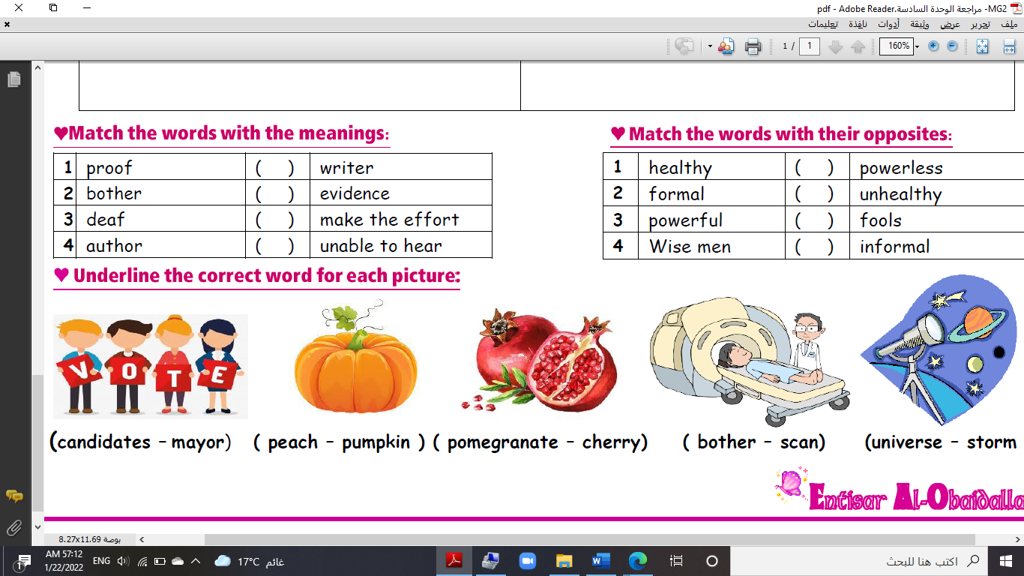
pumpkin – meteorite – bull – battery – oil well – tornado
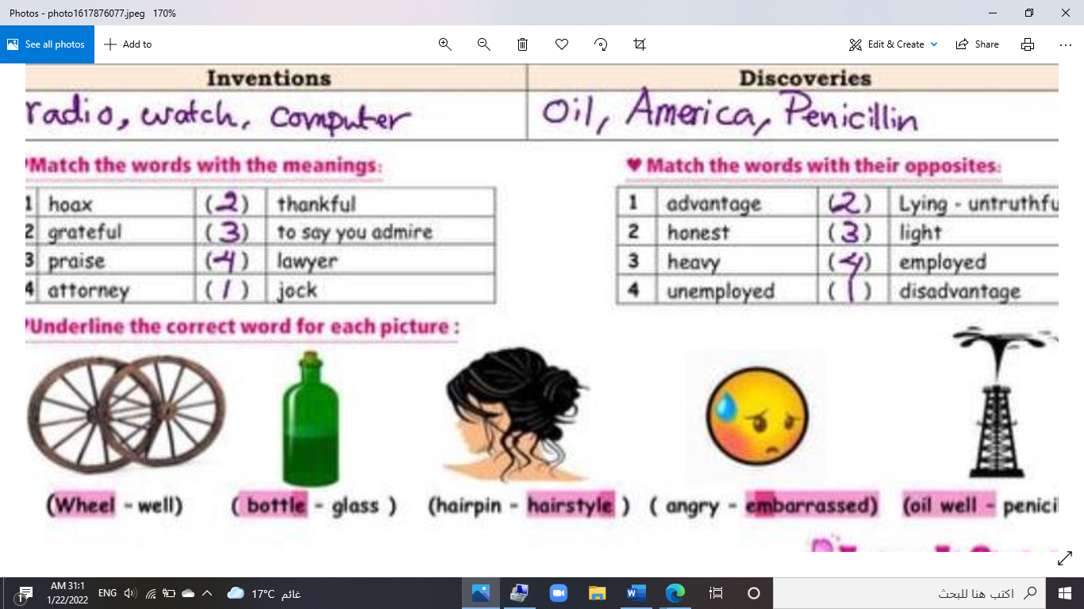
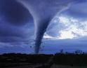

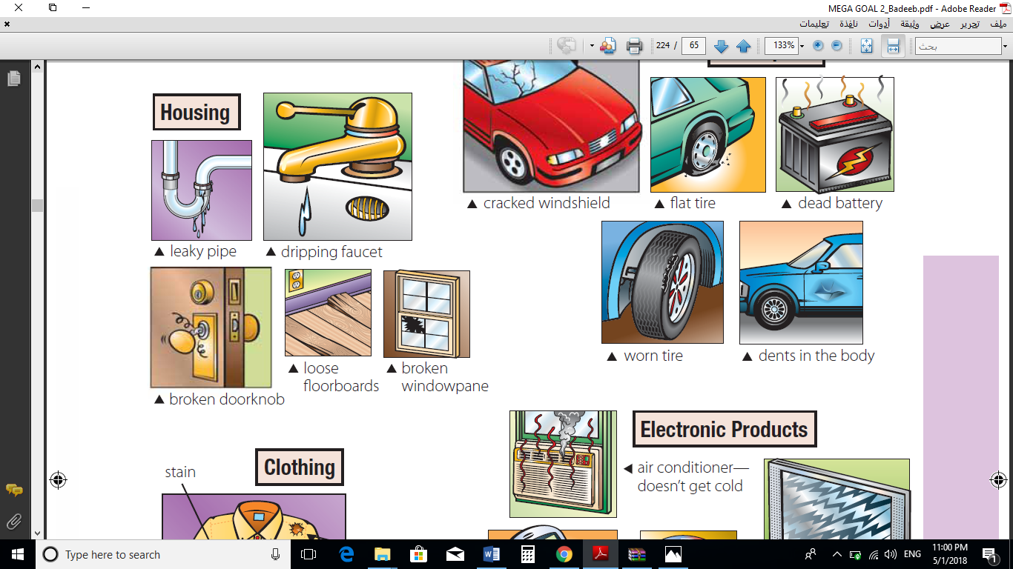

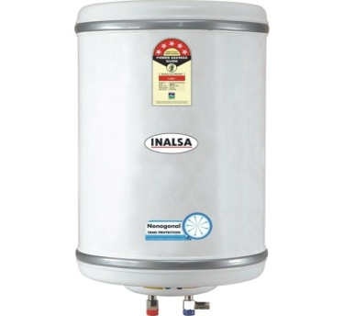
------ --------- ----------- ---------- --------- --------
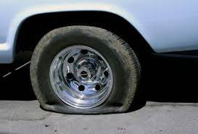
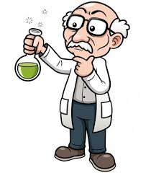
A) Match to form new words or expressions:
1. electric ---- a. evidence
2. remote ---- b. bulb
3. hair ---- c. distant
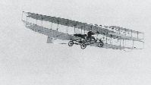

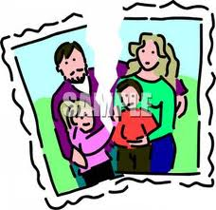
4. devasted ---- d. dryer
5. baby ---- e. destroyed
6. proof ---- f. stroller

End of Questions
Best of Luck https://t.me/abokhaledamer

