
المادة : لغة انجليزية الدور : الأول
الصف : أولى ثانوي الزمن : ساعتان

الدرجة:

المملكة العربية السعودية
وزارة التعليم
الإدارة العامة للتعليم بمنطقة القويعية

متوسطة وثانوية حلبان

أسئلة اختبار نهاية الفصل الدراسي الثالث للعام الدراسي 1443هـ

1429 - 1430

بسم الله الرحمن الرحيم

30

: ..............

اسم الطالبة / ............................................ رقم الجلوس : _____________

Number | Question |  | Student’s Mark Number | Student’s Mark Written
Number | Question | Mark | Student’s Mark Number | Student’s Mark Written
Q1 | Reading Comprehension | 12
Q2 | Grammar | 10
Q3 | Vocabulary | 8
Total Written Tasks |  | 30

(A)Read the following passage, then answer the questions that follow:

I brush my teeth three times a day. That's the way I stay healthy. I wash my hands and face to keep them clean. That's the way I stay healthy . I sleep every night and wake up early. That's the way I stay healthy . I do exercise everyday to be strong and have strong body . That's the way I stay healthy .Fruits and vegetables, meat and bread , I eat them every day. I feel great because I am healthy. I am proud to stay healthy. Remember ! that " health is wealth."

------
12

A- Choose:-
1- I feel great because I am ______ | a. healthy | b. sleaping
2- I brush my teath _____ times a day | a. one | b. three
3- The opposite ≠ of (Remember) is :___ | a. play | b. forget
4- " Health is ______ " | a. wealth | b. nothing
5- To have healthy body you should do____ | a. cooking | b. excercise
6- The word (them) in line 2 refers to: | a.fruits | b. hands and face

------

10

(B) Grammar: Choose the correct answer:

1- The car is crashed, it needs to be ……………………... | a. repaired | b. repair
2- Sara is never on time. She is going to tell…………to be punctual. | a. him | b. her
3- If you heat the ice, it _______ | a. melts | b. melting
4- Rida should have ………….to doctor. | a. go | b. gone
5- if I had known it was going to rain , I ………………………… an umbrella. | a. would have taken | b. would taken
6- Imad …………..very long, his friends are waiting for him. | a. stay | b. can not stay
7- It started to rain, but Karen …………..her umbrella at home. | a. had left | b. left
8- If my friends ………………………me , I would have gone to the library. | a. asked | b. had asked
9-the pencils needs to be ………………………. | a. sharpened | b. sharpen
10- I ________ (feel) much better after I ________ (see) the results of my test. | a. felt , saw | b. felt, had seen
يتبع

8

(C) VOCABULARY & ORTHOGRAPHY,Choose the correct answer:
1- This is ……………..  | . a reporter | b. candidate
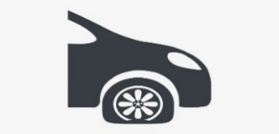  2- This is …………….. | - funny  tire | b. flat tire
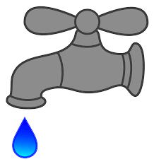  3- This is …………….. | - dripping  faucet | - torn
4. It sounds like means: | a. It seems to be. | b.this has gone  too far.
5- you never know means: | - anything is  good | b. anything is  possible
6-dynamic means | a. always steady | b. always changing
7 – security | a. guard | b. bulb
8– scan means | a-get an image  with computer | - evidence

……………………………………………………
- انتهت الأسئلة -
مع تمنياتنا للجميع بالتوفيق والنجاح

