  Kingdom of Saudi Arabia  Ministry of Education  Secondary  School in Qurayyat | English Language  1st secondary Grade  3rd Term Exam 1443 -2021  Time: 3 hours  The first session
Name/ …………………………………………………………… | Seat No./ …………………………

( اللهم لا سهل إلا ماجعلته سهلا وأنت تجعل الحزن إذا شئت سهلا )

Student’s Mark Written | Student’s Mark Number | Question |  | Number
Student’s Mark Written | Student’s Mark Number | Mark | Question | Number
 |  | 6 | Guided composition | Q1
 |  | 6 | Free composition | Q2
 |  | 6 | Reading Comprehension | Q3
 |  | 6 | Grammar | Q4
 |  | 6 | Vocabulary | Q5
 |  | 30 | Total Written Tasks

عدد الصفحات : 4 صفحات

اسم المصححة وتوقيعها :
اسم المراجعة وتوقيعها :
اسم المدققة وتوقيعها :

1

Q – 1 ( guided composition )

6
Lucy`s grandmother likes drinking tea. Read the instructions.
Write ( 5 ) sentences . Use the following words:
Next – First – After that – Then – Finally.
1 – Put a teabag into acup.
2 – Pour very hot water into the cup.
3 – Leave it for three minutes.
4 – Take the teabag out.
5 – Pour some milk into the tea, but not to much.

………………………………………………………………………………………………………………………………………………………………………………………………………………………………………………………………………………………………………………………………………………………………………………………………………………………………………………………………………………………………………………………………………………………………………………………………………………………………
Q – 2 ( Free composition )

6
Write a free paragraph about your best friend not less than 5 correct sentences.
………………………………………………………………………………………………………………………………………………………………………………………………………………………………………………………………………………………………………………………………………………………………………………………………………………………………………………………………………………………………………………………………………………………………………………………………………………………………

6
Q – 3 ( Reading comprehension )
Read the following passage then answer the questions :

Did you know that spiders are not insects ? They are actually called Arachnids ,
a group of animals related to insects that have 8 legs and that have venom. There are many different kinds of spiders. They live all over the world and can be found in just about every habitat. Most like dark places , which may include your home , closets or basement.
Spiders are very interesting. Some spin silk webs to catch and eat prey , while others attack their prey . Some spiders , like tarantulas, are large enough to eat lizards and mice ! Many people are afraid of spiders because they bite .Most spiders will may bite if they think they are danger and most are harmless. Spiders are actually helpful to people because many eat insects like cockroaches and mosquitoes.

A – Answer the following questions:
1 – Why are spiders helpful to people ?
2
……………………………………………………………………………………………………………………………..
B – Choose the correct answer:
1 – Spiders are called………..
a – Tarantulas. b – Insects. c – Arachnids.
2 – Spiders have ……………………
a – 8 legs. b – 6 legs. c – 4 legs.
3 – Some spiders , like tarantulas, are large enough to eat ………………
a – elephants. b – lizards and mice. c – dogs.
4 – Most spiders bite if they think they are ………….
a – big b – sad c – danger.
C – Put ( T ) or ( F ) :
1 – Spiders like open places. ( )
2 – There are many different kinds of spiders. ( )
Q – 4 ( Grammar )

6
A – Choose :
1 – The window needs to be ( clean – cleaned ).
2 – Before we visited friends, we ( had called – calling ).
3 – If they had slept early , they would have ( be – been ) on time.
4 – He can`t stand ( wait – waiting ) in line.
5 – Has he taken the car to the garage ? yes, he ( has – have ).
6 – We need to invite our friends . I can ask ( her - them ).
7 – Amal needs to ( buy – buying ) some snacks.
8 – We ( move – moved ) to Muscat three years ago.
B – Complete with the correct answer :

1 – The direct question is :
a – Where is the nearest bank ? b – Do you know where the nearest bank is ?

2 – To agree with affirmative statement + ( I ate at the new pizza restaurant ) :
a – Neither do I . b – So did I . c – I didn`t either.

3 – To disagree with the statement ( I am not very tall ) :
a – I didn`t . b – I can`t . c – I am .

4 – The reported speech of ( I am talking to Mary ) is :
a – She said she was talking to Mary. B – They said they were talking to Mary.

3

Q – 5 ( vocabulary )

6

A –Write the problem under its picture :

( flat tire – dead battery – leaky pipe – broken windowpane – stained T-shirt – scratched DVD ).
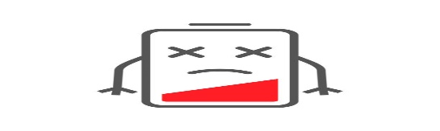

……………………………….. ……………………………….. …………………………………

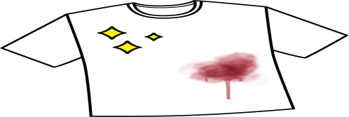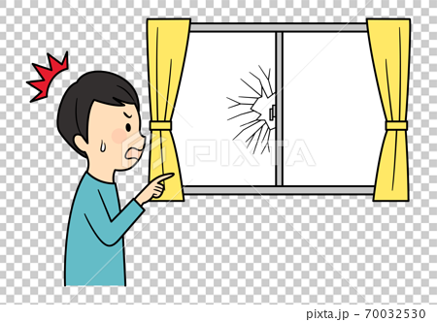

............................................. ……………………………. …………………………..

B - Match to form new words or expressions:
a – oil . ( ) 1 – load
b – heavy . ( ) 2 – well
c – hair. ( ) 3 – bulb
d – electric. ( ) 4 – style
e – security. ( ) 5 – a trick
6 – hoax . ( ) 6 – guard

Good luck….
T. Maram Almari.

( إجعل دقائق الإنتظار مليئة بالإستغفار )

4
4

