Choose the correct answer :
1-I want to buy a phone, (and - but – or – so ) I don’t have enough money
2-If you ( wake up - wakes up – woke up – waking up) late , you will miss the bus
3-Sara didn't' eat breakfast or lunch. She (can't – must – might – can) be hungry now.
4-I (can – could – may – might) run 10 miles when I was young.
5-He has lived in Dammam (for - since – ago – yet) 1999.
6-I should have (call -calls – called- calling) you earlier, But I didn’t.
Correct the mistakes :
1-If I had (study) ……………………………………hard, I might have passed the exam
2-I didn't ( needed to ) …………………………………….wait, she was just on time

Fill in the spaces with suitable words :
(serve – crashed – invented )
1-The Sumerians……………………………………………. the wheel in 5000 B.C.E.
2-The Kingdom is honored to welcome and …………………………………an increasing number of pilgrims

Match the words with their opposite:
light | )) | 1-advantage
disadvatage | )) | 2-heavy
Ordinary-normal | )) | 3-weird
unemployed | )) | 4-employed  5-upgrade

1

Choose the correct meanings :
1-Beats me
a)Anything is bossible b)help me c) I have no idea d) excuseme
2-Remote
a) far away b)near c)quick d)book
3-breathing under someone's neck
a)leave b)constantly checking c)love d)admire
4-Rural
a)dynamic b)business c)modern d)of or relating to the country

Ask for a permission :
Go to bathroom
………………………………………………….?
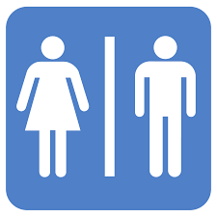

Bonus question
+1

2
Good luck
Tr: Kholoud AlGhamdi

