المملكة العربية السعودية |  |  |  |  |  | المادة: | اللغة الانجليزية (شفوي)
وزارة التعليم |  |  |  |  |  | الصف | الأول متوسط
الادارة العامة للتعليم بمنطقة تبوك |  |  |  |  |  | التاريخ: | /04/1444 هـــ
مدرسة متوسطة وثانوية الحرة الشمالية |  |  |  |  |  | الزمن: | نصـف ساعة
اختبار نهاية الفصل الدراسي الاول – الدور الأول للعام الدراسي 1443/1444 هـ
أسم المصحح |  | التوقيع |  | أسم المراجع |  |  |  | التوقيع
الاستماع 5 |  | التحدث 5 |  | المجموع 10
أسم الطالب |  |  |  | الفصل | أول/ | رقم الجلوس

- Mustafa, this is my____ Mohammed! Nice to meet you |  | 
 | father
 | friend
 | classmate

- When’s your final test? |  | 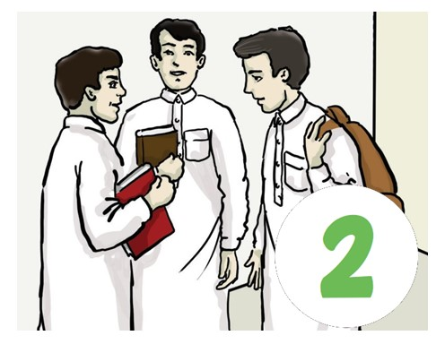
 | It’s on April 7th.
 | It’s on November 17th.
 | It’s on September 27th.

- What’s that? |  | 
 | I don’t know.
 | I think it’s a radio.
 | I think it’s a bicycle.

- Where is Tom from? |  | 
 | He’s from China.
 | He’s from Australia.
 | He’s from New York.

- Do you have any brothers and sisters? |  | 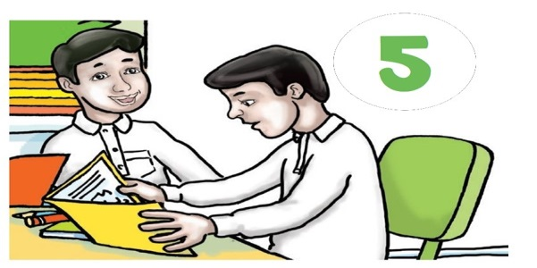
 | No, I’m an only child.
 | Yes, I have one brother.
 | I don’t have any brothers.

المملكة العربية السعودية |  |  |  |  |  | المادة: |  | اللغة الانجليزية (شفوي)
وزارة التعليم |  |  |  |  |  | الصف |  | الأول متوسط
الادارة العامة للتعليم بالإحساء |  |  |  |  |  | التاريخ: |  | /07/1444 هـــ
مدرسة________المتوسطة |  |  |  |  |  | الزمن: |  | نصـف ساعة
اختبار نهاية الفصل الدراسي الثاني – الدور الأول للعام الدراسي 1443/1444 هـ
أسم المصحح |  | التوقيع |  | أسم المراجع |  |  |  |  | التوقيع
الاستماع 5 |  | التحدث 5 |  | المجموع 10
أسم الطالب |  |  |  | الفصل | أول / |  | رقم الجلوس

Listen and circle the right answer:

- What is Ryan doing?
He’s drinking a cup of tea - milk - coffee .

- What time does Amal usually get up?
She usually gets up at 3:15 - 5:30 – 4:30 .

- Do you like math? Yes, I do. It’s great.
I think it’s easy - boring – difficult .

- There’s a rug under - behind – in front of the sofa.

- Where do you live?
I live on Main - Park – 52nd Street.

- The kitchen is small - modern – beautiful .

- Is there a café near here?
It’s next to the bank - bookstore – supermarket .


Write or :

- The restaurant is closed on Saturdays. ( )
- Omar is fourteen years old. ( )
- Lee is from China. ( )

Audio Script:

Super Goal 2 Listening | Resources
- What is Ryan doing?  He’s drinking a cup coffee. | Unit 8 - Page 65  Pair Work  Audio CD2 trick 15
- What time does Amal usually gets up?  She usually gets up at five thirty . | Unit 11- Page 89  Pair Work  Audio CD2 trick 33
- Do you like math?  Yes, I do. It’s great  I think it’s difficult | Unit 10 – Page 81  Pair Work  Audio CD2 trick 27
- There’s a rug in front of the sofa. | Unit 6 – Page 51  Listening  Audio CD2 trick 4
- Where do you live?  I live on Park. Street. | Unit 7 – Page 57  Pair Work  Audio CD2 trick 9
- Omar’s apartment is small. It has one bedroom and one bathroom. There’s a comfortable living room and there’s a modern kitchen. There isn’t a yard. But the apartment has a balcony with a beautiful view. | Unit 6 – Page 49  Listen and discuss  Audio CD2 trick 33
- Is there a café near here?  Yes, there is. Go straight. It’s on the corner on your right. It’s next to the bookstore. | Unit 7 – Page 59  Listening  Audio CD2 trick 10
- I like to cook. It’s very hot in the kitchen, but we’re very busy and I don’t notice it. I prepare meals for customers. The restaurant is excellent. I work all week, except Fridays. The restaurant is closed on Fridays. I work a lot, but I love my job. | Unit 9 – Page 75  Listening  Audio CD2 trick 22
- Omar Hamadan lives in Tabuk. He is sixteen years old  And he’s on the school football team. Omar is very good player, and he’s the team’s top strikers this season. | Unit 9– Page 77  Reading  Audio CD2 trick 25
- Who are your friends in school? Here’s a picture of my school friends the boy with glasses is Lee. He is an exchange student form China. He’s nice and very smart. | Unit 10 – Page 81  Listen and discuss  Audio CD2 trick26

Audio : https://youtube.com/watch?v=Ay7i4pphjWU&si=EnSIkaIECMiOmarE

