Name :………………………………….……………..…………………………. Class :……………………………………
Midterm Exam
- Write the time:
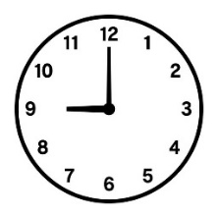
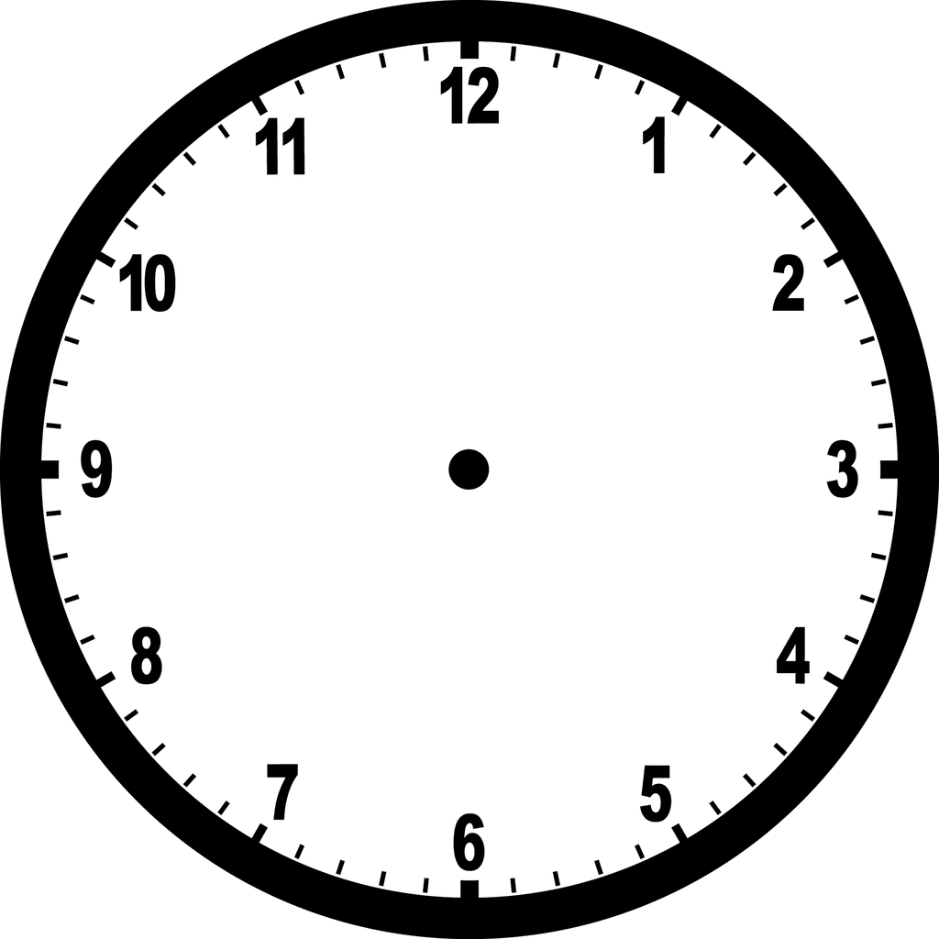
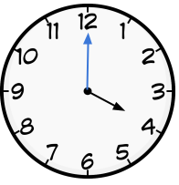
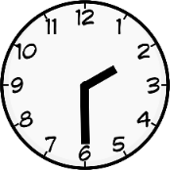
:
:

30 : 7
00 : 5
:


- Read and put ( ) or ( ) :

1- a cook works in restaurant ( )

2- a pilot works in an airplane ( )

3- She is a doctor ( )
4- He is a businessman ( )
- Choose the correct answer:

1- Yesterday I ( eat lunch – ate lunch ) at 4:00 .
2- I usually ( get up – got up ) at 6:00 .
3- Yesterday I ( come home – came home ) at 8:00 .
4- I usually ( take – took ) a bath .
5- I finish school ( at – in ) 1:00
- Choose the correct sound ::





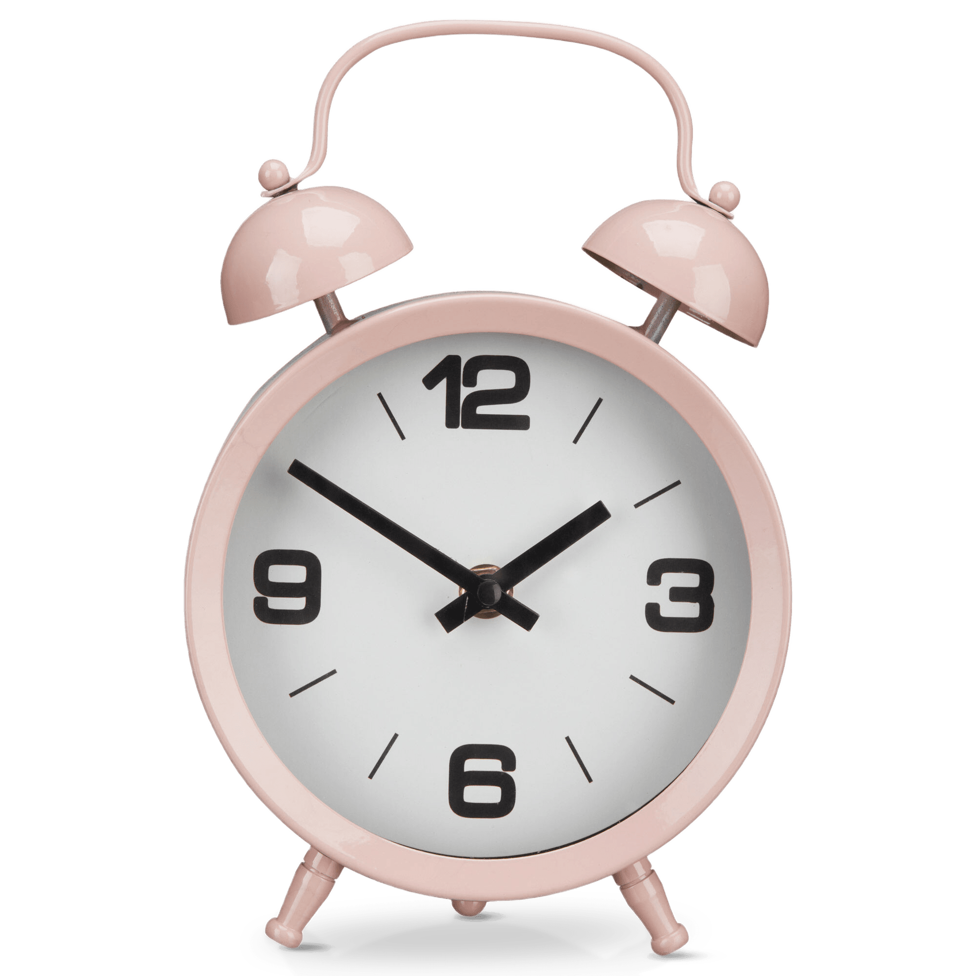

…….ife
gh
kn
gh
kn
gh
li…..t
nk
ng
ng
ng
kn
ni……t
ri…….
ck
dri…….
Clo…….
nk

Your teacher: Alia Al-Qahtani

