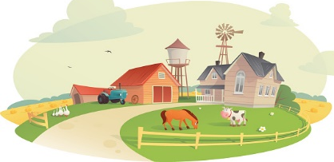
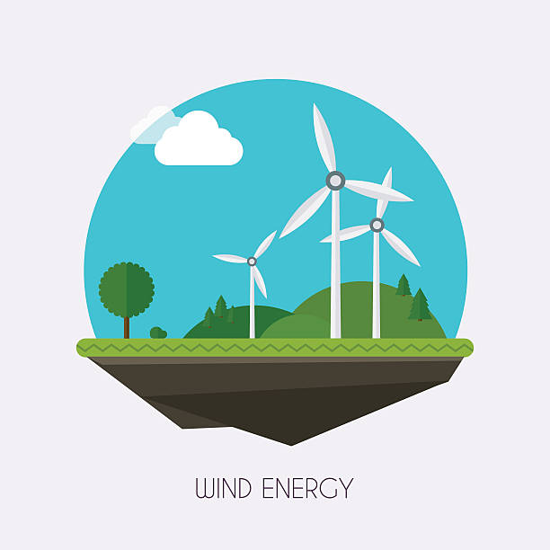
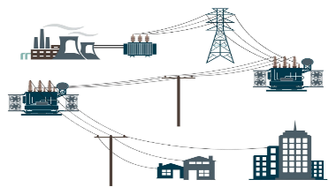
MG2.2 u2 reading
Why did some people decide to live off the grid?
…………………………………………………………..……………………………………………………………………………………………………………………………………..………………….………
How does a windmill produce electricity?
……………………………………………………………………………………………………………………………………………………..………..…………………………………………………………………………………..…………..

What is the grid?
……………………………………………………….………………………..……….……….……………………………………….……………….………………………………………………………………………………………………………..

Paragraph ( 3 )
Paragraph ( 2 )
Paragraph ( 1 )

Paragraph ( 4 )
Paragraph ( 5 )
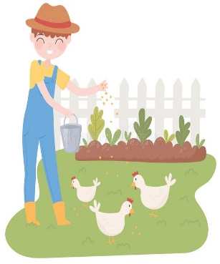
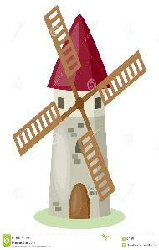
How do people who live off the grid create very little waste?
……………………………………………………………………………………………………………………………………………………………………………………………………………..…………..….
What are Jorge and Ella Alvarez's opinion about living off the grid?
……………………………………………………………………………………………………………………………………………………………………………………………………………..…………..….

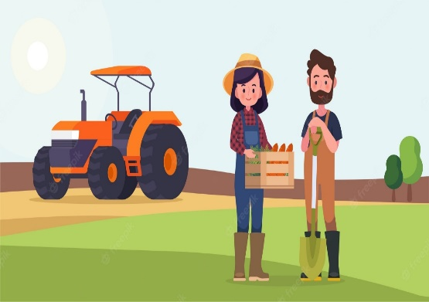

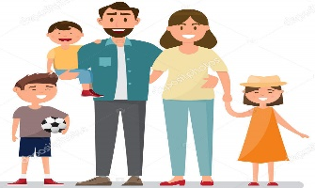
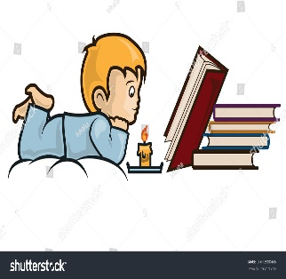
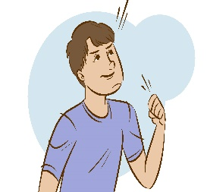
How does the
Johnstons family spend their
time when the power goes down?
…………………………………………………………………………………………………………………………………………………………………………………………………………….……..
What are the two things
Wendy wants for her children?
…………………………………………………………………………………………………………………………………………………………………………………………………………….……..

What is the " bold choice "
referred to in the text?
……………………………………………………………………………………………………………………………………………………………………………………………………………..…………..….
Paragraph ( 8 )
Paragraph ( 7 )
Paragraph ( 6 )

