Unit 1 Test Name : ………………………………………………………………..Class/ ………….
Grammar /Circle the best answer .
1-She broke her nose ……………….( myself -yourself –herself ) .
2-I didn't see Amal …………….( Neither did I – Neither I did – I neither did )
3- Fatima was very sick . ( because -So – ago ) She went to see a doctor .
4-We should ( drinking -drinks – drink )a lot of water everyday .
5- My house is ( on -from -between ) the school and the supermarket .
6- I am very happy today. ( so am I – so I am – I am so )
Vocabulary / Circle the correct words .---------------------------------------------------------------------------
Helmet aggressive hurt bald matches
1-How did you …………………yourself ? 2- ………………………………drivers don’t pay attention to the traffic signs . 3- Mr.Ali is ……………………He doesn't have hair on his head . 4- Always wear a …………………….when you drive a motorcycle
Pills
fracture /arm
Poke /eye sockets matches

Write the words under the correct pictures

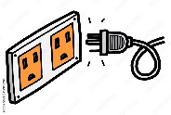


…………………. …………………….. ………………. …………………
Read the following passage and answer the questions below .----------------
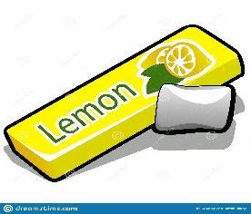
Did you know that chewing gum has been around for thousands years? Historians have found chewing gum that is at least 5,000 years old in Finland. This ancient Chewing gum has been made from various trees, plants, and grasses. It was thought to help clean the mouth as well as freshen breath. Gum was chewed by the ancient Aztecs as well as the Greek.
In the 1860s, in the United States, they use Chicle, a sticky substance from the chicle tree, in the gum. One inventor, Thomas Adams, figured out that the rubbery substance could be used as a new type of chewing gum. All he had to do was adding flavor. Adams opened the world's first chewing gum factory and began selling his gum in 1871.
Circle the best answer .
1-Chewing gums started [ 500 - 5000 -5005 ] years ago. 2-Chewing gums helps to [ remove – plant -clean ] the teeth. 3-In the United State , gum is made from [ chicle tree – grass -factory ] 4-A good title for the reading above is [ Gums -Ancient Aztecs – Historians] True or false ?
1-Chewing gums started in Finland . ( ) 2- Adams opened his gum factory and sold gums in 1860s . ( )
3-

’

