Grade : 2 Midterm Exam Unit 7 - 8
20
Name:…………………………………………………………………

A-Make a Suggestion and give a Respond: (go bowling ) --------------------------
Accept ..…………………………………………… Refuse : ………………………………………………………………..

Give examples of : ( cold – go shopping – clean the room – eyes )
Chores / ………………………………………. Illness / ……………………………………………

Activity/ . ………………..…………………… human body / ……………………….………..

B-Match the problem with the advice :
Advise | ----- | problem
You should go to the dentist |  | - We're very tired
You should take a rest |  | - I have a headache
You should take some Panadol  They should drink a worm liquids |  | - Ahmad has a toothache  - They have a sore throat

C-Choose the correct answer :
1- You should ( prays - pray - prayed ) on time .
2- Why ( don’t - didn’t - doesn’t ) we clean the class ?
3- Let’s go (swimming- swims – swim )
4- I have to ( wash _ washing _ washes ) the dishes .
5- you (must – mustn't – should ) talk during the test .
D-Write the correct word under the picture :

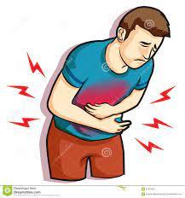
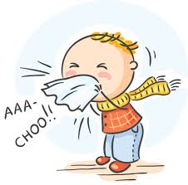
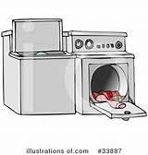
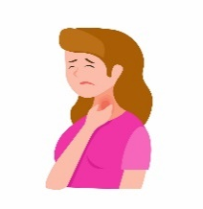
( flu - garbage - sore throat - laundry - stomachache )

………………….…. ……………………………. …………………….. ………………..…………. …………………..………

